Reader enquiries: | Press contact:
congatec AG | SAMS Network
Christian Eder | Michael Hennen
Phone: +49-991-2700-0 | Phone: +49-2405-4526720
info@congatec.com  www.congatec.com | info@sams-network.com  www.sams-network.com

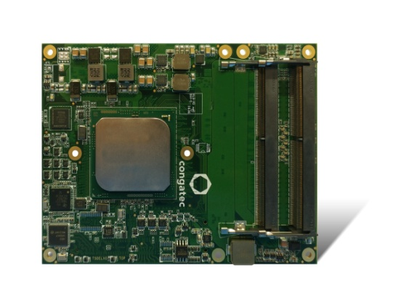
Text and photograph available at: http://www.congatec.com/press
Press release

congatec presents first COM Express Type 7 modules with Intel® Xeon® D processors

congatec's new Server-on-Modules première 10 Gigabit Ethernet performance

Deggendorf, 12. October 2016 * * * congatec – a leading technology company for embedded computer modules, Single Board Computers (SBCs) and embedded design and manufacturing (EDM) services and editor of the upcoming COM Express 3.0 standard that includes the new COM Express Type 7 Pinout– is introducing new Server-on-Modules with Intel® Xeon® D processors (codename Broadwell) parallel to the preview release of the COM Express Type 7 specification. Based on the world-leading COM Express Basic standard form factor (95 x 125 mm), the modules feature 10 Gigabit Ethernet interfaces, 32 PCIe lanes and headless server performance currently with up to 16 server cores and 48 gigabytes of DDR4 ECC RAM. Examples of target applications for the new Server-on-Modules are industrial automation, storage and networking appliances as well as modular server designs and base stations for telecom carriers, service providers‘ server farms as well as cloud, edge and fog servers for IoT and Industry 4.0 applications.

The application-ready, modular core of the long-term available congatec Server-on-Modules offers a standardized footprint, carrier board interfaces and a cooling concept, which significantly simplifies system designs – accelerating the launch of new, robust server technology. Plus, future performance upgrades can be carried out in a remarkably simple and cost-saving way, as only the Server-on-Module needs to be exchanged – even in case of a switch in the processor architecture. Without module technology, upgrading proprietary SBC designs and ATCA platforms used for carrier infrastructures is significantly more expensive.

Christian Eder, Marketing Director at congatec and editor of the COM Express 3.0 specification that includes the new COM Express Type 7 Pinout, emphasizes the significance of the new COM Express Type 7 specification Server-on-Modules: “Up to now, it was not possible to execute 10 Gigabit Ethernet natively on the modules. However, this bandwidth is required to create easily scalable, module server topologies via virtualization. The Type 7 pinout fulfils these demands. It offers up to four 10 Gigabit Ethernet ports and an impressive number of 32 PCIe lanes which are commonly used on this type of server to connect fast SSDs or discrete GPUs. The COM Express footprint is tiny and allows more cores per rack. This extremely compact and robust server technology allows 10 GbE connections to be carried into the field, which is essential for hosting IoT applications.“

The feature set in detail
The new conga-B7XD COM Express Type 7 Server-on-Modules come in a headless design and are available with ten different server processors: From the 16 Core Intel® Xeon® processor D1577 to the Intel® Pentium® processor D1519 for the industrial temperature range (-40 °C to +85 °C). In terms of memory, they offer up to 48 gigabytes of fast 2400DDR4 memory with or without error correction code (ECC) depending on customers’ requirements.

An outstanding characteristic of the new congatec Server-on-Modules is the high level of network performance due to 2x 10 Gigabit Ethernet ports. It also supports the NC-SI Network Controller Sideband Interface for connecting a Baseboard Management Controller (BMC) allowing out-of-band remote manageability. Powerful system extensions including Flash memory can be connected via up to 24 PCI Express Gen 3.0 Lanes and 8x PCIe Gen 2.0 Lanes. 2x SATA 6G ports are available for conventional storage media. Further I/O interfaces, including 4x USB 3.0, 4x USB 2.0, LPC, SPI, I2C Bus and 2x UART, are featured.

congatec offers operating system support for all popular Linux distributions and Microsoft Windows variants, including Microsoft Windows 10 IoT. An extensive range of accessories, such as standardized cooling solutions and the new COM Express Type 7 carrier board for evaluation, simplifies the design-in and will become available parallel to the launch of the new modules.

Processor |  | Cores |  | Intel® Smart Cache [MB] |  | Clock/ Burst  [GHz] |  | TDP  [W] |  | Temperature range
Intel® Xeon™ D1577 |  | 16 |  | 24 |  | 1.3 / 2.1 |  | 45 |  | 0 to +60 °C
Intel® Xeon™ D1548 |  | 8 |  | 12 |  | 2.0 / 2.6 |  | 45 |  | 0 to +60 °C
Intel® Xeon™ D1527 |  | 4 |  | 6 |  | 2.2 / 2.7 |  | 35 |  | 0 to +60 °C
Intel® Xeon™ D1559 |  | 12 |  | 18 |  | 1.5 / 2.1 |  | 45 |  | -40 to +85 °C
Intel® Xeon™ D1539 |  | 8 |  | 12 |  | 1.6 / 2.2 |  | 35 |  | -40 to +85 °C
Intel® Xeon™ D1529 |  | 4 |  | 6 |  | 1.3 |  | 20 |  | -40 to +85 °C
Intel® Pentium™ D1519 |  | 4 |  | 6 |  | 2.1 / 1.5 |  | 25 |  | -40 to +85 °C
Intel® Pentium™ D1508 |  | 2 |  | 3 |  | 2.2 / 2.6 |  | 25 |  | 0 to +60 °C
Intel® Pentium™ D1509 |  | 2 |  | 3 |  | 1.5 |  | 19 |  | 0 to +60 °C

For more information about congatec’s conga-B7XD COM Express Type 7 Server-on-Modules please visit: http://www.congatec.com/products/com-express-type7/conga-b7xd.html

For more information about the new COM Express Type 7 pinout, download the Whitepaper from congatec here: http://www.congatec.com/en/technologies/com-express/com-express-type-7/type-7-whitepaper-registration.html

About congatec AG
Headquartered in Deggendorf, Germany, congatec AG is a leading supplier of industrial computer modules using the standard form factors COM Express, Qseven and SMARC as well as single board computers and EDM services. congatec’s products can be used in a variety of industries and applications, such as industrial automation, medical, entertainment, transportation, telecommunication, test & measurement and point-of-sale. Core knowledge and technical know-how includes unique extended BIOS features as well as comprehensive driver and board support packages. Following the design-in phase, customers are given support via extensive product lifecycle management. The company’s products are manufactured by specialist service providers in accordance with modern quality standards. Currently congatec has entities in Taiwan, Japan, China, USA, Australia and the Czech Republic. More information is available on our website at www.congatec.com or via Facebook, Twitter and YouTube.

* * *

Intel and Intel Xeon, Pentium are registered trademarks of Intel Corporation in the U.S. and other countries.

