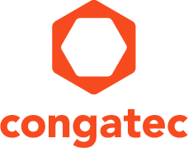
Reader enquiries: | Press contact:
congatec AG | SAMS Network
Christian Eder | Michael Hennen
Phone: +49-991-2700-0 | Phone: +49-2405-4526720
info@congatec.com  www.congatec.com | info@sams-network.com  www.sams-network.com

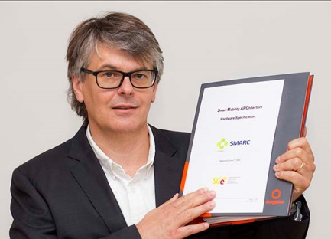
congatec’s Christian Eder played a major role in drafting the SMARC 2.0 specification

Text and photograph available at: http://www.congatec.com/press
Press release

congatec fully supports SMARC 2.0 specification
SMARC 2.0: A complementary solution
well positioned between Qseven and COM Express

Deggendorf, 30 June 2016 * * * congatec – a leading technology company for embedded computer modules, single board computers (SBCs) and embedded design and manufacturing (EDM) services – has announced its full support of the new SMARC 2.0 specification, which was released by the Standardization Group for Embedded Technologies e.V. (SGET) just a few days ago. This major technology adaption extends congatec’s leading and extensive Computer-on-Module portfolio to include a brand new solution which is perfectly positioned between Qseven and COM Express. First congatec SMARC 2.0 modules as well as carrier boards and starter kits including extensive software, driver and BIOS support will be available in August.

congatec’s support of the standard is no surprise for insiders, as congatec played a major role within the SGET in developing the SMARC 2.0 specification. The new specification heralds a milestone in embedded Computer-on-Module technology and is especially designed for particularly multimedia oriented and IoT-connected small systems.

Christian Eder, Marketing Director at congatec, Member of the SGET Board and editor of the SMARC 2.0 specification comments on the importance of the new specification: “Revision 2.0 has elevated SMARC onto an excellent quality level and we can unconditionally recommend it to our customers. Known issues with previous versions – like the all too random Alternate Function Block – have been removed and this eases customers‘ entry into SMARC technology and secures long-term availability. SMARC 2.0 has got all the right qualifications to become an extremely successful new module standard, and win significant market share."

“With congatec in the role of draft editor we were able to significantly drive the advanced enhancements of this new specification," Jason Carlson, CEO of congatec AG explains “As the market leader in EMEA for Computer-on-Modules we utilized our knowledge and market experience to position SMARC 2.0 as a specification that will support the needs of the market for many years to come. We see SMARC 2.0 as complementary to our existing product offerings of Qseven and COM express, and by supporting all three platforms we will have a broader product offering to meet the expanding needs of our customers.”

SMARC 2.0 offers numerous leading-edge serial IOs as well as IoT, network and video interfaces and is thus destined for a wide range of multimedia and graphics-oriented IoT applications. SMARC is perfectly positioned between the rugged, ultra-low-power standard Qseven for deeply embedded systems and the feature-rich COM Express standard for especially high performance embedded designs, which even include edge and fog servers.

Technical highlights of SMARC 2.0
With the big step from SMARC 1.1 to 2.0, SMARC’s position in the established COM market has become clearly defined. Underlining SMARC 2.0‘s focus on multimedia, via the 314 pins of the MXM 3.0 connector, numerous multimedia interfaces are available, allowing up to four video outputs. 2x 24 Bit LVDS / eDP / MIPI DSI plus HDMI/DP++ and DP++ are executed. Additionally, there are 2x MIPI camera interfaces and two audio interfaces via HDA and I2S. SMARC 2.0 now features additional USB ports for up to 6x USB including 2x USB 3.0, a second Ethernet port for vertical IoT connection, a fourth PCI Express Lane and 1x eSPI. Obsolete interfaces such as the parallel ports for camera and display, the Alternative Function Block, off module eMMC, SPDIF and one of three I2S channels have been dropped.

About congatec AG
Headquartered in Deggendorf, Germany, congatec AG is a leading supplier of industrial computer modules using the standard form factors Qseven, COM Express, XTX and ETX, as well as single board computers and EDM services. congatec’s products can be used in a variety of industries and applications, such as industrial automation, medical, entertainment, transportation, telecommunication, test & measurement and point-of-sale. Core knowledge and technical know-how includes unique extended BIOS features as well as comprehensive driver and board support packages. Following the design-in phase, customers are given support via extensive product lifecycle management. The company’s products are manufactured by specialist service providers in accordance with modern quality standards. Currently congatec has entities in Taiwan, Japan, China, USA, Australia and the Czech Republic. More information is available on our website at www.congatec.com or via Facebook, Twitter and YouTube.

* * *

