


Press release

congatec and Ennoconn join forces to deliver custom-built turnkey solutions across automation, IIoT, medical, and critical infrastructure

congatec and Ennoconn join forces through aReady.YOURS to accelerate Solutions as a Service

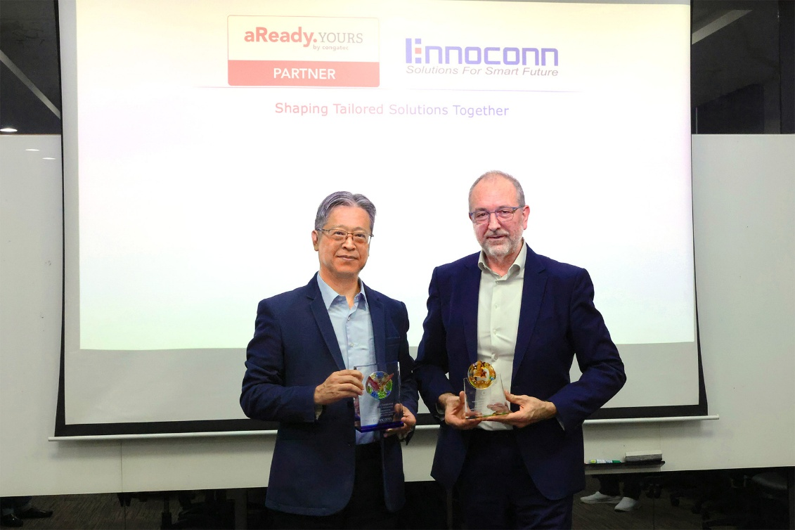
Aven Lou, GM at Ennoconn Corporation and Chairman of Ennoconn Suzhou, and Konrad Garhammer, COO & CTO at congatec, are excited about the extended partnership (from left to right).

Deggendorf/Shanghai, Germany/China, October 13, 2026 * * * congatec – a leading provider of embedded and edge computing technology – and Ennoconn Corporation today announced at CIIF 2026 the strategic expansion of their collaboration under congatec’s aReady.YOURS Partner Program. This collaboration is aimed at delivering custom-built turnkey solutions and embedded technology for automation, IIoT, medical, and critical infrastructure. It combines congatec’s application-ready embedded hardware and software building blocks with Ennoconn’s system-level design, global supply-chain, and industrial manufacturing capabilities.

Through this partnership, congatec and Ennoconn deliver fully customized, application-specific solutions for Artificial Intelligence and the Internet of Things (AIoT), and machine learning. By pairing standards-based aReady.COM platforms with Ennoconn’s system-level design, ODM/EMS manufacturing, and global supply-chain capabilities, OEMs benefit from lower development risks, reduced overall production costs, and shortened overall time-to-market.

Supporting digital transformation in APAC
As AIoT, 5G and cloud connectivity drive digital transformation, OEM engineers face rising complexity when designing embedded solutions. The cooperation between congatec and Ennoconn within the framework of the aReady.YOURS program leverages the respective strengths of each to mitigate this complexity and help OEMs bring customized embedded solutions from concept to rollout quickly and reliably.

congatec provides the application-ready embedded computing brain, pre-configured with essential software building blocks such as operating systems, a hypervisor for system consolidation, and IoT connectivity. Ennoconn utilizes its extensive ecosystem of intelligent solutions under the Ennoconn Solutions as a Service (ESaaS) banner to speed up production process design and increase solution quality for their customers.

“Ennoconn’s design and manufacturing services with a strong focus in China make them an ideal aReady.YOURS partner,” said Peter Müller, VP Global Custom Solutions at congatec. “The combination of our modular approach with Ennoconn’s extensive ODM and EMS footprint across Asia will greatly help OEMs get turnkey embedded solutions for automation, IIoT, medical, and infrastructure applications.”

“By pre-integrating hypervisors, OS configurations, and connectivity directly onto our aReady.COM platforms, we eliminate complex low-level engineering hurdles upfront,” said Konrad Garhammer, COO & CTO at congatec. “Pairing these computing cores with Ennoconn’s system-level design and cloud-edge capabilities allows OEMs to bypass base hardware risks and focus entirely on their proprietary innovations.”

“Partnering with congatec within the aReady.YOURS ecosystem perfectly complements our ESaaS model,” stated Aven Lou, GM at Ennoconn Corporation and Chairman of Ennoconn Suzhou. “Integrating congatec’s modular computing cores with our system-level design, global supply-chain, ODM/EMS manufacturing, and cloud capabilities gives OEMs a proven, turnkey path to production that accelerates digital transformation while optimizing supply-chain efficiency.”

For more information, please visit https://www.congatec.com/aready-yours/

* * *

About congatec
congatec is a leading global provider of high-performance hardware and software building blocks for embedded and edge computing solutions based on Computer-on-Modules (COMs). These advanced computer modules drive systems and devices across industries such as industrial automation, medical technology, robotics, telecommunications, and more. congatec's high-performance aReady. ecosystems simplify and accelerate the solution development, from COM to cloud. This application-ready approach combines COMs with services and customizable technologies that enable cutting-edge advancements in system consolidation, IoT, security, and artificial intelligence. Supported by its majority shareholder, DBAG Fund VIII – a German mid-market fund focused on driving growth for industrial enterprises – congatec has the financial backing and M&A expertise to capitalize on expanding market opportunities. For more information, visit www.congatec.com or follow us on LinkedIn and YouTube.

About Ennoconn
Ennoconn Corporation, a global technology solutions provider, delivers world-class Industrial IoT and Embedded Technology, system-level design and ODM/EMS manufacturing services supported by a global supply chain, IT and System Integration Services into high-growth markets, including Smart City, Smart Manufacturing, Smart Retail, Financial Services, and Media and Entertainment.
With a commitment to Digital Transformation, Ennoconn’s “Digitalization as a Service” strategy integrates and delivers manufacturing systems with emerging technology solutions that address the revolutionary demand in cloud data storage, machine learning / AIoT / 5G / Cloud IoT Integration. They deliver Digital Transformation strategies across all internal design, manufacturing, and supply chain platforms and disciplines.

Reader enquiries:
congatec
Phone: +49-991-2700-0
info@congatec.com
www.congatec.com

Press contact congatec:
congatec
Christof Wilde
Phone: +49-991-2700-2822
christof.wilde@congatec.com

