


Press release

congatec extends its aReady.YOURS Partner Program with local expertise to deliver highly customized embedded system solutions in APAC

congatec and EFCO strengthen partnership for customized embedded systems in APAC
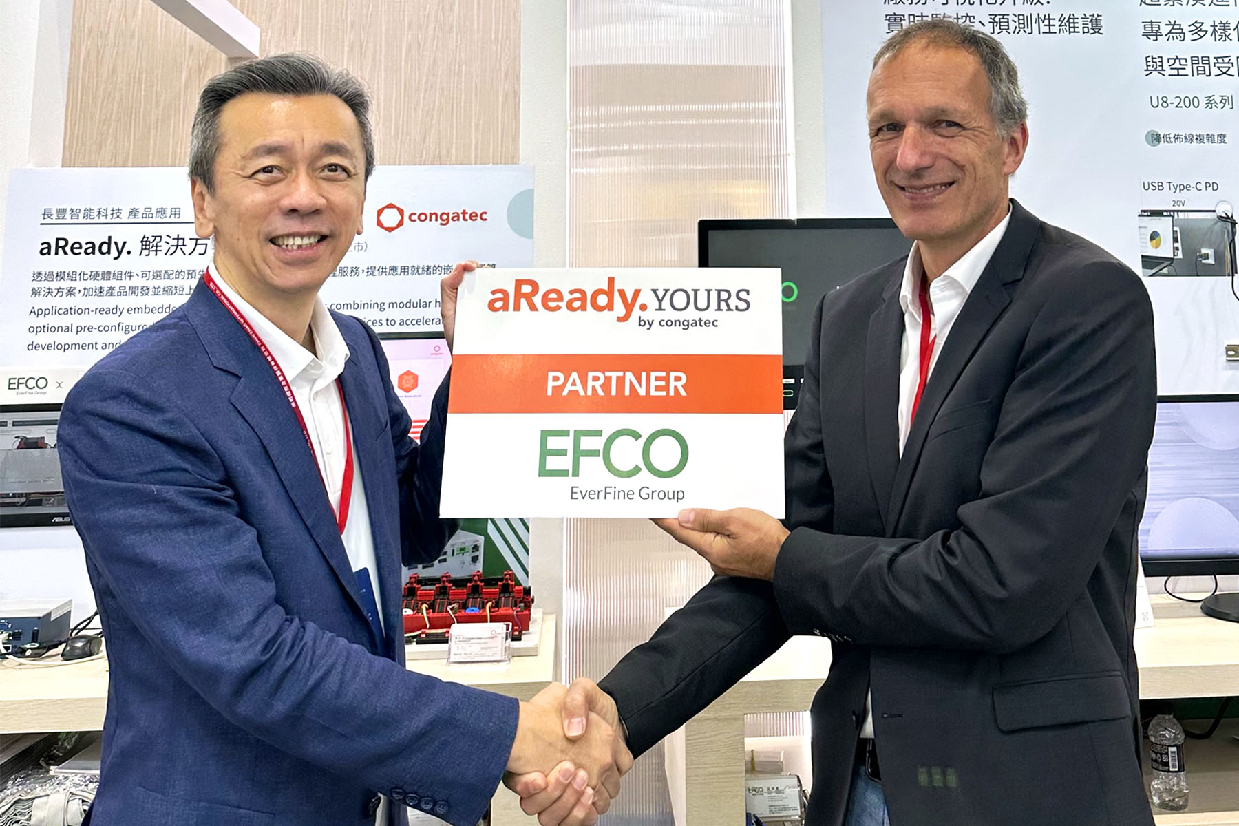
Bryan Lin, CEO at EFCO, and Dr. Dominik Ressing, CEO at congatec, are excited about the extended partnership (from left to right).

San Diego/Taipei City, USA/Taiwan, August 20, 2026 * * * congatec – a leading provider of embedded and edge computing technology – today announced at Automation Taipei the expansion of its aReady.YOURS Partner Program through a strategic partnership with Taiwan-based EFCO Technology. The focus is to deliver application-specific, customized system solutions built by EFCO based on congatec’s aReady.COM platforms. Building on a successful 20-year history of collaboration, the partnership combines congatec’s global module engineering expertise with EFCO’s local market knowledge, system design, and manufacturing know-how. OEMS across the APAC region will benefit from tailored embedded and edge solutions that significantly reduce their development efforts, lower design risks, and accelerate time-to-market.

Within the aReady.YOURS framework, congatec provides the application-ready computing core, including Computer-on-Modules (COMs) and low-level software building blocks such as operating systems, hypervisors for system consolidation, and IoT connectivity. EFCO complements this with custom system-level design, contributing carrier board development, application-specific interfaces, rugged enclosures, and full Electronic Manufacturing Services (EMS).

Tailored embedded systems for APAC industrial automation markets
The expanded cooperation primarily targets OEMs in the industrial automation sector, with a specific focus on Industrial PC (IPC) and Human-Machine Interface (HMI) applications. By offering pre-validated reference solutions based on congatec modules, the joint effort enables OEMs to adapt complex hardware and software architectures quickly to specific regional and application demands. This directly meets the requirements of the fast-paced APAC market, where customers demand high quality and industrial-grade reliability combined with cost competitiveness. Furthermore, the provided long-term availability and seamless upgrade paths significantly lower the total cost of ownership (TCO) over the entire product lifecycle.

Another advantage for customers is EFCO’s ability to support both module-level integration and complete system manufacturing, which means OEMs benefit from shorter coordination paths, greater implementation efficiency, and a tightly aligned route from embedded module to finished system.

Bryan Lin, CEO at EFCO explains: “Our partnership with congatec is built on more than 20 years of trustful cooperation and a shared commitment to engineering excellence. Because our teams know each other so well and share the same values, we can collaborate seamlessly to transform congatec’s application-ready module platforms into fully customized system solutions. For our customers in APAC, this deep alignment translates into faster execution, frictionless communication, and highly reliable IPC and HMI platforms optimized for performance and cost efficiency.”

“With technologies such as AI, connectivity, and system consolidation continuously increasing the complexity of embedded system design, OEMs need implementation-ready platforms that allow them to stay focused on their own core application software,” said Dr. Dominik Ressing, CEO at congatec. “Since we already have a team with deep roots in APAC, having a strong regional partner like EFCO allows us to address the unique requirements of our local customers directly. It combines our global module leadership with agile, local-for-local execution to deliver the speed, flexibility and tailored support APAC OEMs expect.”

“With aReady.YOURS, we enable OEMs to move much faster from idea to a fully customized system,” added Peter Müller, VP Global Custom Solutions at congatec. “EFCO is an ideal long-term partner for APAC, perfectly embodying our local-for-local strategy by combining deep regional system design expertise with full EMS capabilities. Customers benefit from ready-to-customize solutions for industrial automation from a partner model in which module integration and complete system manufacturing are closely aligned, streamlining communication and support, increasing reliability, and accelerating deployment.”

For more information, please visit https://www.congatec.com/aready-yours/

* * *

About congatec
congatec is a leading global provider of high-performance hardware and software building blocks for embedded and edge computing solutions based on Computer-on-Modules (COMs). These advanced computer modules drive systems and devices across industries such as industrial automation, medical technology, robotics, telecommunications, and more. congatec's high-performance aReady. ecosystems simplify and accelerate the solution development, from COM to cloud. This application-ready approach combines COMs with services and customizable technologies that enable cutting-edge advancements in system consolidation, IoT, security, and artificial intelligence. Supported by its majority shareholder, DBAG Fund VIII – a German mid-market fund focused on driving growth for industrial enterprises – congatec has the financial backing and M&A expertise to capitalize on expanding market opportunities. For more information, visit www.congatec.com or follow us on LinkedIn and YouTube.

About EFCO
Established in 1992, EFCO is a leading provider of embedded computer platforms with a demonstrated history of delivering solutions matched specifically to individual customer requirements. Their industrial-grade products cover a variety of vertical market solutions. These include Wide-temperature Rugged Fanless Computers, Multi-touch Panel PCs, Casino Gaming Solutions and IoT Nodes. EFCO also offers COMe carriers board design service, OEM/ODM design and manufacturing services, and Computer on Module (COM) thermal solutions.
EFCO is headquartered in Taipei Taiwan, with offices in the USA, China, UK and Germany.

Reader Enquiries:
congatec
George T. Hilliard
George.Hilliard@congatec.com
www.congatec.us

Press Contact:
congatec
Janene Rae
Phone: 858-457-2600
janene.rae@congatec.com
www.congatec.us

