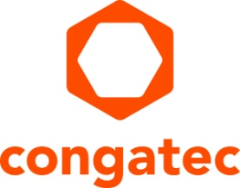
Press release

congatec and ECTrons have entered into a strategic partnership for the development and commercialization of AI-powered industrial computing solutions

Accelerating application-ready edge AI

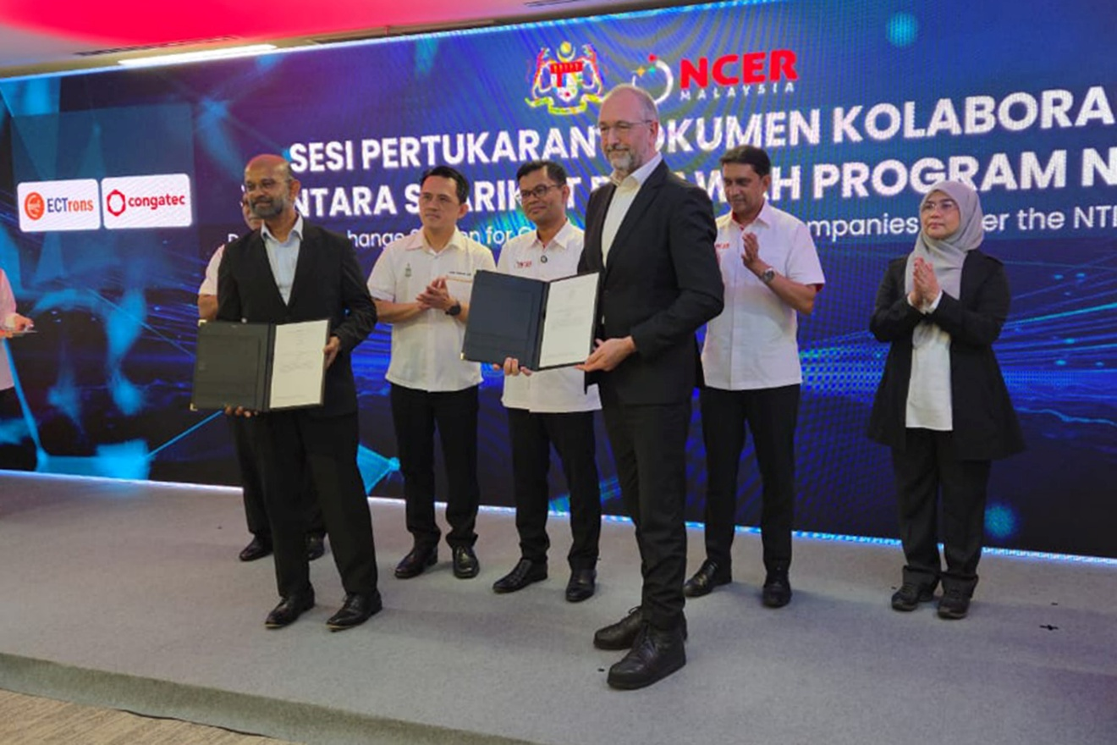
Dato’ Dr. Shanmuganathan, CEO of ECTrons (front left), and Konrad Garhammer, COO & CTO of congatec, proudly present the signed MoC.

Deggendorf, Germany, 23 June 2026 * * * congatec – a leading vendor of embedded and edge computing technology – and ECTrons Sdn. Bhd. – a Penang-based embedded computing specialist – entered into a strategic partnership for the development and commercialization of AI-powered industrial computing solutions. The agreement was signed on June 10, 2026, at the official launch ceremony of the NCER Technology Innovation Centre (NTIC) in Bayan Lepas, Penang, Malaysia.

The partnership aims to accelerate the design of AI-powered industrial computing platforms to shorten time-to-market and reduce the total cost of ownership for next-gen Industry 5.0 solutions. To achieve this, ECTrons, an edge AI specialist, leverages congatec's application-ready aReady.COM hardware and software building blocks to design its industrial solutions. System designs include AI I/O controllers, hybrid Industrial PCs, and Edge AI systems, which are specifically designed for Asian markets. The first joint designs from ECTrons will be based on congatec’s conga-SMX95 SMARC modules with NXP i.MX95 processors.

“By collaborating with ECTrons, congatec expands its footprint in a strategically important growth market for industrial digitalization and edge AI as well as intensifies its local-for-local strategy,” said Konrad Garhammer, COO & CTO at congatec. “With our application-ready aReady.COM building blocks we support ECTrons with everything needed to bring innovative edge AI systems from prototype to production quickly, including hardware building blocks, functional software, and preconfigured and licensed tech stacks.”

"ECTrons contributes deep expertise in industrial digitalization, Edge AI, and embedded computing, with a strong focus on developing regionally deployable innovations that address real-world industrial challenges," said Dato’ Dr. Shanmuganathan, CEO of ECTrons. “By collaborating with congatec, our customers benefit from innovative solutions with high-performance embedded building blocks. This accelerates the deployment of AI-enabled IR5.0 applications at the edge for both local industries and international markets across ASEAN and India.”

The collaboration amplifies congatec’s move to anchor high-value embedded computing design, customization and technical support capabilities in Malaysia. It is also intended to strengthen Malaysia’s semiconductor and electronics ecosystem by enabling embedded computing solutions developed in Malaysia for local and international markets across ASEAN and India.
* * *
About congatec
congatec is a leading global provider of high-performance hardware and software building blocks for embedded and edge computing solutions based on Computer-on-Modules (COMs). These advanced computer modules drive systems and devices across industries such as industrial automation, medical technology, robotics, telecommunications, and more. congatec's high-performance aReady. ecosystems simplify and accelerate the solution development, from COM to cloud. This application-ready approach combines COMs with services and customizable technologies that enable cutting-edge advancements in system consolidation, IoT, security, and artificial intelligence. Supported by its majority shareholder, DBAG Fund VIII – a German mid-market fund focused on driving growth for industrial enterprises – congatec has the financial backing and M&A expertise to capitalize on expanding market opportunities. For more information, visit www.congatec.com or follow us on LinkedIn and YouTube.

About ECTrons ECTrons is a Malaysian technology company specializing in Embedded Computing Technology (ECT), Edge AI, Industrial IoT, and intelligent automation solutions. Its integrated ecosystem, including AI Controller, hybrid Industrial Computing (hIPC), MES Lite, ERP Lite, and AI-powered Agentic Collaboration tool helps manufacturers and industrial organizations accelerate digital transformation, improve productivity, and enhance operational visibility. Committed to advancing “Made by Malaysia” innovation, ECTrons collaborates with industry, government, and global technology partners to strengthen technological self-reliance and expand across ASEAN, India, and international markets. For more information, visit www.ectrons.com or follow us on LinkedIn

Reader enquiries:
congatec
Phone: +49-991-2700-0
info@congatec.com
www.congatec.com

Press contact congatec:
congatec
Christof Wilde
Phone: +49-991-2700-2822
christof.wilde@congatec.com

Press contact ECTrons:
ECTrons
Wan Noor Rizal Bin Wan Mohd Tahir
Phone: +60 13-404 4007
wanrizal@electrons.com

