
Press release

From computer-on-module to cloud: embedded hardware and software building blocks simplify system development

congatec strengthens aReady.COM with patented technology for cybersecure edge architectures

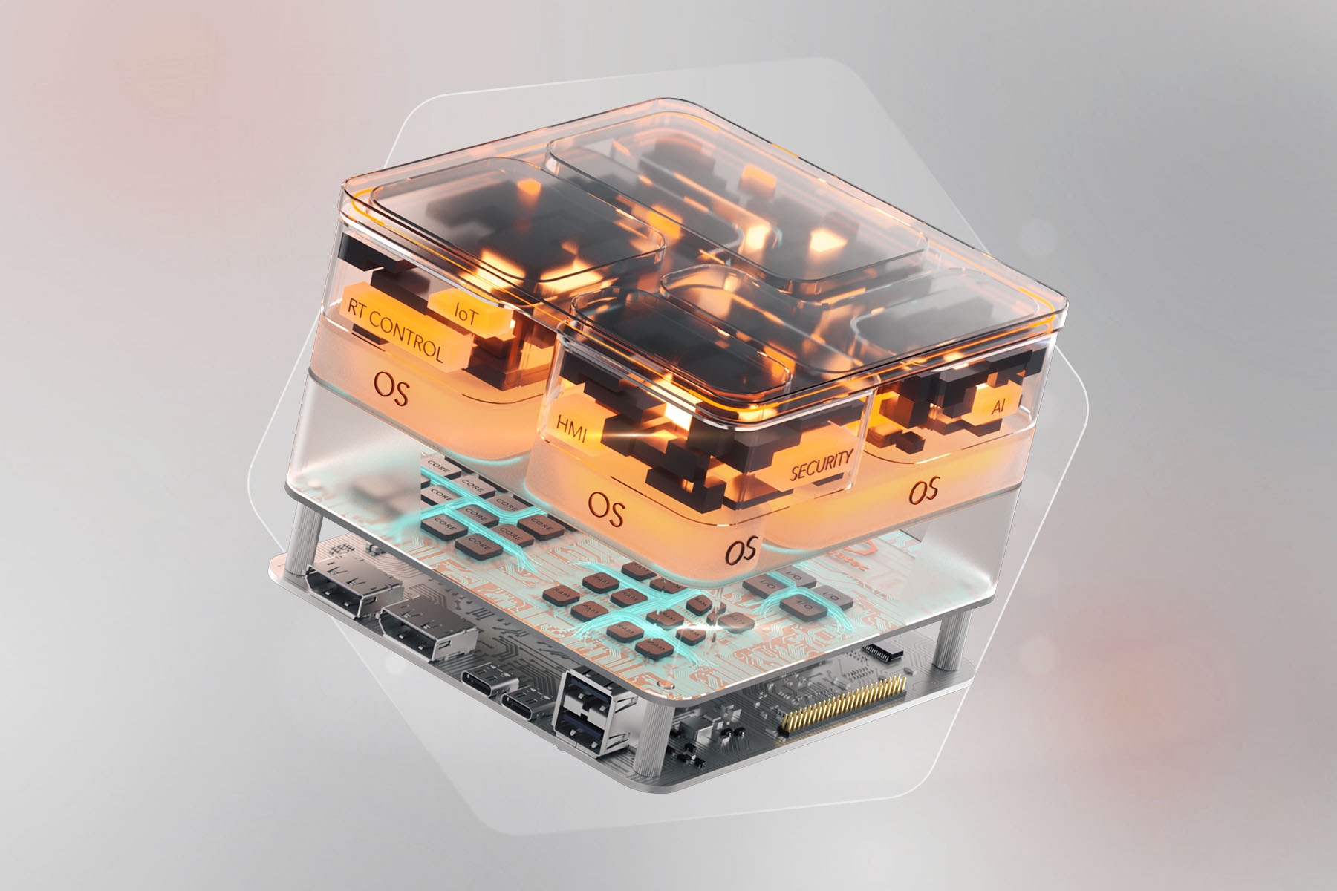

Deggendorf, Germany, 25 August, 2026 * * * congatec – a leading vendor of embedded and edge computing technology – demonstrates the innovative strength of its application-ready aReady.COM modules with an active patent for cybersecure communication between operational technology (OT) and IT infrastructure. aReady.COM from congatec encompasses application-ready embedded hardware and software building blocks, enabling companies to simplify and accelerate the integration of IoT connectivity, security, virtualization, and AI into their solutions.

Patent number WO2025186118A1 describes the interaction between the conga-zones hypervisor and the conga-connect IoT software running on a COM. The conga-zones hypervisor provides isolated system partitions, operating via a gateway to create strict data separation between the OT data acquisition side and the IT data transmission side. A security barrier between these two virtual machines prevents direct data forwarding from the IT side to the OT side and vice versa. Furthermore, transmission via data projection prevents external access to the OT device via the IT infrastructure, as well as access to the IT infrastructure via the embedded device. This approach enables machine, application, and communication functions to be combined within a single platform that is secure by design.

With aReady.COM, customers can increase functionality on consolidated system architectures, shorten development times, and optimize total cost of ownership (TCO). At the same time, the filing of this patent is a clear indication of congatec’s technical development capabilities and the disruptive potential of its aReady.COM approach. It establishes that congatec consistently thinks beyond COMs as pure hardware, presenting them as pre-integrated, application-ready system building blocks for secure and connected industrial edge applications.

“With aReady.COM, we address key challenges faced by our customers: developing market-ready systems and new digital services for new business models faster; integrating more functionality into their systems; and simultaneously reducing complexity, integration risks, and operating costs,” says Andreas Bergbauer, Manager Solution Management at congatec. “The patent shows how conga-zones and conga-connect work together within aReady.COM to provide secure data exchange as well as isolated functional domains – for example for AI, real-time control, and user interfaces.”

“The patented combination of isolated partitions, controlled data exchange, and VPN-based communication is an important building block for ensuring the security by design of our aReady.COMs in secure and cost-effective edge architectures,” adds Konrad Garhammer, COO & CTO at congatec. “With aReady.COM, we simplify the use of complex embedded technologies and create the basis for simple system consolidation, high functional integration, and optimized TCO in industrial applications.”

Further information on congatec aReady.COM is available at:
https://www.congatec.com/en/aready/areadycom/

* * *

About congatec
congatec is a leading global provider of high-performance hardware and software building blocks for embedded and edge computing solutions based on Computer-on-Modules (COMs). These advanced computer modules drive systems and devices across industries such as industrial automation, medical technology, robotics, telecommunications, and more. congatec's high-performance aReady. ecosystems simplify and accelerate solution development, from COM to cloud. This application-ready approach combines COMs with services and customizable technologies that enable cutting-edge advancements in system consolidation, IoT, security, and artificial intelligence. Supported by its majority shareholder, DBAG Fund VIII – a German mid-market fund focused on driving growth for industrial enterprises – congatec has the financial backing and M&A expertise to capitalize on expanding market opportunities. For more information, visit www.congatec.com or follow us on LinkedIn and YouTube.

Reader enquiries:
congatec
Phone: +49-991-2700-0
info@congatec.com
www.congatec.com

Press contact congatec:
congatec
Christof Wilde
Phone: +49-991-2700-2822
christof.wilde@congatec.com

