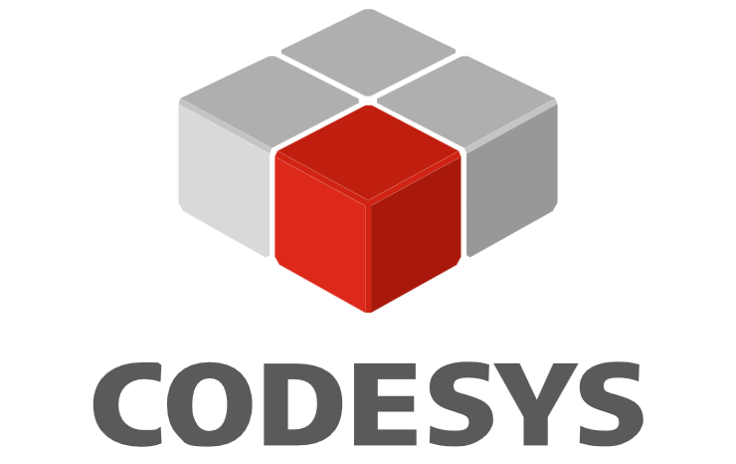


Press release

congatec and CODESYS initiate strategic partnership for virtualized real-time control

congatec hypervisor and CODESYS PLC: streamlining mixed-critical workload consolidation

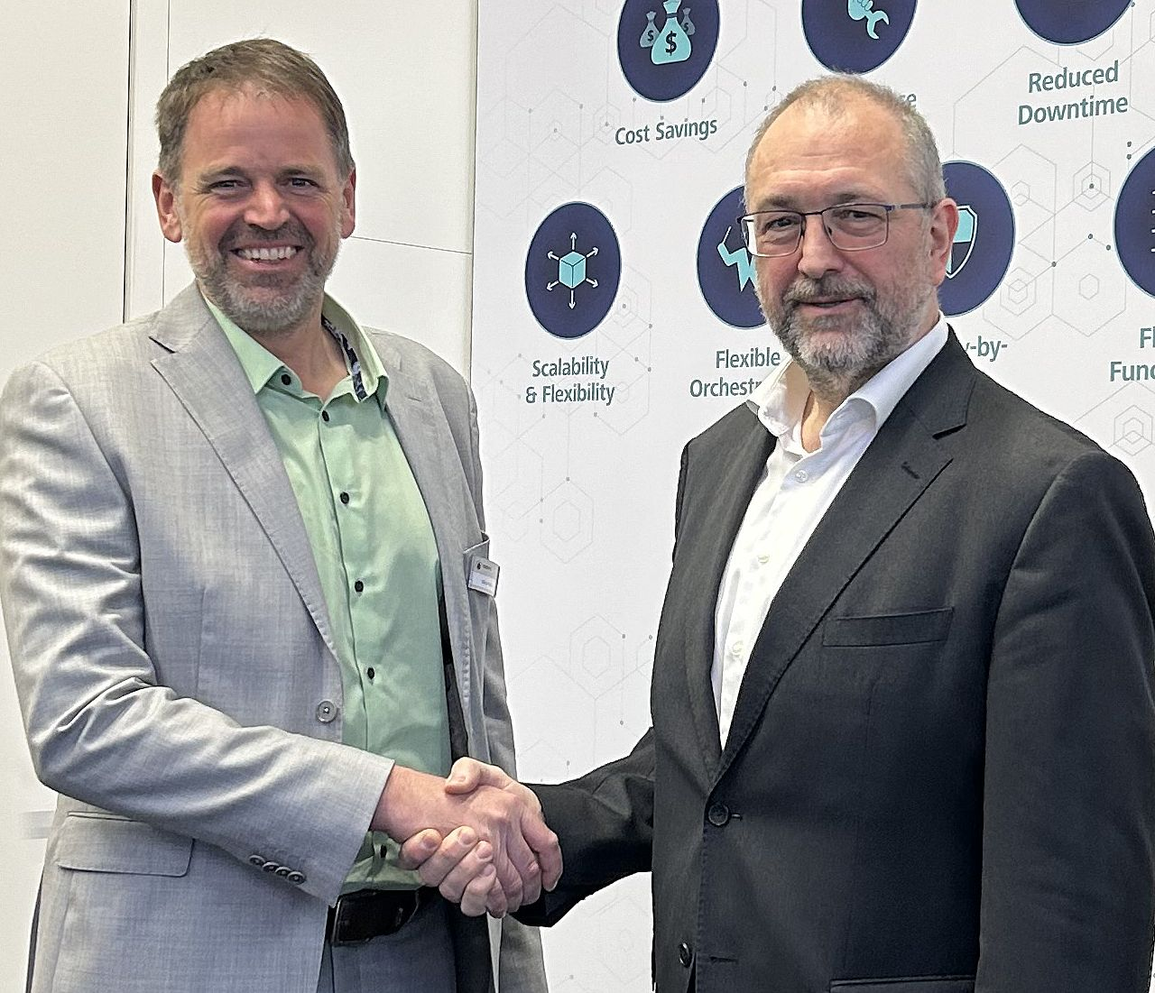
Hilmar Panzer, CTO of the CODESYS Group, and Konrad Garhammer, COO & CTO at congatec, welcome the strategic cooperation to deliver virtualized real-time control platforms for mixed-critical workloads.

Deggendorf, Germany, 30 June, 2026 * * * congatec – a leading vendor of embedded and edge computing technology – and CODESYS Group - a market leader in hardware-independent control software - today announced the initiation of a strategic cooperation. This new partnership is set to deliver highly integrated virtualized real-time control platforms for mixed critical workloads. Such multifunctional platforms with workload consolidation bring a new level of flexibility and efficiency to industrial automation.

This strategic alliance is set to combine congatec’s proven aReady.VT virtualization technology with the CODESYS Control runtime system. The goal is to transform industrial controllers into fully-fledged IEC 61131-3 PLCs for essential automation tasks, purely through software. To achieve this, the hypervisor conga-zones from congatec separates the embedded computing platform into different zones. General purpose operating systems run in parallel with CODESYS PLC-based real-time control in dedicated zones, ensuring both deterministic real-time behavior and secure isolation on one system. The combination of the conga-zones hypervisor and CODESYS PLC delivers the reliability, virtualization flexibility and deterministic performance that are crucial as the industry moves towards control technology virtualization.

"Our partnership with CODESYS unites congatec’s conga-zones hypervisor and the CODESYS PLC, bringing customers an easy-to-install, cost-effective solution that runs on standard hardware while ensuring robust real-time performance and isolation," says Konrad Garhammer, COO and CTO at congatec. "Our hypervisor technology enables the seamless operation of various operating systems alongside the CODESYS PLC in industrial applications, providing a new level of flexibility, efficiency and reliability for automation and robotics."

Hilmar Panzer, CTO of the CODESYS Group, adds: "Virtualization of control technology is an important trend for optimizing the cost, scalability and security of embedded control platforms. At Embedded World, we presented a demo using congatec’s conga-zones hypervisor to showcase this concept, which we are now set to bring to realization. With our cooperation, we will enable machine and plant builders, as well as their customers who operate such systems, to directly benefit from this trend. This will create a win-win-win situation for both our companies - but above all for our shared customers."

* * *
About congatec
congatec is a leading global provider of high-performance hardware and software building blocks for embedded and edge computing solutions based on Computer-on-Modules (COMs). These advanced computer modules drive systems and devices across industries such as industrial automation, medical technology, robotics, telecommunications, and more. congatec's high-performance aReady. ecosystems simplify and accelerate the development of solutions, from COM to cloud. This application-ready approach combines COMs with services and customizable technologies that enable cutting-edge advancements in system consolidation, IoT, security, and artificial intelligence. Supported by its majority shareholder, DBAG Fund VIII – a German mid-market fund focused on driving growth for industrial enterprises – congatec has the financial backing and M&A expertise to capitalize on expanding market opportunities. For more information, visit www.congatec.com or follow us on LinkedIn and YouTube.

About CODESYS
CODESYS is the leading manufacturer-independent IEC 61131-3 development platform for industrial automation, used by more than 500 device manufacturers worldwide. Hundreds of thousands of automation engineers and PLC programmers use the CODESYS Development System every day to automate stationary and mobile machines, complex energy/building systems, and processes. CODESYS enables PLC programming, visualization, motion control, and safety applications within a single integrated engineering environment. The cross-platform runtime runs on virtually any hardware architecture — from embedded microcontrollers to high-performance industrial PCs or server architectures.

Reader enquiries:
congatec
Phone: +49-991-2700-0
info@congatec.com
www.congatec.com

Press contact congatec:
congatec
Christof Wilde
Phone: +49-991-2700-2822
christof.wilde@congatec.com

Press contact CODESYS:
CODESYS GmbH
Roland Wagner
Phone: +49-831-54031-17
r.wagner@codesys.com

