
Press Release

congatec receives IEC 62443-4-1 certification for development and support of embedded building blocks and tech stacks

Certified processes for development of cyber-secure embedded applications

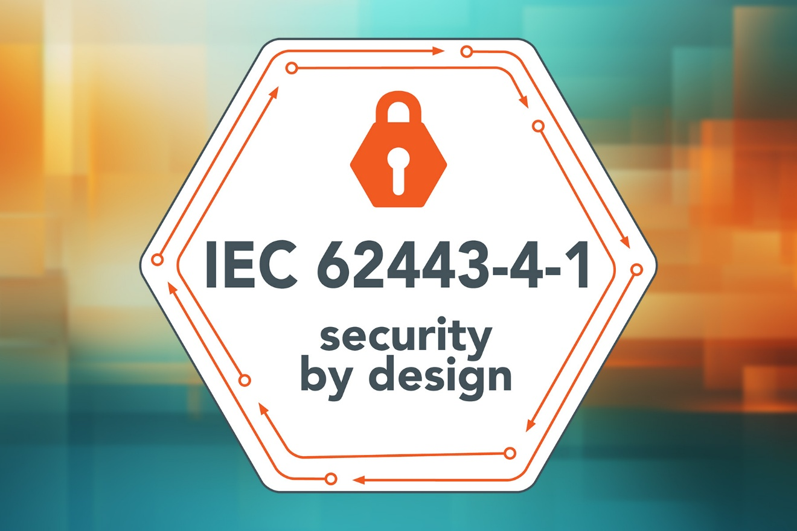

Deggendorf, June 9th, 2026 * * * congatec – a leading provider of embedded and edge computing technology – has been certified to IEC 62443-4-1:2018 for the development and support of its embedded building blocks and tech stacks. With the certification issued by TÜV NORD, customers using congatec’s portfolio gain a solid foundation for developing their own products quickly and efficiently under increasing security and compliance requirements, while also demonstrably securing their supply chains. Customers benefit from secure implementation, including coding guidelines, verification and validation, as well as vulnerability, patch and obsolescence management for congatec’s application-ready building blocks and aReady.COM technology stacks. This offers significant time-to-market advantages, particularly in regulated markets such as automation and robotics, medical and energy technology, as well as transportation.

The company’s certified development and support processes demonstrate that cybersecurity is an integral part of all development phases from the outset. The tech stacks, consisting of a computer-on-module, licensed operating systems such as Ubuntu Pro and ctrlX OS, as well as software building blocks such as conga-connect (aReady.IOT) and conga-zones (aReady.VT), are based on audited development and support processes. This is also an important prerequisite for OEMs seeking to place electronic devices on the EU market, making it easier to meet the upcoming regulatory requirements of the Cyber Resilience Act (CRA), which becomes mandatory from 11 December 2027.

“By achieving IEC 62443-4-1 certification, we are demonstrating in accordance with internationally applicable guidelines, that we integrate cybersecurity consistently and verifiably into our development and support processes,” Konrad Garhammer, COO & CTO of congatec explains. “This gives our customers application-ready embedded building blocks and tech stacks based on certified development and support processes. It further supports integration into their own applications, simplifies security verification for customers and regulatory authorities, and creates a robust foundation for CRA-relevant compliance processes.”

“Our tech stacks developed in accordance with IEC 62443-4-1, including licensed operating systems, hypervisor and IoT connectors, help customers build their own compliance and security evidence more efficiently and simplify and accelerate certification work,” Dominik Ressing, CEO of congatec adds. “Companies, already relying on our building blocks today are positioning themselves early and efficiently for the requirements of the CRA and comparable regulatory frameworks.”

For further information, please visit:
https://www.congatec.com/en/security-by-design-congatec/
https://www.congatec.com/en/technologies/security/

About congatec
congatec is a leading global provider of high-performance hardware and software building blocks for embedded and edge computing solutions based on Computer-on-Modules (COMs). These advanced computer modules drive systems and devices across industries such as industrial automation, medical technology, robotics, telecommunications, and more. congatec’s high-performance aReady. ecosystems simplify and accelerate solution development, from COM to cloud. This application-ready approach combines COMs with services and customizable technologies that enable cutting-edge advancements in system consolidation, IoT, security, and artificial intelligence. Supported by its majority shareholder, DBAG Fund VIII – a German mid-market fund focused on driving growth for industrial enterprises – congatec has the financial backing and M&A expertise to capitalize on expanding market opportunities. For more information, visit congatec.com, aReady.com, or follow us on LinkedIn and YouTube.

Reader enquiries:
congatec
Phone: +49-991-2700-0
info@congatec.com
www.congatec.com

Press contact:
congatec
Christof Wilde
Phone: +49-991-2700-2822
christof.wilde@congatec.com

