Press Release

congatec expands Penang R&D presence, anchoring high-value embedded computing capabilities in Malaysia

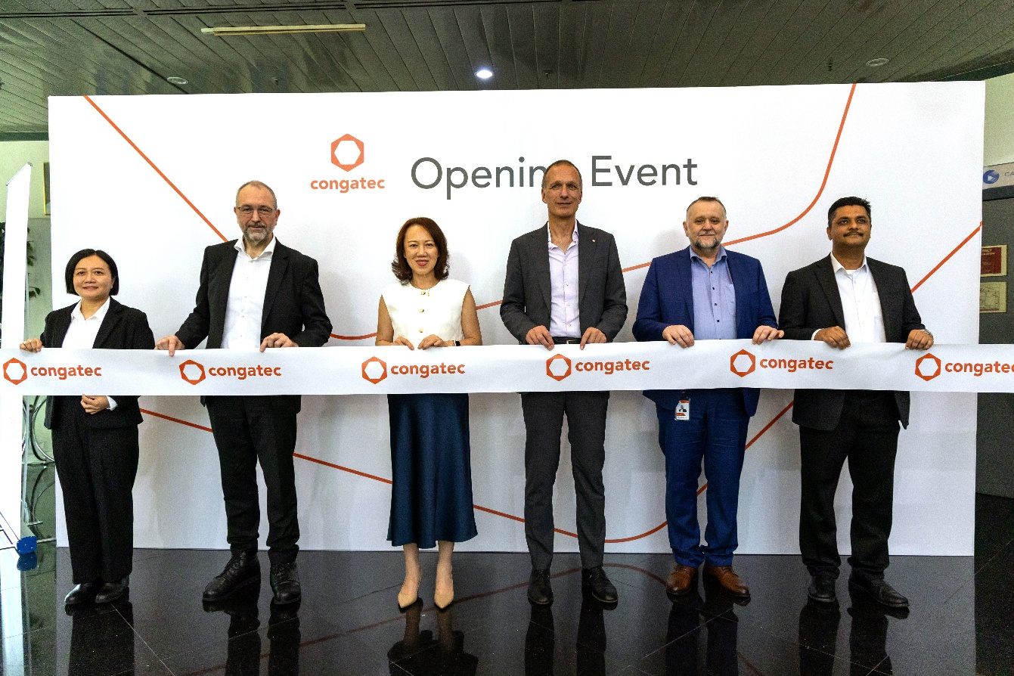
From left to right: Yeun Nee Tan, Managing Director, congatec Asia Embedded Design; Konrad Garhammer, COO and CTO, congatec; Dato’ Loo Lee Lian, CEO, InvestPenang; Dr. Dominik Ressing, CEO, congatec; Fritz Krauss, VP Global Technology, congatec; Muhammad Ghaddaffi, Director, MIDA.

Deggendorf, Germany / Penang, Malaysia, 26 January 2026 – congatec – the leading vendor of embedded and edge computing technology – today announced the establishment of its new subsidiary in Penang, Malaysia, marking a strategic expansion of its engineering and research footprint in Asia. The move signals congatec’s commitment to anchoring high-value embedded computing design, customisation and technical support capabilities in Malaysia as part of its global “local for local” strategy.

As part of the expansion, congatec has onboarded an experienced embedded engineering team from Kontron Asia, comprising 23 specialised engineers, with plans to scale the Penang operation to approximately 70 employees over the medium term. The new subsidiary strengthens congatec’s regional research and development (R&D) and technical support capabilities, enabling faster development cycles, application-ready (aReady.) solutions and closer collaboration with customers across the Asia-Pacific market.

Dato’ Loo Lee Lian, Chief Executive Officer of InvestPenang (representing the Right Honourable Mr. Chow Kon Yeow, Chief Minister of Penang), stated, “Penang’s 50 years of industrialisation has shaped a deep and highly skilled talent base spanning engineering, design, manufacturing, and advanced technologies. This long-standing industrial maturity enables investors like congatec to scale R&D, technical support, and regional operations efficiently, supported by talent that is both globally competitive and industry-ready.” She further added, “We are confident that congatec’s presence will generate meaningful technological spillovers for Penang. The integration of “Designed in Germany” quality standards with Penang’s robust industrial ecosystem—supported by our highly skilled talent—will create strong synergies for innovation and growth.”

Datuk Sikh Shamsul Ibrahim Sikh Abdul Majid, Chief Executive Officer of the Malaysian Investment Development Authority (MIDA), said, “congatec’s expansion to establish its R&D subsidiary in Penang exemplifies Malaysia’s shift towards high-value, innovation-driven activities within our electrical and electronics ecosystem. This investment underscores the growing recognition of Malaysia as a strategic location for advanced embedded computing capabilities. By anchoring sophisticated engineering and technical support functions here, we strengthen domestic R&D capacity, accelerate technology adoption, and create meaningful career pathways for Malaysian engineering talent. Aligned with the New Industrial Master Plan 2030, congatec's expansion contributes to Malaysia's position as a competitive hub for next-generation embedded and edge computing innovation in the region.”

Dr. Dominik Ressing, CEO of congatec, stated, “The opening of our Malaysian subsidiary is a natural next step in our ‘local for local’ philosophy. Regional development and support resources enable us to respond faster and more precisely to local requirements. Our goal is to improve customers’ time-to-market, total cost of ownership, and return on investment through local engineering expertise, while reducing barriers to application development across the APAC region.”

Mr. Konrad Garhammer, Chief Operating Officer (COO) and Chief Technology Officer (CTO) of congatec, added, “We are delighted to welcome such an experienced and highly motivated engineering team to the congatec family. With our new location in the ‘Silicon Valley of the East,’ we gain access to an outstanding ecosystem of semiconductor manufacturers and production partners. This enables us to combine our German engineering DNA with the dynamism of the Asian market. The new team brings extensive experience in developing highly integrated embedded computing platforms, enabling us not only to expand our portfolio but also to deliver maintenance and support services within our customers’ time zones. Furthermore, we are gaining vital capabilities across production, production support, and production engineering - expertise we plan to expand further. These are decisive factors in ensuring operational excellence.”

The Penang centre will support the APAC market with standard and customised embedded computing platforms developed in alignment with congatec’s “Designed in Germany” quality standards. In addition to advanced x86-based solutions based on Intel and AMD processors, the team will develop Computer-on-Modules (COMs leveraging technologies from Qualcomm, Texas Instrument, and NXP), alongside expanded aReady. software and solution stacks. These validated platforms are designed to shorten design-in cycles, reduce non-recurring engineering costs and accelerate customers’ time-to-market.

-END-

About MIDA
The Malaysian Investment Development Authority (MIDA) is the government’s principal investment promotion and development agency under the Ministry of Investment, Trade and Industry (MITI) to oversee and drive investments into the manufacturing and services sectors in Malaysia. Headquartered in Kuala Lumpur Sentral, MIDA has 12 regional and 20 overseas offices. MIDA continues to be the strategic partner to businesses in seizing the opportunities arising from the technology revolution of this era. For more information, please visit www.mida.gov.my and follow us on X, Instagram, Facebook, LinkedIn, TikTok and YouTube channel.

About InvestPenang
InvestPenang is the Penang State Government’s principal agency for the promotion of investment. Its objectives are to develop and sustain Penang’s economy by enhancing and continuously supporting business activities in the State through foreign and local investments, including spawning viable new growth centers. To realise its objectives, InvestPenang also runs initiatives like the SMART Penang Center (providing assistance to SMEs), Penang CAT Center (for talent attraction and retention), Global Business Services (GBS) Focus Group (promoting and developing digital economy) and Penang Silicon Design @5km+ (establishing a unique and interconnected ecosystem for IC design and technology enterprises). For more information, please visit https://investpenang.gov.my/ and follow InvestPenang’s social media channels: Facebook; LinkedIn; WhatsApp Channel and TikTok.

About congatec
congatec is the leading global provider of high-performance hardware and software building blocks for embedded and edge computing solutions based on Computer-on-Modules (COMs). These advanced computer modules drive systems and devices across industries such as industrial automation, medical technology, robotics, telecommunications, and more. congatec's high-performance aReady. ecosystems simplify and accelerate the solution development, from COM to cloud. This application-ready approach combines COMs with services and customizable technologies that enable cutting-edge advancements in system consolidation, IoT, security, and artificial intelligence. Supported by its majority shareholder, DBAG Fund VIII – a German mid-market fund focused on driving growth for industrial enterprises – congatec has the financial backing and M&A expertise to capitalize on expanding market opportunities. For more information, visit congatec.com, aReady.com, or follow us on LinkedIn and YouTube.

For media enquiries, please contact:

MIDA
Mohd Mazlan Mokhtar (Mr.)
Director of Electrical & Electronics Division
T: 03- 2267 6655
E:mazlan@mida.gov.my

InvestPenang
Elaine Cheah / Arief Ferdaus
Communications & Business Intelligence
Tel: +604-646 8833
Email: elaine@investpenang.gov.my / arief@investpenang.gov.my

Reader enquiries:
congatec
Phone: +49-991-2700-0
info@congatec.com
www.congatec.com

Press contact congatec:
congatec
Christof Wilde
Phone: +49-991-2700-2822
christof.wilde@congatec.com

