# Press release Congatec_Standardlogo_RGB.jpg

congatec showcases high-performance computing ecosystems for smart factory digitization

# Empowering smart factories: congatec highlights application-ready solution platforms

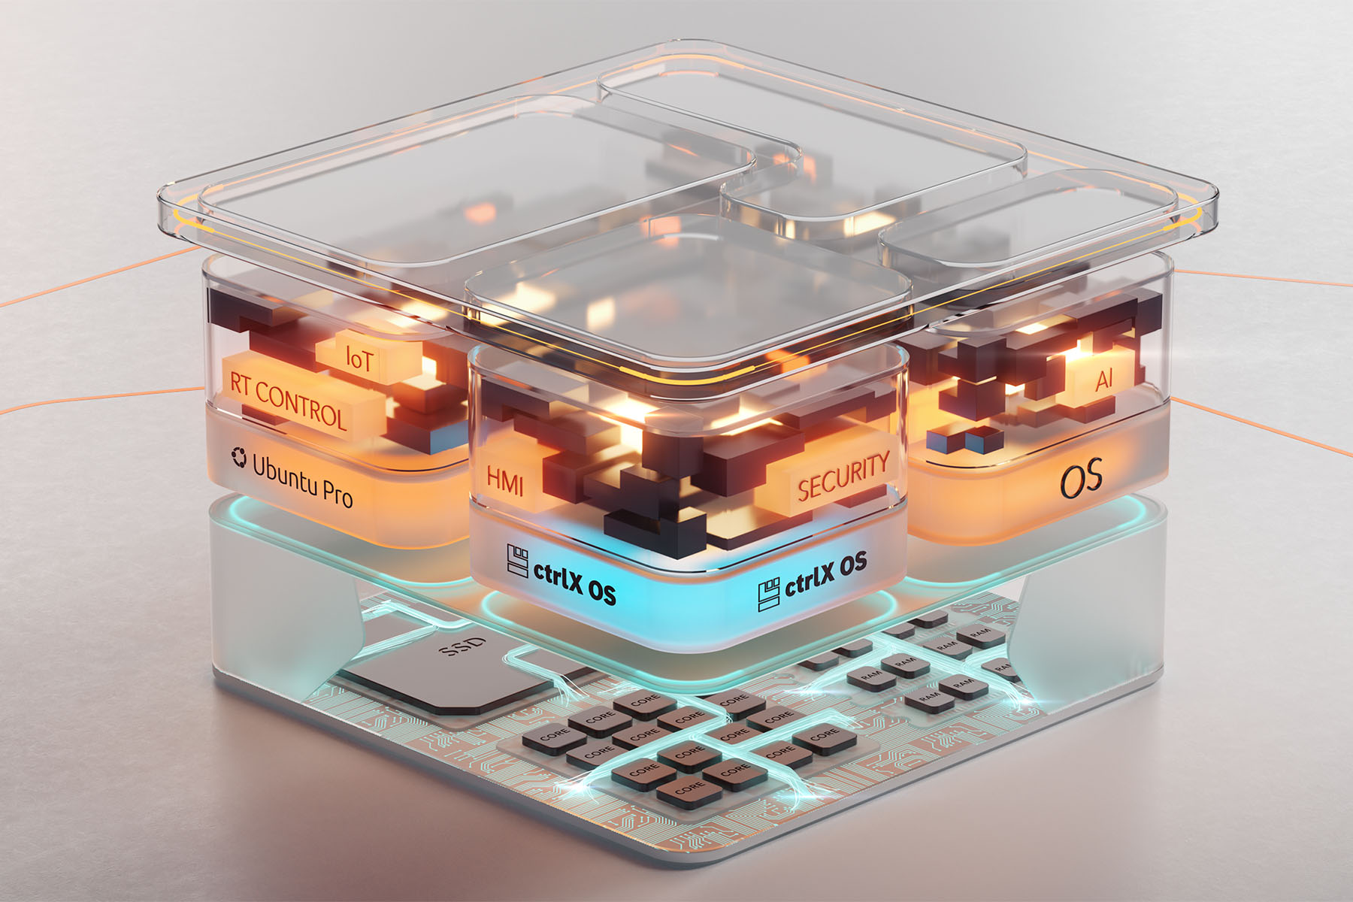

**Taipei, Taiwan, February 20, 2025 \* \* \*** congatec – a leading vendor of embedded and edge computing technology – will showcase its latest advances in application-ready solution platforms for automation and machine building at Smart Factory + Automation World 2025, booth D316 in Seoul, South Korea, from March 12 to 14. Presentations will focus on extended aReady.COM and aReady.IOT offerings providing a new level of application readiness to simplify module-based application designs, increase security, and accelerate time-to-market of innovative solutions. Additionally, visitors will discover congatec’s optimized range of standards-based Computer-on-Modules, along with a showcase of an exemplary edge server design for shop floor applications.

**Showcase highlight: aReady.COM**

congatec’s aReady.COM strategy enhances its Computer-on-Module (COM) ecosystem with pre-installed, application-ready software building blocks. Customers can configure aReady.COM with real-time hypervisors to consolidate multiple functions – including real-time control, HMI, AI, and IoT connectivity – on a single module. Supported operating systems, such as Ubuntu Professional and Bosch Rexroth’s ctrlX, come fully licensed and certified, reducing integration complexity and accelerating deployment.

Visitors can experience aReady.COM through an interactive and engaging virtual game for a chance to win a special gift. Attendees can also enter a raffle, where one lucky winner will receive a prize after the show.

**Secure digitization with aReady.IOT**

With aReady.IOT, congatec introduces powerful software building blocks for secure IoT connectivity from the COM to the cloud. These preconfigured building blocks enable communication with machines, systems, devices, and even sensors via protocols such as OPCUA, MQTT, and REST. Users can leverage them for data acquisition, remote monitoring, maintenance and management (e.g., OEE – Overall Equipment Efficiency), as well as predictive maintenance. Additionally, they have the option to process data directly at the edge for storage and visualization. This enables quick and easy implementation of automated processes such as data analysis, software updates, or event-triggered calls to action. A live demo at the booth lets visitors experience firsthand the overall capabilities of aReady.IOT in a smart factory environment.

**Rugged edge server for the shop floor**

The third highlight of congatec’s presentation will be fanless edge server designs based on COM-HPC Server modules. Such rugged microservers accelerate the next generation of real-time workloads in harsh environments requiring extended temperature support. Based on the latest COM-HPC Server modules, performance features include up to 22 cores, up to 1 TB RAM, PCIe Gen 4 speed, as well as up to 100 GbE connectivity and TCC/TSN support. Target applications range from industrial workload consolidation for automation, robotics, to outdoor servers for utilities and critical infrastructures like smart grids for oil, gas and electricity as well as rail and communication networks.

For more information on congatec’s presentations at Smart Factory + Automation World 2025, Seoul, booth D316, March 12 to 14, please visit: <https://www.congatec.com/en/congatec/events/smart-factory-automation-world/>

\* \* \*

**About congatec**

congatec is a leading global provider of high-performance hardware and software building blocks for embedded and edge computing solutions based on Computer-on-Modules (COMs). These advanced computer modules drive systems and devices across industries such as industrial automation, medical technology, robotics, telecommunications, and more. congatec's high-performance aReady. ecosystems simplify and accelerate the solution development, from COM to cloud. This application-ready approach combines COMs with services and customizable technologies that enable cutting-edge advancements in system consolidation, IoT, security, and artificial intelligence. Supported by its majority shareholder, DBAG Fund VIII – a German mid-market fund focused on driving growth for industrial enterprises – congatec has the financial backing and M&A expertise to capitalize on expanding market opportunities. For more information, visit [www.congatec.com](http://www.congatec.com/) or follow us on [LinkedIn](https://www.linkedin.com/company/congatec/) and [YouTube](https://www.youtube.com/congatecAE).

*Intel, the Intel logo, and other Intel marks are trademarks of Intel Corporation or its subsidiaries.*

**Reader enquiries:**

congatec

Crysta Lee

Phone: +886 2 25978577

[info@congatec.com](mailto:info@congatec.com)

[www.congatec.com](http://www.congatec.com)

**Press contactcongatec:**

congatec

Christof Wilde

Phone: +49 991 2700 2822

christof.wilde@congatec.com