# Press release Congatec_Standardlogo_RGB.jpg

New local manufacturing capacities strengthen congatec's global presence and address international trade disruptions

**congatec extends its global manufacturing capacity with Kontron cooperation**

**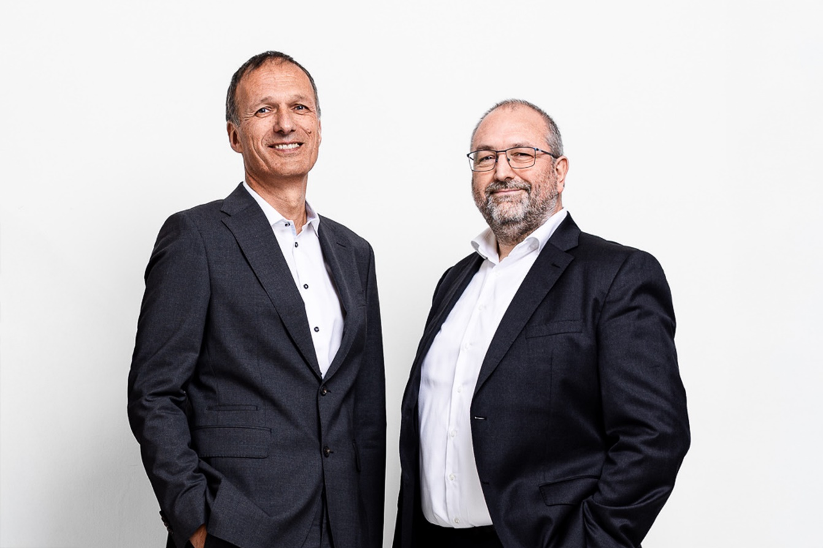**

*Dr. Dominik Reßing, CEO of congatec, and Konrad Garhammer, COO and CTO of congatec, are excited about the extended cooperation with Kontron.*

**Deggendorf, Germany, 15 May, 2025 \* \* \*** congatec – a leading vendor of embedded and edge computing technology – announced today it is extending its cooperation with Kontron – a leading global supplier of IoT technology – to add Kontron to congatec's existing partners for manufacturing Computer-on-Modules. This cooperation is an important element of congatec’s local for local approach to increase efficiency in the light of international trade disruptions and growing customer demand driven by geopolitical considerations.

congatec gains access to Kontron's broad international production network of over 20 plants in different configurations, leveraging Kontron's expertise in SMT assembly. By making use of Kontron’s local production facilities in the United States, congatec expects significant cost advantages and avoidance of tariffs into the USA. Furthermore, congatec will utilize Kontron’s supply chain management, production, and logistics capabilities to further enhance its global reach and local presence in all regions of the world.

“The manufacturing cooperation with Kontron is a natural move, as both companies share the same values and innovative technology roadmap with powerful partnerships with leading silicon vendors including Intel, AMD, Qualcomm, Texas Instruments, and NXP,” explains Konrad Garhammer, COO and CTO of congatec. “Based on our broad Computer-on-Modules portfolios, we both serve the highest customer requirements in demanding industries, including medical, industrial automation, robotics and embedded edge computing for transportation, avionics and in-vehicle.”

**Cooperation expected to expand in the near future**

“With Kontron subsidiary JUMPtec and congatec both being leading developers of embedded modules for the standards COM Express, COM-HPC, SMARC Module, and Qseven, we are planning to extend our cooperation to other areas in the near future,” adds Dr. Dominik Reßing, CEO of congatec. “Currently we are discussing potential partnerships for development, know-how exchange, and joint sales and marketing activities that could, subject to reaching an agreement, also lead to a capital investment of congatec in JUMPtec.”

\* \* \*

**About congatec**

congatec is a leading global provider of high-performance hardware and software building blocks for embedded and edge computing solutions based on Computer-on-Modules (COMs). These advanced computer modules drive systems and devices across industries such as industrial automation, medical technology, robotics, telecommunications, and more. congatec's high-performance aReady. ecosystems simplify and accelerate the solution development, from COM to cloud. This application-ready approach combines COMs with services and customizable technologies that enable cutting-edge advancements in system consolidation, IoT, security, and artificial intelligence. Supported by its majority shareholder, DBAG Fund VIII – a German mid-market fund focused on driving growth for industrial enterprises – congatec has the financial backing and M&A expertise to capitalize on expanding market opportunities. For more information, visit [www.congatec.com](http://www.congatec.com/) or follow us on LinkedIn and YouTube.

**About Kontron**

Kontron AG ([www.kontron.com](http://www.kontron.com), ISIN AT0000A0E9W5, WKN AOX9EJ, KTN) is a leading loT technology company. For more than 20 years, Kontron has been supporting companies from a wide range of industries to achieve their business goals with intelligent solutions. From automated industrial operations, smarter and safer transport to advanced communications, connectivity, medical, and energy solutions, the company delivers technologies that add value for its customers. With the acquisition of Katek SE in early 2024, Kontron significantly strengthens its portfolio with the new GreenTec division, focusing on solar energy and eMobility, and grows to around 7,000 employees in over 20 countries worldwide. Kontron is listed on the SDAX® and TecDAX® of the German Stock Exchange.

**Reader enquiries congatec:**

Phone: +49-991-2700-0

info@congatec.com

[www.congatec.com](http://www.congatec.com)

**Press contact congatec:**

Christof Wilde

Phone: +49-991-2700-2822

christof.wilde@congatec.com

**Press contact Kontron AG:**

Alexandra Kentros  
Tel: +49 151 151 938 81  
[group-pr@kontron.com](mailto:group-pr@kontron.com)