**Press release**

congatec presents new COM Express Compact module

**Unrivaled AI performance for COMs with Intel Core Ultra processors**

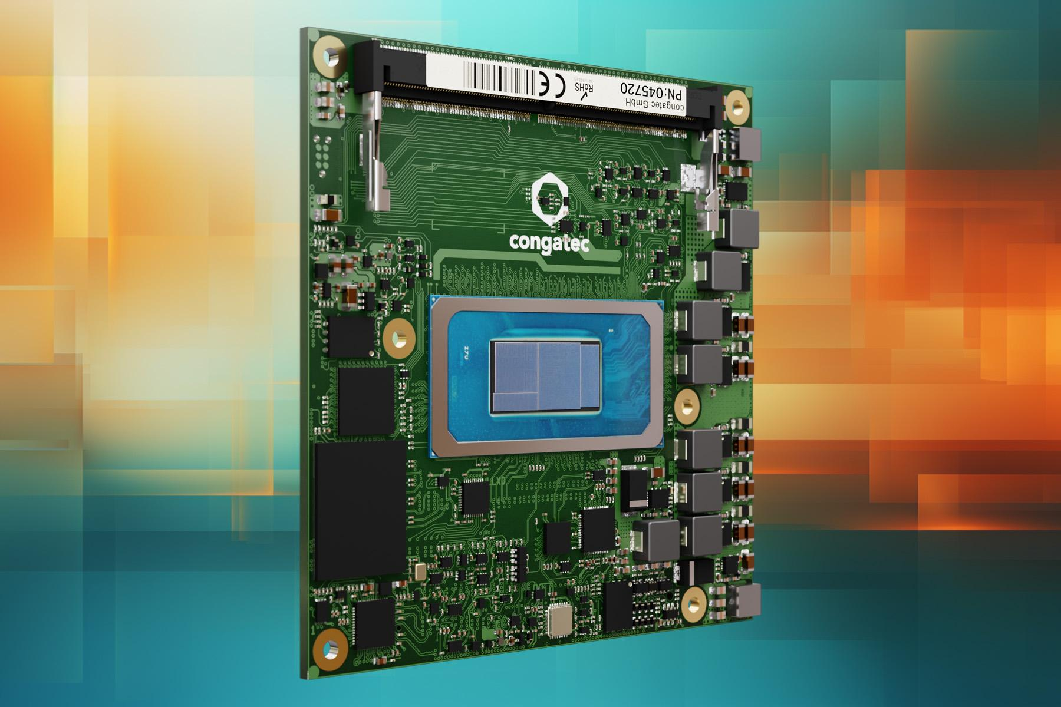

**San Diego, CA, March 11, 2025** * * * congatec – a leading provider of embedded and edge computing technology – boosts AI performance for medical, robotics, industrial, retail, and gaming applications, delivering up to 99 TOPS (Tera Operations per Second). This exceptional AI performance is driven by the new conga-TC750 Computer-on-Module (COM) in the COM Express Compact Type 6 form factor, which is powered by Intel Core Ultra Series 2 processors (codenamed Arrow Lake) with Lion Cove and Skymont P- and E-cores, providing up to 16 cores and 22 threads alongside an integrated GPU and NPU.

Developers already working with COM Express Compact platforms (95 mm x 95 mm), such as the conga-TC700, will benefit particularly from the quick upgrade path to unprecedented AI performance. Applications with high-performance requirements – especially in graphics and AI – can take advantage of the enhanced x86 and AI capabilities offered by Intel’s new System-on-Chip (SoC) with minimal development effort and a faster time-to-market.

The SoC achieves 99 TOPS by combining the exceptional AI performance of the integrated Intel Xe-LPG+ graphics processor (iGPU) – optimized for parallel, high-throughput workloads and delivering up to 77 TOPS (compared to its predecessor Meteor Lake’s 18 TOPS) – with a highly energy-efficient NPU providing up to 13 TOPS, and a CPU contributing 9 TOPS for fast response times. The new SoC also features Intel’s latest Xe-LPG+ graphics engine. With its standardized module concept enabling simple upgrades and high scalability, the conga-TC750 is an excellent choice for high-performance IPCs and thin clients, allowing them to stay up to date with easy module replacements. Additionally, AI-supported medical imaging, test and measurement, and graphics-based applications benefit greatly from the new module’s significant performance.

“Our new conga-TC750 COM Express Compact modules with Intel Core Ultra Series 2 processors are ideal for applications that always require the latest performance and follow innovation cycles of three to five years. The module concept excels in these scenarios, providing an application-ready computing core that helps developers save time and costs during design-in, scale easily, and achieve a shorter time-to-market. By replacing modules while retaining the carrier board, developers avoid the expense and effort of a full system replacement or redesign,” explains Maximilian Gerstl, Product Manager at congatec.

**The feature set in detail**

The new conga-TC750 COM Express Compact modules are powered by Intel Core Ultra Series 2 processors with a long-term availability of five years. This makes them ideal for high-performance applications requiring upgrades every three to five years.

Beyond their impressive 99 TOPS AI performance, the conga-TC750 modules also offer up to 128 GB DDR5 memory with speeds of up to 6400 MT/s and in-band ECC. An optional NVMe x4 SSD provides up to 1 TB of non-volatile storage. To meet future connectivity demands, the modules feature a 2.5 GbE port via the Intel i226 Ethernet controller with TSN support. They also provide comprehensive peripheral connectivity, including up to 16 PCIe Gen4/5 lanes, two USB4, four USB3.2 Gen2, and eight USB2.0 ports, as well as SATA, UART, GPIOs, SPI, LPC, and I2C. Supported operating systems include Microsoft Windows 11, Windows 10/11 IoT Enterprise, ctrlX OS, Ubuntu, Linux, and Yocto. The conga-TC750 also enables system consolidation through the integrated Hypervisor-on-Module from Real-Time Systems.

Additionally, the conga-TC750 is available as an application-ready aReady.COM module and can, for instance, be pre-configured with licensed ctrlX OS from Bosch Rexroth and Ubuntu Pro. The aReady.VT option allows developers to consolidate multiple workloads, such as real-time control, HMI, AI, and IoT gateway functions, on a single module. For IIoT connectivity, congatec offers its aReady.IOT software building blocks, which enable data exchange, maintenance/management of the module, carrier, and peripherals, as well as cloud connectivity upon request. To further simplify application development, congatec provides an extensive ecosystem that includes evaluation and production-ready carrier boards, customized cooling solutions, comprehensive documentation, design-in services, and high-speed signal integrity measurements.

The new conga-TC750 COM Express Compact modules are available in the following versions:

| **Model** | **Base TDP [W]** | **Cores/ (P, E + LP-E)** | **Threads** | **Base clock / Turbo [GHz]** | **Execution Units** |
| --- | --- | --- | --- | --- | --- |
| conga-TC750/ultra9-285H | 45 | 16 (6 + 8 + 2) | 16 | P-cores: 2.9 / 5.4  E-cores: 2.7 / 4.5  LP E-cores: 1.0 / 2.5 | 128 |
| conga-TC750/ultra7-255H | 28 | 16 (6 + 8 + 2) | 16 | P-cores: 2.0 / 5.1  E-cores: 1.5 / 4.4  LP E-cores: 0.7 / 2.5 | 128 |
| conga-TC750/ultra7-255U | 15 | 12 (2 + 8 + 2) | 14 | P-cores: 2.0 / 5.2  E-cores: 1.7 / 4.2  LP E-cores: 0.7 / 2.4 | 64 |
| conga-TC750/ultra5-225H | 28 | 14 (4 + 8 + 2) | 14 | P-cores: 1.7 / 4.9  E-cores: 1.3 / 4.3  LP E-cores: 0.7 / 2.5 | 112 |
| conga-TC750/ultra5-225U | 15 | 12 (2 + 8 + 2) | 14 | P-cores: 1.5 / 4.8  E-cores: 1.3 / 3.8  LP E-cores: 0.7 / 2.4 | 64 |

Further information about the new conga-TC750 modules is available at: <https://www.congatec.com/en/products/com-express-type-6/conga-tc750/>

For further information about the COM Express standard, see <https://www.congatec.com/en/technologies/com-express/>

* * *

**About congatec**

congatec is a leading global provider of high-performance hardware and software building blocks for embedded and edge computing solutions based on Computer-on-Modules (COMs). These advanced computer modules drive systems and devices across industries such as industrial automation, medical technology, robotics, telecommunications, and more. congatec's high-performance aReady. ecosystems simplify and accelerate the solution development, from COM to cloud. This application-ready approach combines COMs with services and customizable technologies that enable cutting-edge advancements in system consolidation, IoT, security, and artificial intelligence. Supported by its majority shareholder, DBAG Fund VIII – a German mid-market fund focused on driving growth for industrial enterprises – congatec has the financial backing and M&A expertise to capitalize on expanding market opportunities. For more information, visit [www.congatec.com](http://www.congatec.com) or follow us on [LinkedIn](https://www.linkedin.com/company/congatec/) and [YouTube](https://www.youtube.com/congatecAE).

**Reader Enquiries:**

congatec

Farhad Sharifi

Phone: 858-457-2600

[Farhad.Sharifi@congatec.com](mailto:Farhad.Sharifi@congatec.com)

[www.congatec.us](http://www.congatec.us)

**Press Contact:**

congatec

Janene Rae

Phone: 858-457-2600

[janene.rae@congatec.com](mailto:janene.rae@congatec.com)

www.congatec.us

**PR Agency:**

Publitek GmbH

Julia Wolff

+49 (0)4181 968098-18

[julia.wolff@publitek.com](mailto:julia.wolff@publitek.com)

Bremer Straße 6

21244 Buchholz

**Please send print publications to**:

Publitek GmbH

Joke Klein

Bremer Straße 6

21244 Buchholz