# Press release Congatec_Standardlogo_RGB.jpg

congatec showcases high-performance embedded building blocks at ElectroneX 2025

# High-performance ecosystems for innovative solutions

**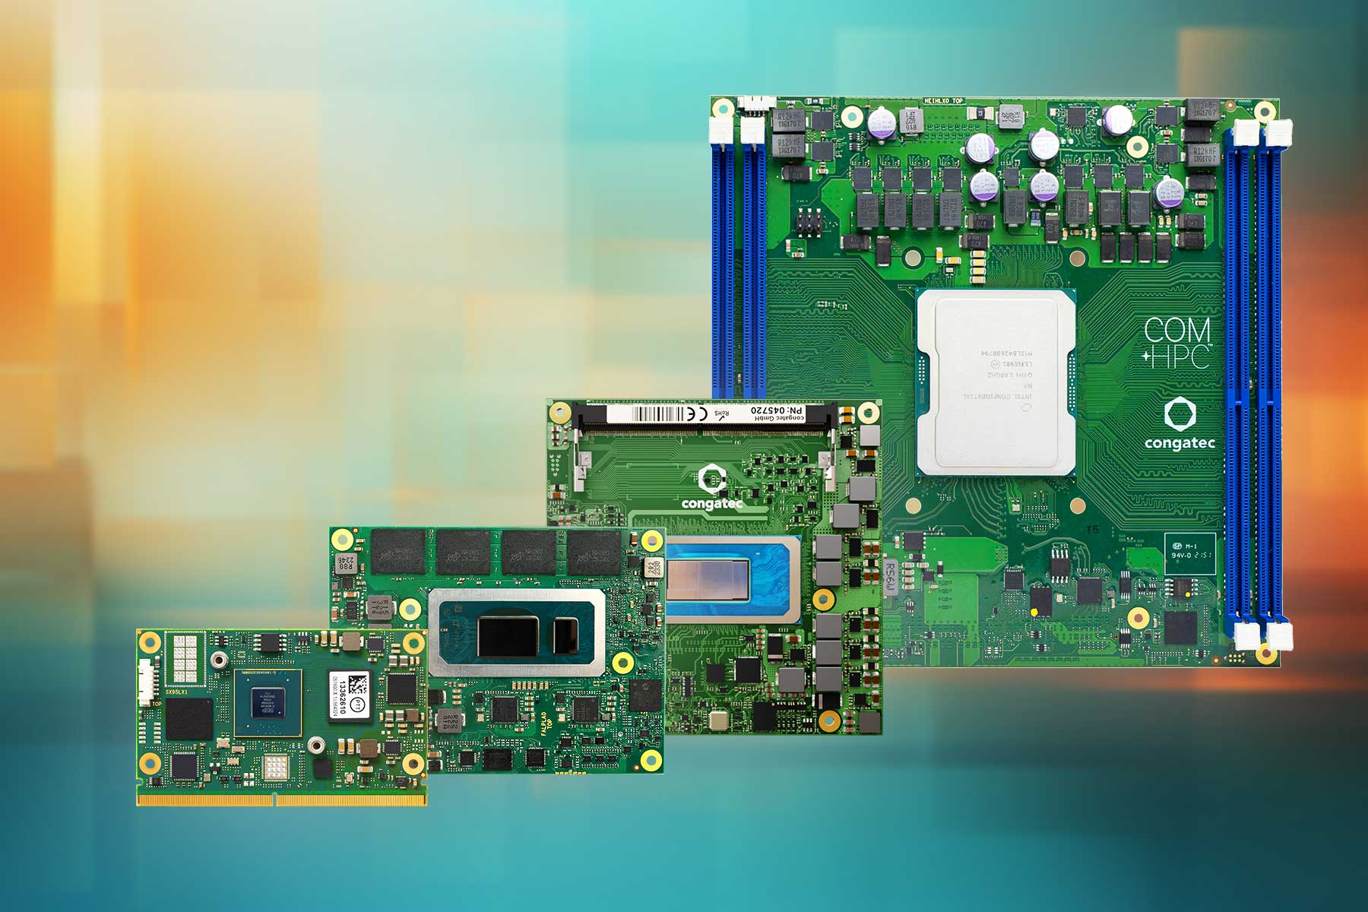**

**Gold Coast, Australia, 29th April 2025 \* \* \*** congatec – a leading vendor of embedded and edge computing technology – will present its latest high-performance hardware and software building blocks at ElectroneX 2025, taking place at the Melbourne Convention and Exhibition Centre from May 7th to 8th. At Booth A10, congatec will demonstrate its application-ready ecosystems designed to simplify and accelerate the development of embedded applications, boosting future competitiveness in practically every Australian industry sector.

“Market leadership is increasingly dependent on the utilization and integration of the latest electronics into all aspects of manufacturing, production, assembly, systems development, maintenance, and services”, explains Kathryn Chan, country manager for Australia and New Zealand at congatec. “Standardized hardware and software building blocks like aReady.COM based on Computer-on-Modules simplify the design of innovative applications and provide a secure upgrade path to implement future technologies.”

Visitors can expect to see a broad range of congatec Computer-on-Modules (COMs) and solution platforms that address the growing demands for performance, security, connectivity, and agility in embedded applications.

**Experience aReady.COM – Play the Game!**

Visit the congatec booth to experience the power of aReady.COM in an interactive and engaging way! The aReady.COM game lets visitors explore the benefits of application-ready software building blocks and discover how to streamline the development process.

**COM-HPC Client Ecosystem: High performance, ready for application**

congatec's COM-HPC Client ecosystem, featuring the conga-aCOM/mRPL, delivers exceptional performance for demanding embedded applications. This ecosystem is designed to accelerate time-to-market with application-ready solution platforms, providing scalable performance to meet evolving application needs. The ecosystem also enhances design flexibility with a wide range of carrier board options and increases reliability for mission-critical applications.

**Passively cooled edge server for harsh environments**

The rugged edge server design based on the conga-HPC/sILH COM-HPC Server module and the conga-HPC/uATX-Server application carrier board is engineered for reliable operation in challenging environments where fanless, fully sealed systems are essential. The design ensures robust performance in extreme temperatures and conditions, increases system reliability through passive cooling, minimizes maintenance, and maximizes uptime with its fanless operation. This makes it ideal for industrial automation, outdoor installations, and critical infrastructure.

**SMARC Ecosystem: Compact and powerful**

congatec's SMARC ecosystem, including the new conga-SMX95 modules, provides compact, energy-efficient modules for applications where optimized size and power consumption are critical. With a small form factor for space-constrained applications, low power consumption for energy efficiency, and scalable options to fit various performance needs, they are ideal for mobile systems, IoT devices, and embedded vision.

**COM Express Ecosystem: Performance and legacy support**

congatec's COM Express Type 6 ecosystem, featuring the new conga-TC750 modules, delivers high performance for demanding applications. Adherence to the industry-standard COM Express form factor ensures compatibility with existing designs, while long-term availability supports efficient product lifecycle management. These attributes make the modules well-suited for industrial control, medical imaging, and communication systems.

For more information on the aReady.COM conga-aCOM/mRPL, please visit: <https://www.congatec.com/en/products/acom/conga-acommrlp/>

For more information on congatec's COM-HPC Client ecosystem, please visit: <https://www.congatec.com/en/ecosystems/com-hpc-client-ecosystem/>

For more information on the COM-HPC Server ecosystem from congatec, please visit: <https://www.congatec.com/en/ecosystems/com-hpc-server-ecosystem/>

For more information on the conga-SMX95 SMARC module, please visit: <https://www.congatec.com/en/products/smarc/conga-smx95/>

For more information on the conga-TC750 COM express compact module, please visit: <https://www.congatec.com/en/products/com-express-type-6/conga-tc750/>

\* \* \*

**About congatec**

congatec is a leading global provider of high-performance hardware and software building blocks for embedded and edge computing solutions based on Computer-on-Modules (COMs). These advanced computer modules drive systems and devices across industries such as industrial automation, medical technology, robotics, telecommunications, and more. congatec's high-performance aReady. ecosystems simplify and accelerate the solution development, from COM to cloud. This application-ready approach combines COMs with services and customizable technologies that enable cutting-edge advancements in system consolidation, IoT, security, and artificial intelligence. Supported by its majority shareholder, DBAG Fund VIII – a German mid-market fund focused on driving growth for industrial enterprises – congatec has the financial backing and M&A expertise to capitalize on expanding market opportunities. For more information, visit [www.congatec.com](http://www.congatec.com/) or follow us on LinkedIn and YouTube.

Text and photograph available at: <https://www.congatec.com/en/congatec/press-releases.html>

*Intel, the Intel logo, and other Intel marks are trademarks of Intel Corporation or its subsidiaries.*

**Reader enquiries:**

congatec

Crysta Lee

Phone: +61 755200841

[info@congatec.com](mailto:info@congatec.com)

[www.congatec.com](http://www.congatec.com)

**Press contact congatec:**

congatec

Christof Wilde

Phone: +49-991-2700-2822

[christof.wilde@congatec.com](mailto:christof.wilde@congatec.com)

**Please send links to digital publications to:**

[christof.wilde@congatec.com](mailto:christof.wilde@congatec.com)