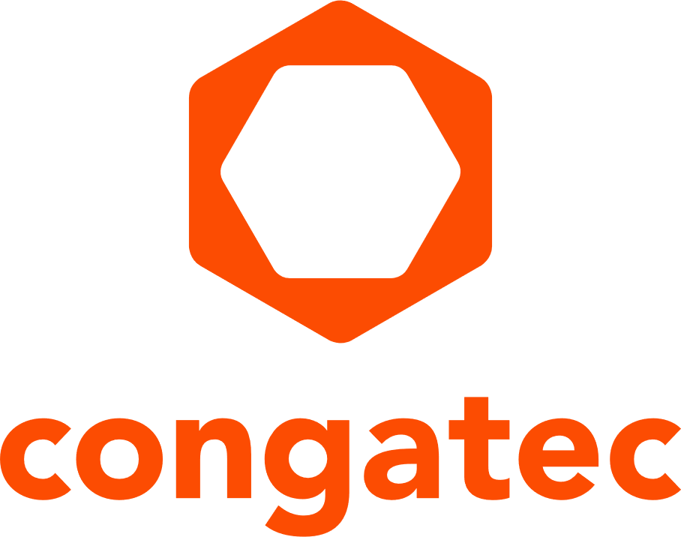
Press release

congatec Showcases AI, IoT and Embedded Edge Computing Platforms at embedded world North America

Company drives attendance with free exhibit hall pass, $50 value



San Diego, CA — October 24, 2025 * * * congatec — a leading vendor of embedded and edge computing technology — will share its latest developments in embedded and edge computing with attendees of embedded world North America (November 4-6, 2025, Anaheim, CA) Offering an application-ready modular hardware approach supported by functional embedded software, congatec’s platforms run in an almost infinite number of applications and deployment scenarios — from agile AI-enabled medical devices and high-security internet of things (IoT)/industrial internet of things (IIoT) to rugged transport systems, and edge AI systems for autonomous robots.
The company will also address the fruits of its recent investment in JUMPtec (the module business of Kontron AG), a move that augments its global presence and market leadership in standardized COMs across a multitude of applications and deployment scenarios.
“congatec is driven to accelerate the design to delivery of embedded and edge computing applications in markets spanning industrial automation, medical, robotics, energy, infrastructure, autonomous systems, IIoT and industry 4.0, transportation, and more,” said Dan Demers, regional vice president of sales & marketing, congatec Americas. “To achieve this reality, we consistently play a leadership role in application-ready COM building blocks, which include modules, carriers, and thermal management. We’re actively engaged in open standards, including SGeT and PICMG. And we promote standardized x86 and Arm-based hardware — including COM Express, COM-HPC and SMARC — for wide-ranging markets.
“What’s more, we recognize the vital role of embedded functional software in our customers’ product commercialization — which is why our aReady.COM offerings include flexible software combinations for system consolidation and secure IoT connectivity including optional pre-installed and licensed operating systems like Ubuntu Pro or ctrlX from Bosch,” added Demers.
Highlights of congatec booth #3039
- congatec’s COM-HPC Mini ecosystem — experience advancements in the upcoming high-performance computing standard in a near-credit card-sized form factor.
- SMARC Module ecosystem — explore the slim standard for space-constrained and rugged applications based on low-power x86 and ARM processors.
- Featured technology — an aReady.COM demo featuring system consolidation based on the conga-TC700 with Intel® Core Ultra™ processor runs motion control, AI vision and human-machine interface (HMI) on one module — an approach that boosts efficiency, reduces costs, and ensures real-time performance.
Get free exhibit hall pass and meet with congatec
congatec welcomes in-person meetings at embedded world North America. Use the congatec coupon code, CONGAT25, for a free exhibit hall pass valued at US$50: https://embedded-world-na.com/embedded-world-north-america-2025-registration/
Schedule a meeting at congatec booth #3039 during show hours, November 4-November 5, 2025: 9:00 a.m.-5:00 p.m.; November 6: 9:00 a.m.-3:00 p.m. sales-us@congatec.com

* * *
About congatec
congatec is a leading global provider of high-performance hardware and software building blocks for embedded and edge computing solutions based on Computer-on-Modules (COMs). These advanced computer modules drive systems and devices across industries such as industrial automation, medical technology, robotics, telecommunications, and more. congatec's high-performance aReady. ecosystems simplify and accelerate the solution development, from COM to cloud. This application-ready approach combines COMs with services and customizable technologies that enable cutting-edge advancements in system consolidation, IoT, security, and artificial intelligence. Supported by its majority shareholder, DBAG Fund VIII – a German mid-market fund focused on driving growth for industrial enterprises – congatec has the financial backing and M&A expertise to capitalize on expanding market opportunities. For more information, visit www.congatec.com or follow us on LinkedIn and YouTube.

Press contact, congatec:
Janene Rae
Phone: 858-457-2600
janene.rae@congatec.com
www.congatec.us

Press contact, ThroughPut Marketing:
Maria Vetrano
Phone: +857-212-6550
maria@throughput.agency

Intel, the Intel logo, and other Intel marks are trademarks of Intel Corporation or its subsidiaries.

