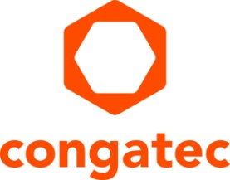
Press release

congatec presents its expanded portfolio and aReady.COM platforms

congatec to showcase application-ready embedded solution platforms at EdgeTech+ Japan 2025
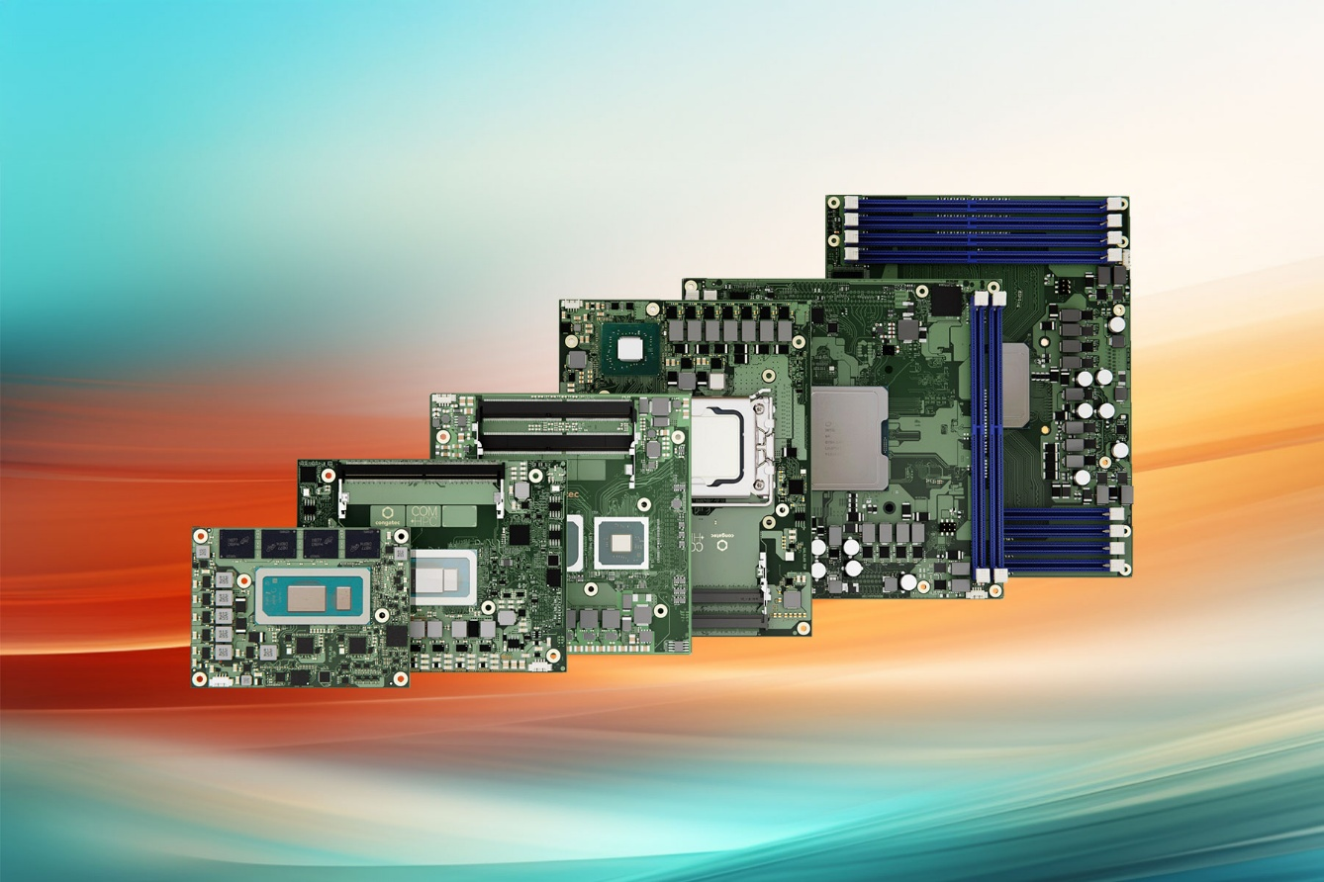
Tokyo, Japan – November 13, 2025 – congatec – a leading provider of embedded and edge computing technology – will be exhibiting at EdgeTech+ 2025 in Yokohama, Japan, from November 19 to 21, 2025. At Booth CS-12, visitors can experience congatec’s latest solution platforms built on standards-based Computer-on-Modules, designed to simplify the use of embedded technology.
congatec's focus at EdgeTech+ Japan is to demonstrate how its application-ready hardware and software building blocks significantly reduce development complexity and help customers implement new technologies and bring their innovative solutions to market faster. Visitors this year can expect an even broader product portfolio, as the presentation is strengthened by the integration of the JUMPtec module portfolio (previously the module business of Kontron). This integration expands congatec’s offerings and underscores its leadership as the most comprehensive vendor of computer modules in the embedded market.

Highlights at the Booth
One of the key highlights is the high-performance aReady.COM ecosystem, which includes pre-installed, application-ready software building blocks to significantly simplify application designs while improving efficiency, security, and cost-effectiveness.
In an interactive game, customers can configure their own aReady.COM. They can use a real-time hypervisor to consolidate multiple functions, select a pre-installed and licensed OS like Ubuntu Pro or ctrlX, and combine real-time control, HMI, AI, and IoT connectivity on a single module.
Key highlights will include:
- Real-Time Hypervisor-on-Module: A showcase of how aReady.COM’s building blocks can consolidate multiple general purpose and real-time operating systems onto a single Computer-on-Module. This system consolidation reduces system count, weight, power, and cost in complex industrial applications.
- Secure IoT Connectivity: An aReady.IOT installation demonstrating secure connectivity from the COM to the cloud. This platform enables seamless communication with machines, systems, and sensors via widely used industrial protocols like OPCUA, MQTT, and REST.
- Latest Processor Technology: congatec will exhibit its extensive Computer-on-Module ecosystems based on the latest processor technology, including:
  - Our ecosystem of COM-HPC modules, including the new COM-HPC Mini form factor, cooling solutions, and carrier boards.
  - Latest AI-accelerated x86 and Arm silicon with integrated NPUs on the leading COM Express and SMARC form factors, featuring processors from AMD, Intel, NXP, and Texas Instruments. These are available with dedicated carrier boards for direct design-in.

* * *
About congatec
congatec is a leading global provider of high-performance hardware and software building blocks for embedded and edge computing solutions based on Computer-on-Modules (COMs). These advanced computer modules drive systems and devices across industries such as industrial automation, medical technology, robotics, telecommunications, and more. congatec's high-performance aReady. ecosystems simplify and accelerate the solution development, from COM to cloud. This application-ready approach combines COMs with services and customizable technologies that enable cutting-edge advancements in system consolidation, IoT, security, and artificial intelligence. Supported by its majority shareholder, DBAG Fund VIII – a German mid-market fund focused on driving growth for industrial enterprises – congatec has the financial backing and M&A expertise to capitalize on expanding market opportunities. For more information, visit www.congatec.com or follow us on LinkedIn and YouTube.

Reader enquiries:
congatec
Crysta Lee
Phone: +886 2 25978577
info@congatec.com
www.congatec.com

Press contact congatec:
Christof Wilde
Phone: +49-991-2700-2822
christof.wilde@congatec.com

