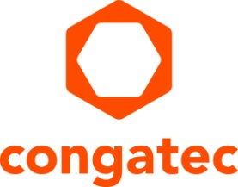
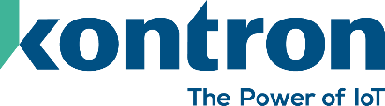

Press release

KontronOS, the secure, hardened Linux®-based Operating System, expands congatec’s standards-based and cybersecure aReady.COM offering

Kontron and congatec unite to deliver secure embedded solutions

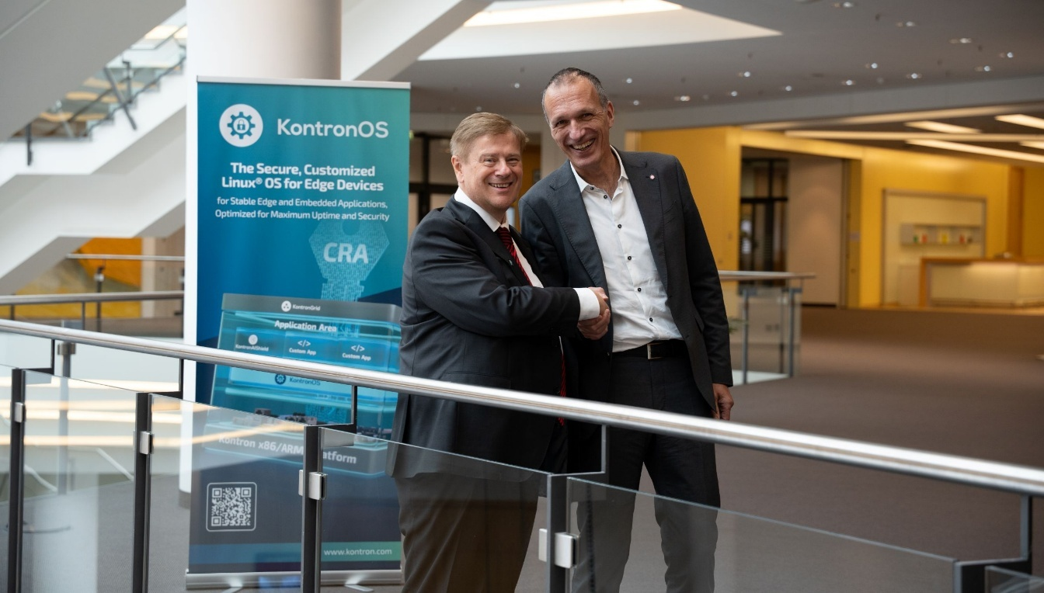
Hannes Niederhauser, CEO of Kontron, and Dominik Ressing, CEO of congatec are delighted about the expanded cooperation (from left to right)

Deggendorf, Germany, 26 November, 2025 * * * congatec – a leading vendor of embedded and edge computing technology – and Kontron – a leading global provider of IoT/Embedded Computer Technology (ECT) – today announced new modular and secure embedded platforms. At the core of this collaboration is the integration of KontronOS, Kontron’s secure, Linux®-based operating system, with congatec’s application-ready aReady.COM hardware and software building blocks. This integrated approach is designed to simplify and accelerate the development of security and application solutions that comply with IEC 62443.

Thanks to the partnership with Kontron, KontronOS is now available as part of the aReady.COM portfolio. This allows customers to receive application-ready modules with a pre-installed and licensed operating system. The combination of congatec’s hypervisor technology, KontronOS, and KontronAIShield separates mission-critical core functions from IoT components, ensuring maximum system security.

"With KontronOS, we are offering a secure, modular, and standardized platform that will be available across all modules in the long term. It will serve as a foundation for future innovations. At the same time, we are responding quickly to new technological requirements driven by the CRA directive and the evolution of AI. We are pleased to strengthen our partnership with congatec to deliver even more powerful and secure solutions for our customers,” said Hannes Niederhauser, CEO of Kontron.

Dominik Ressing, CEO of congatec, added, "We are expanding our application-ready embedded computer hardware and software building blocks with the secure KontronOS. This enhancement provides aReady.COM customers with greater flexibility and security. With aReady.COM, customers can bring secure, innovative solutions to market faster, reducing non-recurring engineering costs and total cost of ownership. We are delighted that Kontron is supporting our aReady strategy with KontronOS, and we are excited that this joint solution is now available to our customers.”

KontronOS is subscription-based and available on aReady.COM. It is extendable with modules such as KontronAIShield and KontronGrid, which can be added as needed. KontronOS helps customers achieve CRA compliance for their products, reducing overall costs.

Building on the partnership established with Kontron in May 2025, which combines the computer-on-module expertise of both companies, congatec will continue to supply embedded modules for Kontron. Together, the companies are pooling their technological capabilities, giving Kontron access to one of the broadest embedded module portfolios worldwide.

Further information on aReady.COM can be found at: https://www.congatec.com/en/aready/areadycom/

* * *

About congatec
congatec is a leading global provider of high-performance hardware and software building blocks for embedded and edge computing solutions based on Computer-on-Modules (COMs). These advanced computer modules drive systems and devices across industries such as industrial automation, medical technology, robotics, telecommunications, and more. congatec's high-performance aReady. ecosystems simplify and accelerate the solution development, from COM to cloud. This application-ready approach combines COMs with services and customizable technologies that enable cutting-edge advancements in system consolidation, IoT, security, and artificial intelligence. Supported by its majority shareholder, DBAG Fund VIII – a German mid-market fund focused on driving growth for industrial enterprises – congatec has the financial backing and M&A expertise to capitalize on expanding market opportunities. For more information, visit www.congatec.com or follow us on LinkedIn and YouTube.

About Kontron
Kontron AG (www.kontron.com, ISIN AT0000A0E9W5, WKN A0X9EJ, KTN) is a leading IoT technology company. For more than 20 years, Kontron has been supporting companies from a wide range of industries to achieve their business goals with intelligent solutions. From automated industrial operations, smarter and safer transport to advanced communications, connectivity, medical, and energy solutions, the company delivers technologies that add value for its customers. With the acquisition of Katek SE in early 2024, Kontron significantly strengthens its portfolio with the new GreenTec division, focusing on solar energy and eMobility, and grows to around 7,000 employees in over 20 countries worldwide. Kontron is listed on the SDAX® and TecDAX® of the German Stock Exchange.

Reader enquiries:
congatec
Phone: +49-991-2700-0
info@congatec.com
www.congatec.com

Press contact congatec:
congatec
Christof Wilde
Phone: +49-991-2700-2822
christof.wilde@congatec.com

