# Press release Congatec_Standardlogo_RGB.jpg

congatec presents its aReady.COM solutions at CIIF 2025

**congatec to showcase application-ready embedded solution platforms at CIIF 2025 in Shanghai**

**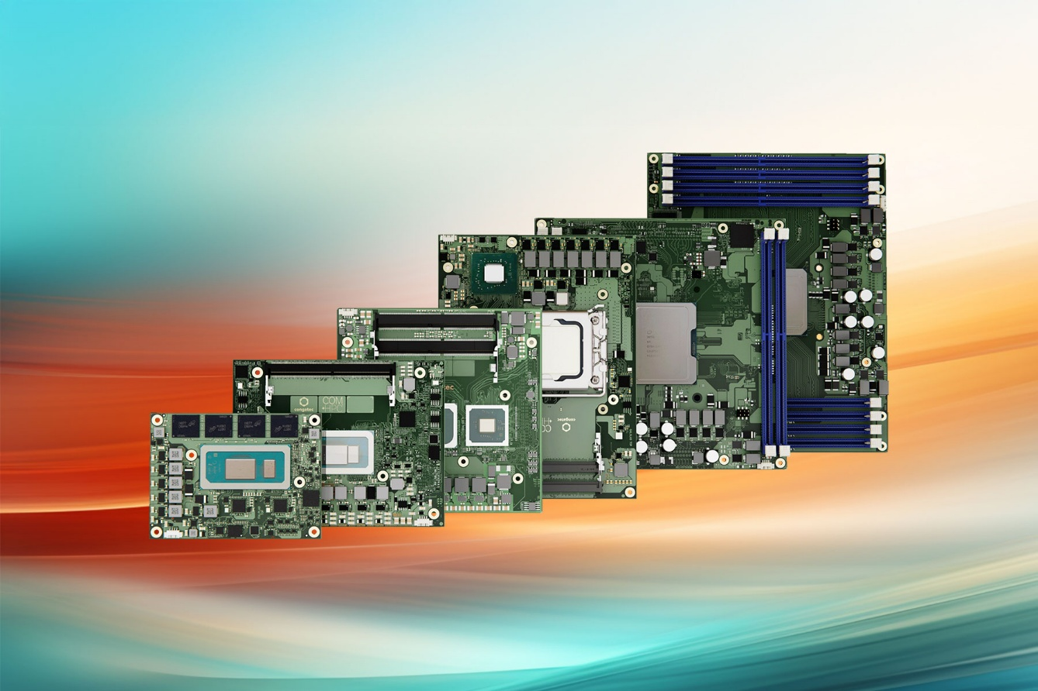**

**Shanghai, China – September 11, 2025** – congatec – a leading provider of embedded and edge computing technology – will be exhibiting at the China International Industry Fair (CIIF) in Shanghai, from September 23 to 27. At **Booth 6.1H-B037**, visitors can experience congatec’s latest solution platforms built on standards-based Computer-on-Modules, designed to simplify the use of embedded technology. congatec's focus at CIIF is to demonstrate how its application-ready hardware and software building blocks significantly reduce development complexity and help customers implement new technologies, stay agile and bring their innovative solutions to market faster.

# Highlights at the Booth

One of the key highlights is the high-performance aReady.COM ecosystem, including pre-installed, application-ready software building blocks significantly simplifying application designs while improving efficiency, security, and cost-effectiveness.

In an interactive game, customers can configure their own aReady.COM. They can use a real-time hypervisor to consolidate multiple functions, select a pre-installed and licensed OS like Ubuntu Pro or ctrlX, and combine real-time control, HMI, AI, and IoT connectivity on a single module.

Another demonstration will highlight the advantages of the real-time Hypervisor-on-Module to showcase how aReady.COM's building blocks can consolidate multiple general purpose and real-time operating systems onto one single Computer-on-Module. The systems work separately from each other, reducing system count, weight, power and cost in industrial applications.

Especially interesting for connected industrial applications is the new aReady.IOT installation demonstrating secure IoT connectivity from the COM to the cloud with congatec’s powerful software building blocks. It illustrates the versatility of the preconfigured aReady.IOT platform, enabling communication with machines, systems, and sensors via protocols like OPCUA, MQTT, and REST.

In addition to these, congatec will exhibit its extensive Computer-on-Module ecosystems based on latest processor technology. Highlights include:

* The passively cooledCOM-HPC edge server based on Intel® Xeon® processor technology, designed for demanding environments and extreme industrial temperature ranges.
* Latest AI-accelerated x86 and Arm silicon with integrated NPUs on the leading COM Express and SMARC form factors, featuring processors from AMD, Intel, NXP and Texas Instruments. These also come with dedicated carrier boards for a direct design-in.

\* \* \*

**About congatec**

congatec is a leading global provider of high-performance hardware and software building blocks for embedded and edge computing solutions based on Computer-on-Modules (COMs). These advanced computer modules drive systems and devices across industries such as industrial automation, medical technology, robotics, telecommunications, and more. congatec's high-performance aReady. ecosystems simplify and accelerate the solution development, from COM to cloud. This application-ready approach combines COMs with services and customizable technologies that enable cutting-edge advancements in system consolidation, IoT, security, and artificial intelligence. Supported by its majority shareholder, DBAG Fund VIII – a German mid-market fund focused on driving growth for industrial enterprises – congatec has the financial backing and M&A expertise to capitalize on expanding market opportunities. For more information, visit [www.congatec.com](http://www.congatec.com/) or follow us on LinkedIn and YouTube.

**Reader enquiries:**

congatec

Crysta Lee

Phone: +886 2 25978577

[info@congatec.com](mailto:info@congatec.com)

[www.congatec.com](http://www.congatec.com)

**Press contact congatec:**

Christof Wilde

Phone: +49-991-2700-2822

christof.wilde@congatec.com