# Congatec_Standardlogo_RGB.jpg

# Press release

congatec and Aaronn Electronic join forces to deliver greater product diversity, faster development times, and personalized support in the DACH region

# Combined expertise for embedded Computer-on-Module integration

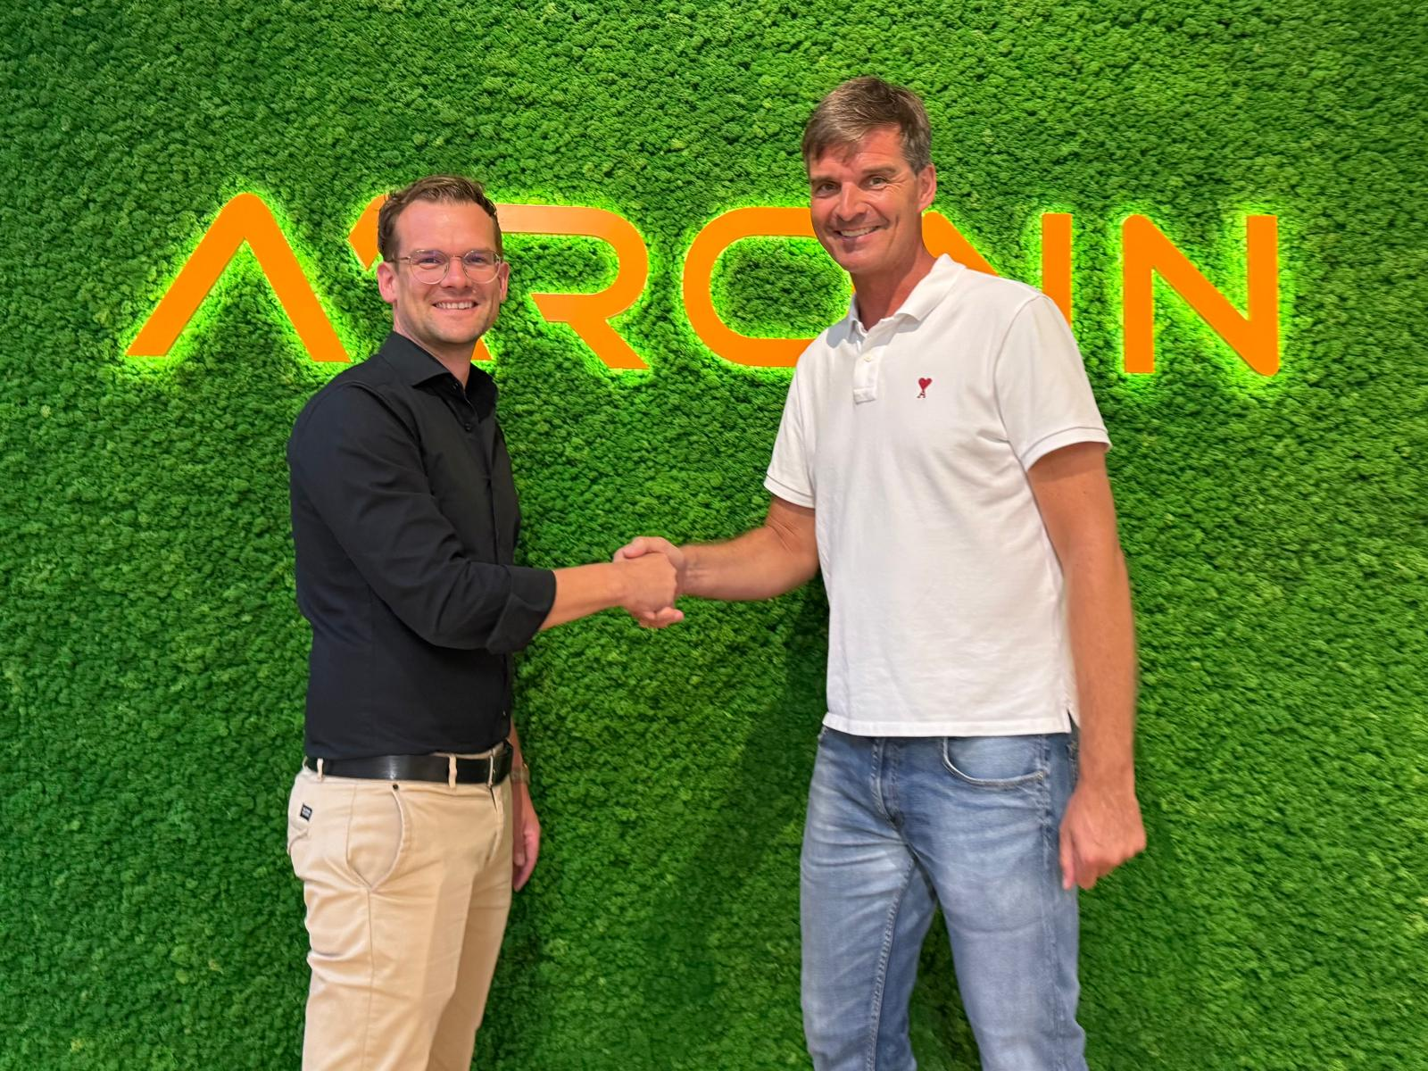

***Florian Haidn, CEO of Aaronn Electronic (left), and Oliver Utesch, Director of Business Development EMEA at congatec (right), seal the new partnership with a handshake.***

**Deggendorf/Puchheim, Germany, 23 September 2025 \* \* \*** congatec – a leading vendor of embedded and edge computing technology – and Aaronn Electronic – one of the most successful system integrators for embedded computing in Germany – announce a strategic partnership to provide developers and OEMs in the DACH region with easier access to a broader range of Computer-on-Modules (COMs), including application-ready software building blocks and full system integration services.

As part of the collaboration, Aaronn Electronic customers will gain access to congatec’s full portfolio of **COM-HPC, COM Express, SMARC, and Qseven modules**. Added value comes from congatec’s application-ready **aReady. building blocks –** including **aReady.VT with** integrated hypervisor for virtualization and workload consolidation, **aReady.IOT** for secure remote monitoring and management, as well as pre-licensed, ready-to-use operating systems such as **Ubuntu Pro** and **ctrlX OS**. These building blocks help reduce integration complexity, shorten development cycles, and accelerate time-to-market.

“With Aaronn Electronic, we’re gaining a system integration partner that brings decades of deep expertise in delivering embedded systems throughout the DACH region. The combination of our market-leading module portfolio and aReady. building blocks empowers customers to shorten their development cycles, minimize risk, and bring innovative systems to market faster,” says **Oliver Utesch, Director of Business Development EMEA at congatec.**

“With congatec, we’re partnering with a company that embodies innovation and market leadership in the Computer-on-Module space. Our customers will benefit from an even wider product range, combined with our proven integration know-how. I’m looking forward to many exciting projects. We’ve had a close partnership with Computer-on-Module pioneer JUMPtec since our founding in 1993. Partnering with congatec feels like things are coming full circle: congatec, the COM market leader founded by former JUMPtec employees, and COM pioneer JUMPtec – together again,” says **Florian Haidn, CEO of Aaronn Electronic**.

The partnership leverages the unique strengths of both companies, each with decades of experience in Computer-on-Modules. Customers can expect shortened development times for tailored solutions and hands-on professional support.

\* \* \*

**About congatec**

congatec is a leading global provider of high-performance hardware and software building blocks for embedded and edge computing solutions based on Computer-on-Modules (COMs). These advanced computer modules drive systems and devices across industries such as industrial automation, medical technology, robotics, telecommunications, and more. congatec's high-performance aReady. ecosystems simplify and accelerate the solution development, from COM to cloud. This application-ready approach combines COMs with services and customizable technologies that enable cutting-edge advancements in system consolidation, IoT, security, and artificial intelligence. Supported by its majority shareholder, DBAG Fund VIII – a German mid-market fund focused on driving growth for industrial enterprises – congatec has the financial backing and M&A expertise to capitalize on expanding market opportunities. For more information, visit [www.congatec.com](http://www.congatec.com/) or follow us on LinkedIn and YouTube.

**About Aaronn Electronic**

Aaronn Electronic GmbH, headquartered in Puchheim near Munich, has been a trusted partner for embedded computing technologies for over 30 years. Evolving from a distributor into one of Germany’s leading system integrators, Aaronn provides expert consulting, dependable support, and tailored solutions – from product analysis and prototype development to series production. For more information, visit [www.aaronn.de](https://www.aaronn.de/en/) or connect with Aaronn on [LinkedIn](https://www.linkedin.com/company/aaronn-electronic-gmbh/).

**Reader enquiries:**

congatec

Phone: +49-991-2700-0

info@congatec.com

[www.congatec.com](http://www.congatec.com)

**Press contact congatec:**

Christof Wilde

congatec

Phone: +49-991-2700-2822

christof.wilde@congatec.com

**Press contact Aaronn Electronic GmbH:**  
Yanping Zou   
Aaronn Electronic GmbH   
Lilienthalstraße 1   
82178 Puchheim

Germany  
Phone: +49-89-894577-11   
[yanping.zou@aaronn.de](mailto:yanping.zou@aaronn.de)   
[www.aaronn.de](https://www.aaronn.de/en/)