
Press Release

New COM-HPC Mini module from congatec with Qualcomm Dragonwing™ IQ-X processors opens up new applications

congatec takes embedded ARM modules to a new level of performance

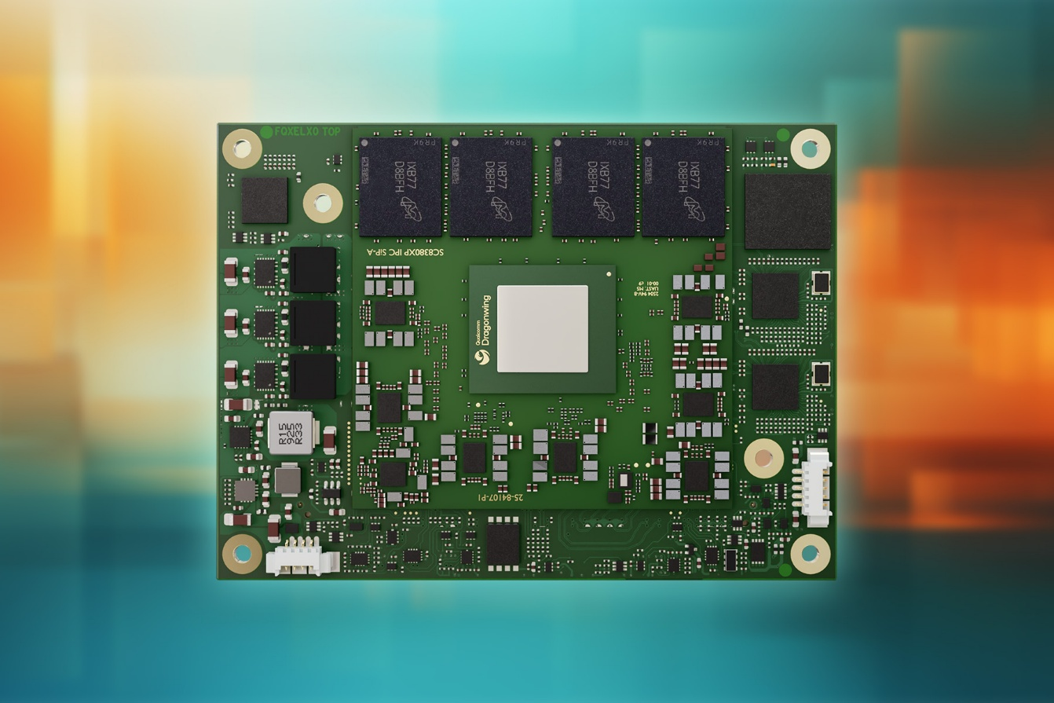

Deggendorf, Germany, 25 November 2025 * * * congatec – a leading vendor of embedded and edge computing technology – launched its first COM-HPC Mini Computer-on-Module (COM) powered by the Qualcomm Dragonwing™ IQ-X Series processors. The new conga-HPC/mIQ-X with the Qualcomm® Oryon™ CPU delivers exceptional single and multithread compute performance - previously achieved only with x86 based-designs - at best-in-class power efficiency. Edge AI applications, including local machine learning (ML), and the running of large language models (LLMs), benefit from up to 45 TOPS of AI performance with the dedicated NPU powered by the Qualcomm ® Hexagon™ processor. The conga-HPC/mIQ-X addresses the growing demand for high-performance, energy-efficient compute platforms in markets such as security, transactional retail, robotics, medical technology, and industrial automation.

Robust, compact, and AI-optimized
With a form factor roughly the size of a credit card, the conga-HPC/mIQ-X features a robust design with soldered, fast LPDDR5X RAM and support for an industrial temperature range from -40 °C to +85 °C.

Typical use cases include video surveillance, sensor and camera systems for edge analytics, and applications with local AI processing. This platform is ideal for developers who want to leverage the strengths of Arm on Microsoft Windows. It significantly reduces development time compared to other implementations through simplified software integration and UEFI-compatible firmware. All size, weight, and power (SWaP) optimized designs also benefit from the high performance per watt of the new mini modules.

“The conga-HPC/mIQ-X takes embedded Arm computing to a new level of performance and simplifies the development of AI-accelerated edge and vision systems through UEFI BIOS support, Windows integration, and a complete ecosystem,” explains Konrad Garhammer, COO and CTO of congatec.

Feature set in detail
The conga-HPC/mIQ-X COM-HPC Mini module - measuring just 95 mm x 70 mm - is based on Qualcomm Dragonwing IQ-X Series processors with up to 64 GB of LPDDR5X memory. With up to 12 Oryon cores, a dedicated Hexagon NPU, DSP, and Qualcomm® Spectra ISP, it offers optimized computing units for ultra-efficient processing of video, image, and audio data. The integrated Qualcomm ® Adreno™ GPU delivers powerful graphics, supporting up to 3 displays and 8K resolution. For fast networking and peripheral connectivity, the COM-HPC Mini module offers 2x 2.5 Gb Ethernet, up to 16x PCIe Gen3/Gen4 lanes, 2x USB4, 2x USB3.2 Gen2x1, and 8x USB2.0. Graphics output is via 2x DDI and eDP, and up to 4 cameras can be connected directly via MIPI CSI. 2x I2C, 2x UART, and 12x GPIO round out the feature set. The integrated TPM 2.0 module serves as the hardware root of trust.

Short time-to-market thanks to aReady.COM
To accelerate time-to-market, congatec offers optimized cooling solutions, evaluation boards, and comprehensive design support. The new COM-HPC Mini module is also available as an application-ready aReady.COM. It is delivered customized with validated and pre-installed operating systems and optional software building blocks for IoT functionality, faster development, and optimized cost.

Available conga-HPC/mIQ-X variants:
Model |  | Cores /  Threads |  | RAM |  | Clock Frequency |  | Base-TDP |  | Operating Temperature
conga-HPC/mIQ-X7-64G UFS128 |  | 12 / 16 |  | 64 GByte |  | 3,4 GHz |  | 28-45 Watt |  | -40 to +85°C
conga-HPC/mIQ-X7-32G UFS128 |  | 12 / 16 |  | 32 GByte |  | 3,4 GHz |  | 28-45 Watt |  | -40 to +85°C
conga-HPC/mIQ-X7-16G UFS128 |  | 12 / 14 |  | 16 GByte |  | 3,4 GHz |  | 28-45 Watt |  | -40 to +85°C
conga-HPC/mIQ-X5-32G UFS128 |  | 8 / 14 |  | 32 GByte |  | 3,4 GHz |  | 15-30 Watt |  | -40 to +85°C
conga-HPC/mIQ-X5-16G UFS128 |  | 8 / 14 |  | 16 GByte |  | 3,4 GHz |  | 15-30 Watt |  | -40 to +85°C

For more information on the COM-HPC Mini Module conga-HPC/mIQ-X, please visit:
https://www.congatec.com/en/products/com-hpc/conga-hpcmiq-x/

* * *

About congatec
congatec is a leading global provider of high-performance hardware and software building blocks for embedded and edge computing solutions based on Computer-on-Modules (COMs). These advanced computer modules drive systems and devices across industries such as industrial automation, medical technology, robotics, telecommunications, and more. congatec's high-performance aReady. ecosystems simplify and accelerate the solution development, from COM to cloud. This application-ready approach combines COMs with services and customizable technologies that enable cutting-edge advancements in system consolidation, IoT, security, and artificial intelligence. Supported by its majority shareholder, DBAG Fund VIII – a German mid-market fund focused on driving growth for industrial enterprises – congatec has the financial backing and M&A expertise to capitalize on expanding market opportunities. For more information, visit www.congatec.com or follow us on LinkedIn and YouTube.

Reader enquiries:
congatec
Phone: +49-991-2700-0
info@congatec.com
www.congatec.com

Press contact congatec:
congatec
Christof Wilde
Phone: +49-991-2700-2822
christof.wilde@congatec.com

