# Press release Congatec_Standardlogo_RGB.jpg

conga-TC675r completes IEC 60068 testing, offering a compact, application-ready embedded module for extreme environments

**congatec Expands Railway Testing for COM Express Module Family**

**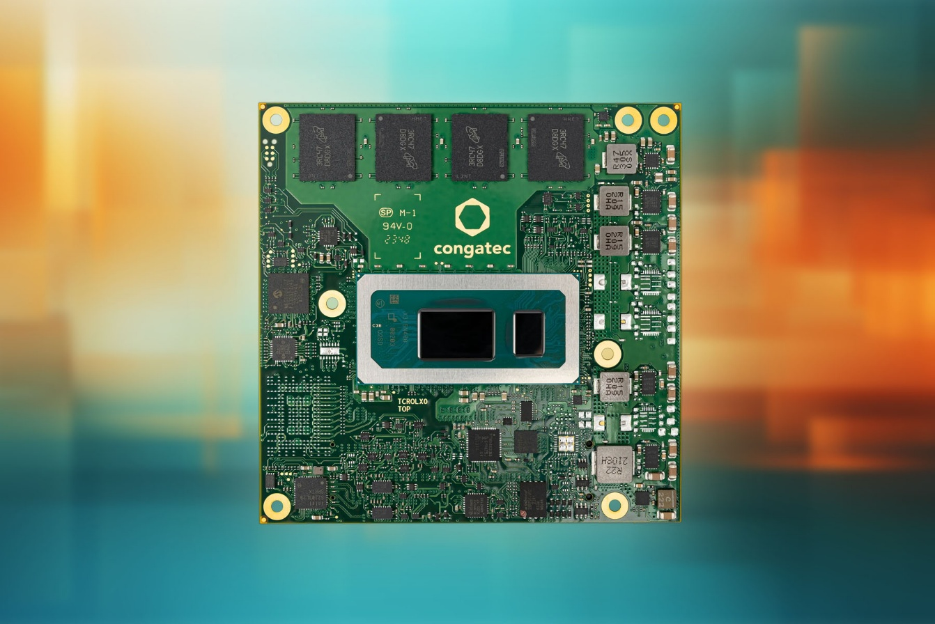**

**San Diego, CA, October 21, 2025 \* \* \*** congatec, a global leader in embedded and edge computing technology, has successfully completed IEC 60068 testing for environmental sustainability — one of the world’s most rigorous testing for extreme environmental conditions — for the conga-TC675r COM Express Compact Type 6 module. The conga-TC675r is a compact, application-ready embedded module with proven ruggedness for autonomous vehicles, autonomous mobile robots (AMR), critical infrastructure, industrial IoT, wayside installations, and other mission-critical systems.

“Embedded systems don’t exist in a vacuum. They’re deployed in wide-ranging real-world applications, with many of them operating in harsh environments,” said Jürgen Jungbauer, Product Line Manager at congatec. “Though application areas such as oil rigs, industrial robots and autonomous vehicles may sound diverse, they demand consistent, reliable performance and long-term availability.”

With this testing, congatec proves that the compact COM Express module fulfills the stringent requirements of IEC 60068, which covers extreme cold and heat stress, humidity, shock, and vibration. The conga-TC675r also addresses the railway industry’s IEC 61373 category 2 standard, which covers another layer of shock and vibration requirements. Collectively, the conga-TC675r’s compliance with these standards ensures its operation in some of the most demanding environmental conditions on Earth.

conga-TC675r modules are based on the 13th generation Intel® Core™ processors (Raptor Lake) and offer maximum reliability thanks to their extended temperature range of -40 to +85 °C, soldered RAM with in-band ECC (IBECC), and operational readiness at 10 to 85 percent humidity. This makes them ideal for use in manned and unmanned rail and off-road vehicles for mining, agriculture, forestry, and other mobility applications. Critical infrastructure, security, railway, and transportation use cases also benefit from the module's robust design.

**Key features of congatec-TC675r**

* Intel® hybrid design combines Performance-and Efficient cores for optimized performance across different workloads.
* -40 to +85 ° C extended temperature range and soldered RAM with In-Band Error-Correcting Code (IBECC) offer highest reliability by design.
* PCI Express Gen 4 and USB 4 support latest high-bandwidth connectivity options
* Soldered-on 6400 MT/s LPDDR5xmemoryenables exceptional performance and power efficiency.
* congatec aReady.VT Hypervisor supports consolidation of multiple workloads — such as real-time control, HMI, AI and IoT gateway functions — on a single module.
* Available pre-configured with Bosch Rexroth ctrlX OS license and Ubuntu Pro, speeding time to deployment.
* Unique passive cooling based on heat pipes offers best-in-class heat dissipation for fanless design. For extremely cold environments, congatec's new acetone thermal management is recommended.

The congatec-TC675r is a member of congatec’s aReady.COM family of pre-validated and pre-configured modular hardware and software building blocks. Tightly integrated aReady.COM platforms include computer-on-modules (COMs), cooling solutions, memory, and fully licensed, pre-installed operating systems — an approach that streamlines embedded development for faster time to market while reducing bill of materials (BOM) costs.

|  |  |  |  |  |  |  |  |  |  |  |
| --- | --- | --- | --- | --- | --- | --- | --- | --- | --- | --- |
| **Processor** |  | **Cores/ (P + E)** |  | **Max. Turbo Freq. [GHz] P-Cores / E-Cores** |  | **Base Freq. [GHz] P-Cores / E-Cores** |  | **Threads** |  | **CPU Base Power [W]** |
| Intel Core i7-13800HRE |  | 14  (6 + 8) |  | 5,0 /4,0 |  | 2,5 / 1,8 |  | 20 |  | 45 |
| Intel Core i7-1370PRE |  | 14  (6 + 8) |  | 4,8 / 3,7 |  | 1,9 / 1,2 |  | 20 |  | 28 |
| Intel Core i7-1365URE |  | 10  (2 + 8) |  | 4,9 / 3,7 |  | 1,7 / 1,2 |  | 12 |  | 15 |
| Intel Core i5-13600HRE |  | 12  (4 + 8) |  | 4,8 / 3,6 |  | 2,7 / 1,9 |  | 16 |  | 28 |
| Intel Core i5-1350PRE |  | 12  (4 + 8) |  | 4,6 / 3,4 |  | 1,8 / 1,3 |  | 16 |  | 28 |
| Intel Core i3-1320PRE |  | 8  (4 + 4) |  | 4,5 / 3,3 |  | 1,7 / 1,2 |  | 12 |  | 28 |

For more information on conga-TC675r COM Express Compact modules, visit: [www.congatec.com/en/products/com-express-type-6/conga-tc675r/](http://www.congatec.com/en/products/com-express-type-6/conga-tc675r/)

\* \* \*

**About congatec**

congatec is a leading global provider of high-performance hardware and software building blocks for embedded and edge computing solutions based on Computer-on-Modules (COMs). These advanced computer modules drive systems and devices across industries such as industrial automation, medical technology, robotics, telecommunications, and more. congatec's high-performance aReady. ecosystems simplify and accelerate the solution development, from COM to cloud. This application-ready approach combines COMs with services and customizable technologies that enable cutting-edge advancements in system consolidation, IoT, security, and artificial intelligence. Supported by its majority shareholder, DBAG Fund VIII – a German mid-market fund focused on driving growth for industrial enterprises – congatec has the financial backing and M&A expertise to capitalize on expanding market opportunities. For more information, visit [www.congatec.com](http://www.congatec.com/) or follow us on LinkedIn and YouTube.

###

**Reader enquiries:**

congatec

Dan Demers

Phone: 858-457-2600

[Dan.Demers@congatec.com](mailto:Dan.Demers@congatec.com)

[www.congatec.us](http://www.congatec.us)

**Press contact, congatec:**

congatec

Janene Rae

Phone: 858-457-2600

[janene.rae@congatec.com](mailto:janene.rae@congatec.com)

[www.congatec.us](file://NAS5000/Kunden/congatec/01-PR/www.congatec.us)

**Press contact, ThroughPut Marketing:**

Maria Vetrano

Phone: +857-212-6550

[maria@throughput.agency](mailto:maria@throughput.agency)

*Intel, the Intel logo, and other Intel marks are trademarks of Intel Corporation or its subsidiaries.*