# Press release Congatec_Standardlogo_RGB.jpg

**New VDC Research white paper with congatec and NXP: Standardized COMs with i.MX 95 processors drive industrial vision AI adoption amidst 48.3% edge AI growth**

# How to unlock the future of industrial AI

**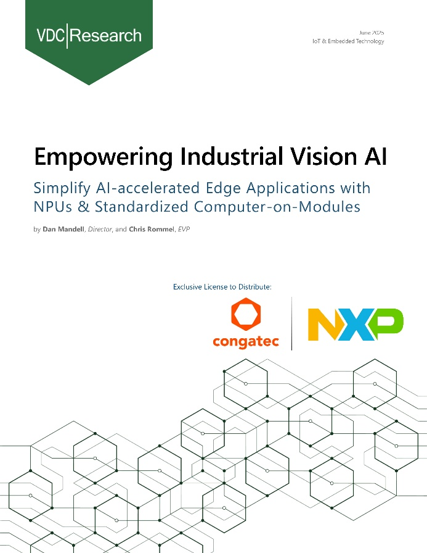**

**Deggendorf, Germany, 16 September, 2025 \* \* \*** congatec – a leading vendor of embedded and edge computing technology – and its long-standing partner NXP Semiconductors N.V. (NASDAQ: NXPI) today announced the immediate availability of a new white paper from VDC Research, "Empowering Industrial Vision AI." This insightful white paper provides an in-depth look at the rapidly evolving industrial edge, where the rise of vision-based technologies powered by AI and machine learning is set to dramatically increase. In fact, the use of AI and machine learning is projected to skyrocket from 15.7% of current projects to 51.2% within just three years. With a projected 48.3% compound annual growth rate (CAGR), the need for flexible, application-ready hardware platforms to manage costs and accelerate development will be a decisive factor in driving business success.

The comprehensive report, based on feedback from 600 engineers, also benchmarks the global revenue for embedded AI boards and modules and shows how edge AI extends computer vision capabilities to improve operational efficiency, security, and safety. A key finding: hardware costs are the biggest factor (43.7%) in making edge AI workloads more affordable. That’s why flexible, high-performance design approaches, like using standardized Computer-on-Modules (COMs) with NXP’s i.MX95 processors, are helping to boost the adoption of AI-accelerated edge solutions.

"How can you navigate this rapid technological shift? This research confirms that standardized Computer-on-Modules are a powerful platform for simplifying the integration of new technologies,” explains Konrad Garhammer, congatec's COO and CTO. “Our partnership with NXP is key. By combining our SMARC modules with NXP's i.MX 95 application processors, we provide developers with a streamlined way to create powerful, future-proof industrial vision AI solutions.”

The white paper is available for free download today from congatec <https://insights.congatec.com/whitepaper-vdc-empowering-industrial-vision-ai-congatec>

\* \* \*

**About congatec**

congatec is a leading global provider of high-performance hardware and software building blocks for embedded and edge computing solutions based on Computer-on-Modules (COMs). These advanced computer modules drive systems and devices across industries such as industrial automation, medical technology, robotics, telecommunications, and more. congatec's high-performance aReady. ecosystems simplify and accelerate the solution development, from COM to cloud. This application-ready approach combines COMs with services and customizable technologies that enable cutting-edge advancements in system consolidation, IoT, security, and artificial intelligence. Supported by its majority shareholder, DBAG Fund VIII – a German mid-market fund focused on driving growth for industrial enterprises – congatec has the financial backing and M&A expertise to capitalize on expanding market opportunities. For more information, visit [www.congatec.com](http://www.congatec.com/) or follow us on LinkedIn and YouTube.

**Reader enquiries:**

congatec

Phone: +49-991-2700-0

info@congatec.com

[www.congatec.com](http://www.congatec.com)

**Press contact**

congatec

Christof Wilde

Phone:  +49-991-2700-2822

christof.wilde@congatec.com