# Congatec_Standardlogo_RGB.jpgPress release

congatec GmbH holds majority of JUMPtec GmbH, strengthens technology leadership and Computer-on-Module portfolio

# Computer-on-Module market leader invests in COM pioneer

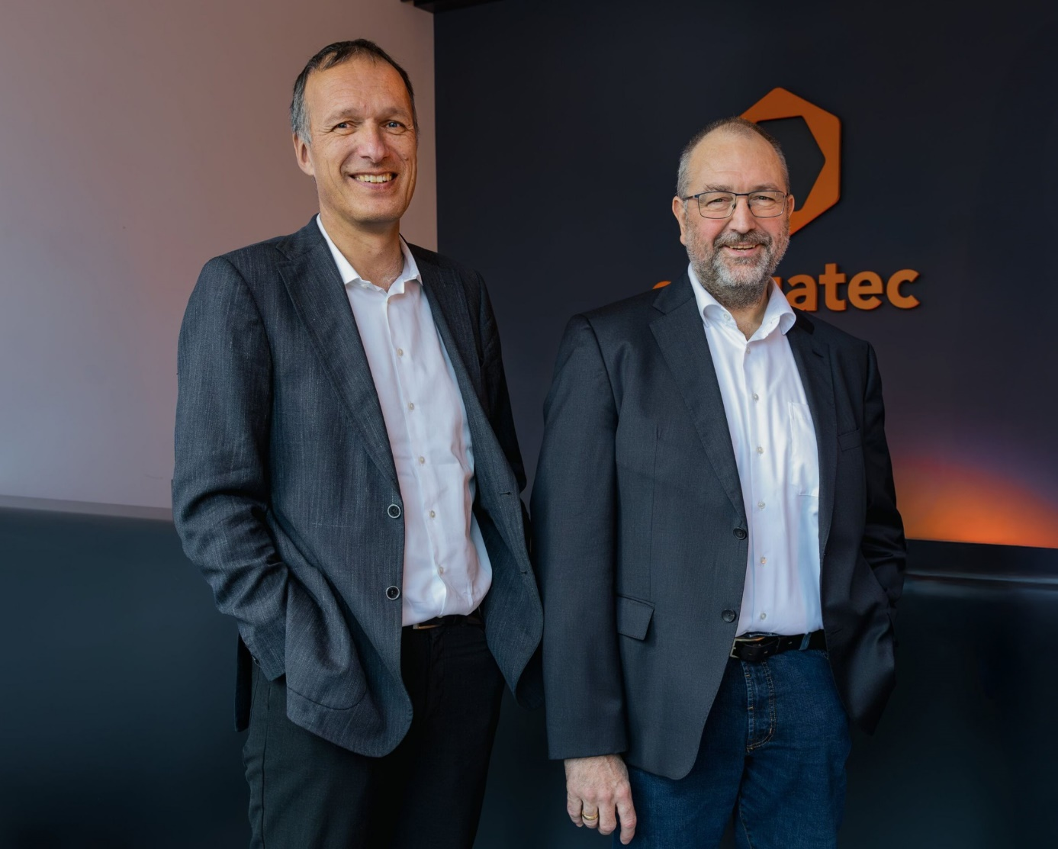

***Dr. Dominik Ressing, CEO of congatec, and Konrad Garhammer, COO and CTO of congatec, are excited to further expand the group's market leadership in Computer-on-Modules.***

**Deggendorf, Germany, 01 July, 2025 \* \* \*** congatec – a leading provider of embedded and edge computing technology – announces an investment in the majority of the module business of Kontron AG. This includes Deggendorf-based JUMPtec GmbH, the pioneer in standardized Computer-on-Modules, Kontron America Modules LLC, and Kontron Asia Embedded Design Sdn. Bhd. With this move, congatec further strengthens its global presence and market leadership in standardized Computer-on-Modules. congatec will seamlessly continue JUMPtec's existing product range and inventory of COM-HPC, COM Express, SMARC and Qseven modules. For JUMPtec customers, all existing business relationships will remain unchanged, ensuring continued, reliable product supply.

**Expanded access to the aReady. portfolio**

congatec will open its aReady. portfolio of application-ready software building blocks to compatible JUMPtec modules. This gives JUMPtec customers direct access to congatec's aReady.VT hypervisor technology and aReady.IOT software. Customers can also opt to have Canonical’s Ubuntu Pro operating system or Bosch Rexroth’s ctrlX OS pre-installed, configured and licensed on their modules. This brings the time-to-market and efficiency benefits of application-ready aReady.COM hardware and software building blocks to an even broader customer base.

**A stronger offering through a stronger partnership**

The transaction also strengthens the already established production and engineering cooperation with Kontron, unlocking new synergies in the development, manufacturing, and deployment of competitive COMs. In addition to JUMPtec's modules, Kontron can now leverage congatec's entire portfolio for its own solution and system offerings. This enables both companies to refine their positioning and intensify their focus on core competencies. The outcome is a more effective partnership that delivers greater value to both companies’ customers.

Konrad Garhammer, CTO and COO of the congatec Group, explains: "By joining forces with JUMPtec, we gain valuable expertise, experienced specialists, and a complementary product portfolio. This enables us to streamline development and accelerate innovation. Module customers worldwide will benefit from this through cutting-edge products, a broader selection, and faster access to new technologies."

Dr. Dominik Ressing, CEO of congatec GmbH, on the strategic significance: "The transaction marks an important milestone in our growth strategy and is the logical next step in our strategic partnership with Kontron. It reinforces our position as a leading provider of embedded and edge computing technologies, while specifically strengthening our portfolio and development capabilities. This puts us in an even better position to deliver innovative, application-ready high-performance ecosystems more quickly – from standalone modules, optimized cooling solutions, and carrier boards to design-in and test services, as well as customized aReady.COM solution platforms. This offers clear advantages to all JUMPtec and congatec customers and provides compelling reasons for those not yet using our COMs to make the switch."

\* \* \*

**About congatec**

congatec is a leading global provider of high-performance hardware and software building blocks for embedded and edge computing solutions based on Computer-on-Modules (COMs). These advanced computer modules drive systems and devices across industries such as industrial automation, medical technology, robotics, telecommunications, and more. congatec's high-performance aReady. ecosystems simplify and accelerate the solution development, from COM to cloud. This application-ready approach combines COMs with services and customizable technologies that enable cutting-edge advancements in system consolidation, IoT, security, and artificial intelligence. Supported by its majority shareholder, DBAG Fund VIII – a German mid-market fund focused on driving growth for industrial enterprises – congatec has the financial backing and M&A expertise to capitalize on expanding market opportunities. For more information, visit [www.congatec.com](http://www.congatec.com/) or follow us on LinkedIn and YouTube.

**Reader enquiries:**

congatec

Phone: +49-991-2700-0

info@congatec.com

[www.congatec.com](http://www.congatec.com)

**Press contact congatec:**

congatec

Christof Wilde

Phone:  +49-991-2700-2822

christof.wilde@congatec.com