# Press release Congatec_Standardlogo_RGB.jpg

congatec presents new SMARC modules on the basis of the NXP i.MX 95 processor series

congatec modules set new benchmarks for secure edge AI applications

**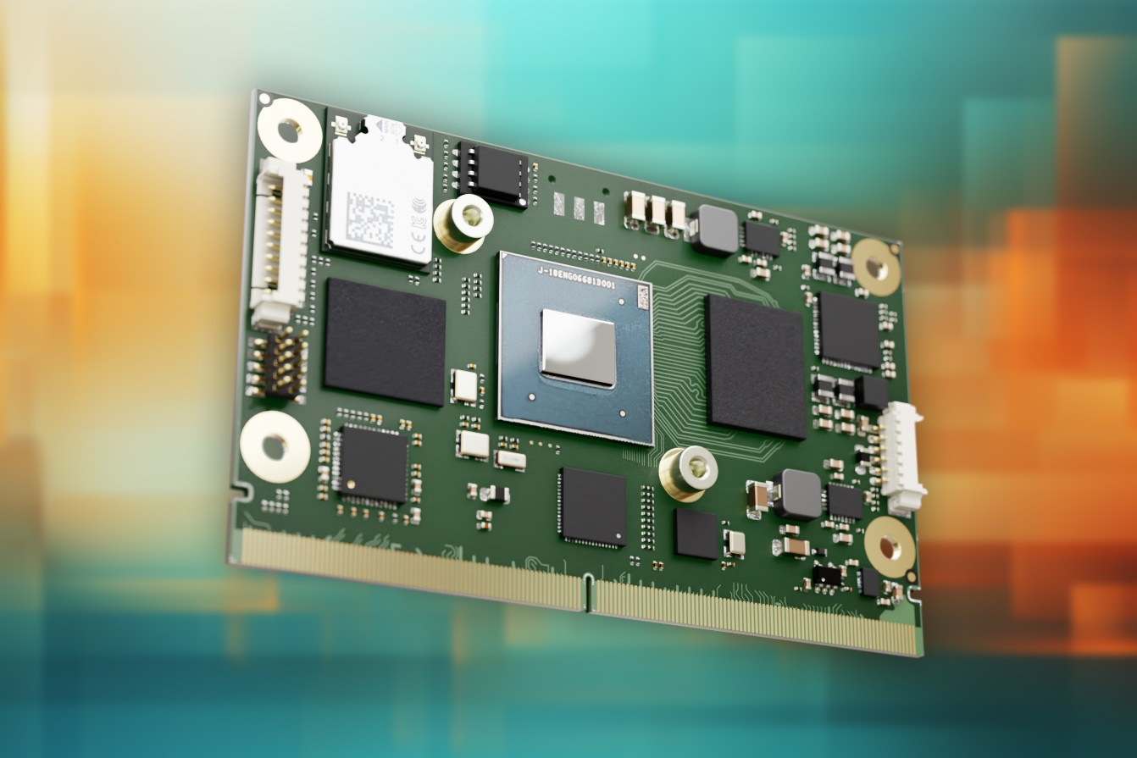**

**Deggendorf, 9 July 2024 \* \* \*** congatec – a leading provider of embedded and edge computing technology – presents new high-performance computer-on-modules (COMs) with i.MX 95 processors from NXP, thereby expanding its extensive module portfolio with low-power NXP i.MX Arm processors. In doing so, congatec underlines its strong partnership with NXP. Customers benefit from straightforward scalability and reliable upgrade paths for existing and new energy-efficient edge AI applications with high security requirements.

In these applications the new modules offer the advantages of up to three times the GFLOPS computing performance compared to the previous generation with i.MX8 M Plus processors. The new neural processing unit from NXP called 'eIQ Neutron' doubles the inference performance for AI accelerated machine vision. In addition, the hardware-integrated EdgeLock® secure enclave simplifies the implementation of in-house cyber security measures.

The new conga-SMX95 SMARC modules are designed for an industrial temperature range of -40°C to +85°C, are robust in mechanical terms and optimised for cost- and energy-efficient applications. The integrated high-performance eIQ Neutron NPU makes it possible for AI accelerated workloads to be performed even closer to the local device level. Specific applications for the new SMARC modules can be found in AI accelerated low-power applications in sectors such as industrial production, machine vision and visual inspection, rugged HMIs, 3D printers, robotics controllers in AMR and AGV, as well as medical imaging and patient monitoring systems. Other target applications include passenger seat back entertainment in buses and aircraft, along with fleet management in transportation, and construction and farming applications.

**The feature set in detail**

The new conga-SMX95 SMARC 2.1 modules are based on the next generation of the NXP i.MX 95 application processors with 4-6 Arm Cortex-A55 cores. NXP is now using the new Arm Mali 3D graphics unit for the first time, which delivers up to three times the GPU performance compared to predecessors based on i. MX8 M Plus. Also new is the image signal processor (ISP) for hardware accelerated image processing. Particularly noteworthy is the NXP eIQ Neutron NPU for hardware accelerated AI inference and machine learning (ML) on-the-edge in the new SMARC modules. The corresponding eIQ® software development environment from NXP offers OEMs a high-performance development environment which simplifies the implementation of in-house ML applications.

In addition, the new SMARC modules integrate a real-time domain for real-time controllers. The conga-SMX95 SMARC modules offer 2x Gbit Ethernet with TSN for synchronised and deterministic network data transmission, LPDDR5 (with inline ECC) for data security. For display connectivity the new modules offer DisplayPort as the standard interface and the still widely used LVDS display interface. For direct camera connectivity the modules have 2x MIPI-CSI.

congatec also offers an extensive hardware and software ecosystem as well as comprehensive design-in-services for simplified and accelerated application development. These include, among other things, evaluation- and production-ready application carrier boards and custom-tailored cooling solutions. In terms of services, congatec offers comprehensive documentation, training and signal integrity measurements for application development.

Further information about the new conga-SMX95 SMARC modules is available at <https://www.congatec.com/de/produkte/smarc/conga-SMX95/>

Further information about the SMARC module standard is available at: <https://www.congatec.com/de/technologien/smarc/>

\* \* \*

**About congatec**

congatec is a rapidly growing technology company focusing on embedded and edge computing products and services. The high-performance computer modules are used in a wide range of applications and devices in industrial automation, medical technology, robotics, telecommunications and many other verticals. Backed by controlling shareholder DBAG Fund VIII, a German midmarket fund focusing on growing industrial businesses, congatec has the financing and M&A experience to take advantage of these expanding market opportunities. congatec is the global market leader in the computer-on-modules segment with an excellent customer base from start-ups to international blue chip companies. More information is available on our website at [www.congatec.com](https://www.congatec.com/) or via [LinkedIn](https://www.linkedin.com/company/congatec/), [X (Twitter)](https://twitter.com/congatecAG) and [YouTube](https://www.youtube.com/user/congatecAE).

**Reader enquiries:**

congatec

Phone: +49-991-2700-0

info@congatec.com

[www.congatec.com](http://www.congatec.com)

**Press contact congatec:**

congatec

Christof Wilde

Phone:  +49-991-2700-2822

christof.wilde@congatec.com

**Press contact agency**:

Publitek GmbH

Julia Wolff

+49 (0)4181 968098-18

[julia.wolff@publitek.com](mailto:julia.wolff@publitek.com)

Bremer Straße 6

21244 Buchholz

**Please send print publications to**:

Publitek GmbH

Diana Penzien

Bremer Straße 6

21244 Buchholz

*Intel, the Intel logo, and other Intel marks are trademarks of Intel Corporation or its subsidiaries.*