Press release

congatec expands its modular edge server ecosystem with a µATX server carrier board and new COM-HPC Server-on-Modules based on the latest Intel Xeon processors

The new µATX server carrier board offers scalability across the entire Intel Ice Lake D processor range and beyond

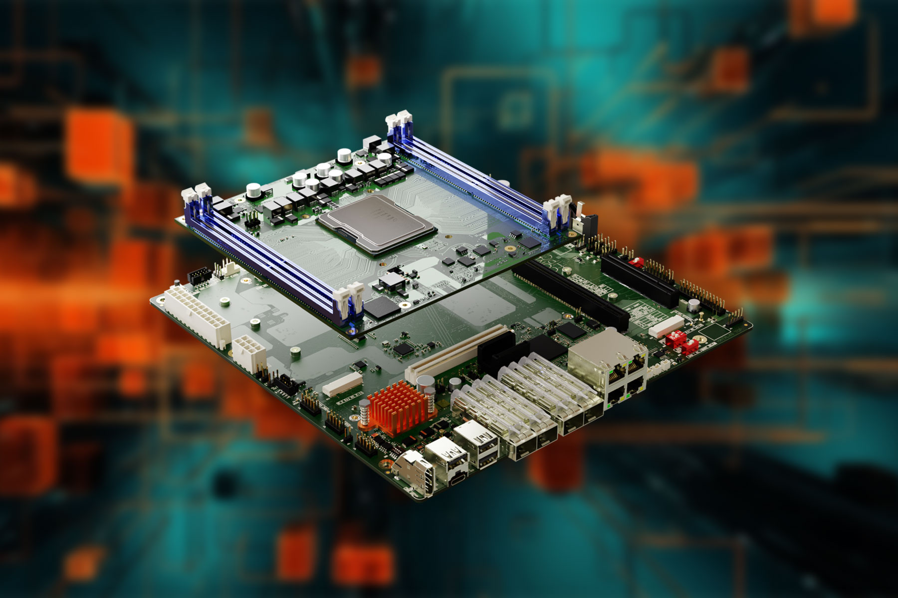

San Diego, CA, March 20, 2024 * * * congatec – a leading provider of embedded and edge computing technologies – has expanded its ecosystem for modular edge servers. New products include a server carrier board in µATX form factor and COM-HPC Server-on-Modules based on the latest Intel Xeon D processors (Ice Lake). The new µATX server board for COM-HPC modules was developed for compact real-time servers that are used in edge applications and critical infrastructures. The board can be flexibly scaled with the latest high-end COM-HPC Server modules from congatec. Together with the updated modules, which are equipped with the latest Intel Xeon D-1800 and D-2800 processors, customers receive a ready-to-use µATX platform for applications with high performance requirements in a space-saving, robust design.
With the new µATX carrier board for COM-HPC Server-on-Modules, congatec underlines its commitment as a supplier of advanced computing solutions for immediate use in demanding industrial applications. The ecosystem of COM-HPC modules and µATX carrier board offers OEMs a wide range of customization options at module, board and system level from which developers can freely choose according to their needs. The ecosystem package is tailored to the stringent requirements of edge computing and offers powerful, reliable and ready-to-use building blocks for industrial environments. The modular approach shortens the time to market for new designs and also makes them future-proof.

The new µATX carrier board conga-HPC/uATX server offers maximum I/O and expansion options in a compact standard form factor. This makes the board an ideal solution for numerous applications, such as consolidating servers for virtual machines (VM) or edge servers for energy microgrids, video processing, facial recognition, security applications, smart city infrastructures and many other applications. The conga-HPC/uATX server offers multiple features to drive such applications, including robust communication options with up to 100 GbE and bandwidth, x8 and x16 PCIe expansion for processing AI-intensive workloads via GPGPUs or other compute accelerators, 2x M.2 Key M slots for NVMe SSDs and a M.2 Key B slot for compact AI accelerators or communication modules for WiFi or LTE/5G.

The new conga-HPC/sILL and conga-HPC/sILH Server-on-Modules take advantage of the latest Intel Ice Lake D-1800 LCC and D-2800 HCC processor series, which offers up to 15% more performance at the same TDP compared to the previous D-1700/D-2700 series 8. The improved performance per watt of the COM-HPC modules is ideal for high-performance applications that were previously limited by their thermal budget. They also benefit from Intel Speed Select technology, which makes it easier to balance the computing performance and maximum TDP of the system design. The latest processors have up to 22 cores with higher clock speeds to support next-generation edge applications with more performance per watt for more energy-efficient and therefore more reliable designs. Scalable edge performance and the modular approach increase the flexibility and future-proofing of designs, reduce total cost of ownership and shorten time to market.

The new COM-HPC server modules impress with their firmware-integrated hypervisor, which makes the evaluation of consolidating servers with virtual machines particularly easy. Also with full real-time capability, which is provided by TCC, TCN and optional SyncE support. This is particularly ideal for all networked 5G solutions that require very low latencies and strict frequency/clock synchronization.

For the new COM-HPC Server-on-Modules based µATX solution platform, congatec also offers various comprehensive cooling solutions, including passive cooling for small chassis. In addition to customizing the conga-HPC/uATX server carrier board, the service package also includes customer-specific BIOS/UEFI and real-time hypervisor implementations as well as expansion with additional IIoT functionalities for digitization purposes.

Further information on the new conga-HPC/uATX server carrier board can be found here and latest Server-on-Modules from congatec can be found here.

You can experience these and other innovations at embedded world from April 9th-11th 2024: https://www.congatec.com/de/congatec/events/congatec-at-embedded-world-2024/
Visit congatec in Hall 3 at Stand 241.

* * *

Please make a note of the press conference on all the latest news about congatec on April 9th from 2 - 2:30pm in the NCC east. An invitation will follow shortly. Please contact us directly if you are interested in joining the press conference and/or a one-to-one meeting at the stand.

About congatec
congatec is a rapidly growing technology company focusing on embedded and edge computing products and services. The high-performance computer modules are used in a wide range of applications and devices in industrial automation, medical technology, robotics, telecommunications and many other verticals. Backed by controlling shareholder DBAG Fund VIII, a German midmarket fund focusing on growing industrial businesses, congatec has the financing and M&A experience to take advantage of these expanding market opportunities. congatec is the global market leader in the computer-on-modules segment with an excellent customer base from start-ups to international blue chip companies. More information is available on our website at www.congatec.com or via LinkedIn, X (Twitter) and YouTube.

Text and photograph available at: https://www.congatec.com/en/congatec/press-releases.html

Intel, the Intel logo, and other Intel marks are trademarks of Intel Corporation or its subsidiaries.

Reader Enquiries:
congatec
Farhad Sharifi
Phone: 858-457-2600
Farhad.Sharifi@congatec.com
www.congatec.us

Press Contact:
congatec
Janene Rae
Phone: 858-457-2600
janene.rae@congatec.com
www.congatec.us

PR Agency:
Publitek GmbH
Julia Wolff
+49 (0)4181 968098-18
julia.wolff@publitek.com
Bremer Straße 6
21244 Buchholz

Please send print publications to:
Publitek GmbH
Diana Penzien
Bremer Straße 6
21244 Buchholz

