Press release

congatec launches new SMARC modules with Intel Core i3 and Intel Atom x7000RE processors (codenamed Amston Lake)

Eight cores unlock advanced virtualization potential

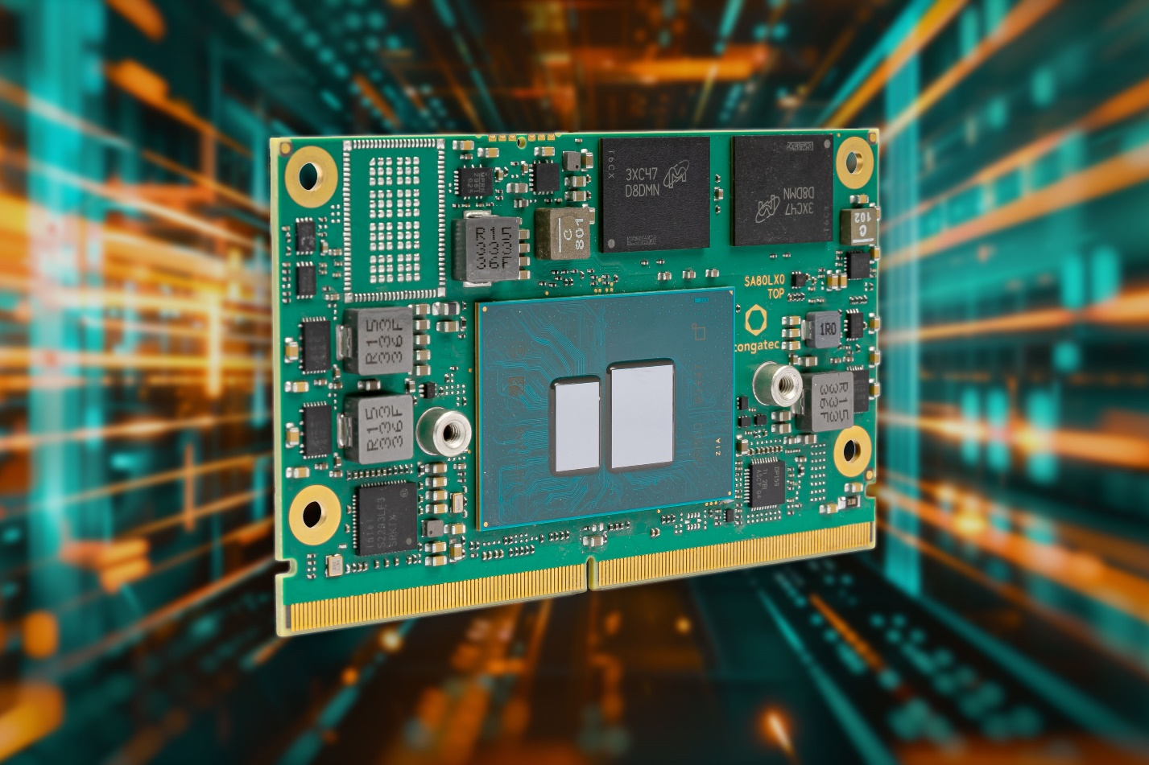

Deggendorf/Nuremberg, Germany, April 9th, 2024 * * * congatec – a leading provider of embedded and edge computing technology – presents new rugged SMARC modules based on the Intel Atom x7000RE processor series (codenamed Amston Lake) and the Intel Core i3 processor. Specially designed for industrial requirements, they deliver eight processor cores –which is double the previous generation – while maintaining the same power consumption. The credit-card-sized conga-SA8 modules therefore set a new performance benchmark for future-facing industrial edge computing and powerful virtualization. With conga-SA8 modules, consolidated edge computing applications in the industrial temperature range of -40°C to +85°C can now also benefit from increased performance and energy efficiency.
New integrated AI capabilities accelerate the processing of deep learning inferences. Such workloads can leverage the optimized Intel AVX2 (Advanced Vector Extensions 2) and Intel VNNI (Vector Neural Network Instructions) instruction sets. As both the CPU and the integrated Intel Gen 12 UHD GPU support INT8 deep learning inference processing, graphics are processed significantly faster and object recognition is even up to 6x faster compared to previous generations. Users benefit from accelerated AI workloads which, when coupled with virtualization, can significantly boost application efficiency and productivity.
The integration of a hypervisor into the firmware makes the modules virtualization-ready and facilitates the consolidation of multiple application-specific workloads. With up to eight cores, a conga-SA8 SMARC module can power a variety of different applications that previously required several dedicated systems. This enables users to create significantly more reliable, cost-effective and sustainable solutions, thereby reducing the total cost of ownership (TCO). Use of the Hypervisor-on-Module is particularly recommended for consolidated systems that must meet real-time and security requirements, including real-time integration via Intel Time Coordinated Computing (Intel TCC) and Time-Sensitive Networking (TSN). The new congatec module fully supports this.
The conga-SA8 is also one of the first SMARC modules to support WiFi 6E. Compared to products with WiFi 5, it delivers almost triple data rates and more stable connectivity in dense/overloaded environments. It also supports TSN over WiFi, enabling deterministic wireless connection with defined throughput. This provides a cost-effective alternative to private 5G networking or new Ethernet cabling.
Other industrial features of the conga-SA8 SMARC modules include in-band ECC for increased data security and soldered DRAM for increased resilience in harsh environments. Typical applications are stationary and mobile control systems for manufacturing and logistics, including AMRs (Autonomous Mobile Robots) and AGVs (Automated Guided Vehicles), and medical technology. Other application areas are rail and transportation as well as machine and robotics solutions for construction, agriculture, and forestry.
The conga-SA8 SMARC module is also available in an application-ready aReady.COM version. Possible application-ready configurations include a pre-installed ctrlX OS from Bosch Rexroth and virtual machines for tasks such as real-time control, HMI, AI, IIoT data exchange, firewall and maintenance/management functions. In addition, a comprehensive ecosystem simplifies application development. This includes design-in services, evaluation and instantly deployable application-ready carrier boards, customized cooling, as well as extensive documentation, training and high-speed signal integrity measurements.
The conga-SA8 SMARC modules from congatec are available with the Intel Core i3-N305 processor and three different Intel Atom processors with up to eight cores, up to 16 GB 4800MT/s LPDDR5 onboard memory, and up to 256 GB eMMC 5.1 onboard flash. The integrated Intel UHD Gen 12 graphics with up to 32 execution units supports up to three independent 4k displays. The range of high-bandwidth interfaces includes 2.5 Gbps Ethernet, USB 3.2 Gen 2, PCIe Gen 3, SATA Gen 3, and various embedded I/Os such as i2C, SPI, UART, and GPIOs. The module further supports the following operating systems: Windows 11 IoT Enterprise, Windows 10 IoT Enterprise 2021 LTSC, and LTS Linux.
The new conga-SA8 SMARC Computer-on-Modules are available in the following versions:
Processor |  | Core/  threads |  | TDP |  | Base frequency |  | Max. turbo |  | GFX exe-cution units |  | Temp. range
Intel Core i3-N305 processor |  | 8/8 |  | 9/15 W |  | 1.0/1.8 Ghz |  | 3.8 GHz |  | 32 EU |  | 0°C to 60°C
Intel Atom x7835RE processor |  | 8/8 |  | 12 W |  | 1.3 GHz |  | 3.6 GHz |  | 32 EU |  | -40°C to 85°C
Intel Atom x7433RE processor |  | 4/4 |  | 9 W |  | 1.5 GHz |  | 3.4 GHz |  | 32 EU |  | -40°C to 85°C
Intel Atom x7425E processor |  | 4/4 |  | 12 W |  | 1.5 GHz |  | 3.4 GHz |  | 24 EU |  | 0°C to 60°C

For further information about the conga-SA8 SMARC Computer-on-Modules, the congatec ecosystem, and the company’s design-in services, please visit https://www.congatec.com/en/products/smarc/conga-sa8/

* * *

About congatec
congatec is a rapidly growing technology company focusing on embedded and edge computing products and services. The high-performance computer modules are used in a wide range of applications and devices in industrial automation, medical technology, robotics, telecommunications and many other verticals. Backed by controlling shareholder DBAG Fund VIII, a German midmarket fund focusing on growing industrial businesses, congatec has the financing and M&A experience to take advantage of these expanding market opportunities. congatec is the global market leader in the computer-on-modules segment with an excellent customer base from start-ups to international blue-chip companies. More information is available on our website at www.congatec.com or via LinkedIn, X (Twitter) and YouTube.

Intel, the Intel logo, and other Intel marks are trademarks of Intel Corporation or its subsidiaries.

Reader enquiries:
congatec
Phone: +49-991-2700-0
info@congatec.com
www.congatec.com

Press contact congatec:
congatec
Christof Wilde
Phone: +49-991-2700-2822
christof.wilde@congatec.com

Press contact agency:
Publitek GmbH
Julia Wolff
+49 (0)4181 968098-18
julia.wolff@publitek.com
Bremer Straße 6
21244 Buchholz
Germany

Please send print publications to:
Publitek GmbH
Diana Penzien
Bremer Straße 6
21244 Buchholz
Germany

