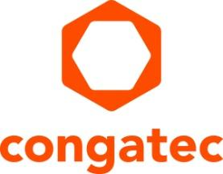
Press release

Smart Factory + Automation World preview: congatec presents application-ready ecosystem for smart automation

Newly integrated IIoT capabilities create added value

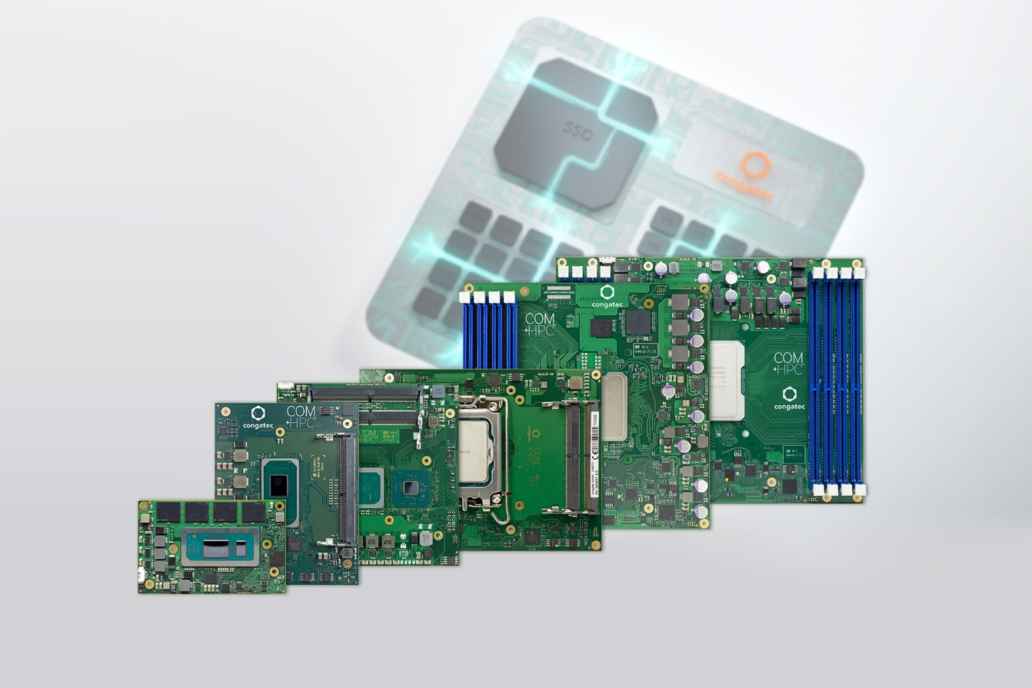
Taipei City, Taiwan, 12 March 2024 * * * congatec – a leading vendor of embedded and edge computing technology – will present its extended range of application-ready building blocks for smart automation at Smart Factory + Automation World 2024 (Booth D243). Premiered modules include Intel Core Ultra processor-based modules with integrated AI capabilities, and virtualization-ready Computer-on-Modules across all performance classes for system consolidation will also be featured. The presentations will focus on increased performance, energy efficiency, and integrated advanced IIoT and security functions, which have not been part of any existing Computer-on-Module (COM) offering before now. These will significantly increase the application readiness of COMs and contribute to the particularly efficient and reliable development of modern, multifunctional, and comprehensively connected embedded and IIoT devices and differentiate congatec's offering from alternative procurement options.

"IIoT presents OEMs with major challenges, which we, as a Computer-on-Modules supplier, are now addressing with a significantly expanded range of functions of our COM-HPC, COM Express, SMARC and Qseven-based modules. For example, module-integrated hypervisor technology and support for Bosch Rexroth’s ctrlX operating system makes it easier for solution providers to enrich their applications, bringing increased functionalities without having to develop or integrate them themselves. We will highlight the added value we offer OEM customers through these newly created functionalities at Smart Factory + Automation World," explains Yoonsun Kim, Korea Country Manager

Embedded systems from OEMs must cover significantly more functionalities to meet all digitalization and IIoT connectivity requirements. congatec addresses these high demands on OEM solutions with its in-house hypervisor technologies and edge IoT functionalities, among other things. The advantages of the seamless integration of this range of solutions into the extended feature set of Computer-on-Modules will be presented by congatec for the first time at Smart Factory + Automation World.

The expanded IIoT functionality and OS implementation for Computer-on-Modules are the logical consequence of the company's value-added strategy: As one of the world's leading embedded and edge computing brands in the field of Computer-on-Modules, congatec is ultimately a pioneer when it comes to extended functions and services for the most simplified integration of COM Express, COM-HPC, SMARC and Qseven-based modules. Its high-performance ecosystem offers sophisticated cooling solutions optimized for the individual modules, carrier boards for easy evaluation and application design as well as accompanying software support and individual integration services. Moreover, congatec’s testing and design services save OEMs additional time and work. All this makes the integration of modules easier and more efficient and offers engineers a high level of design security. Customers benefit from faster time-to-market and can therefore master the ever-shorter innovation cycles in the best possible way.

In addition to covering all functional areas from processors to form factor, congatec modules offer OEMs comprehensive efficiency and convenience. The newly integrated virtualization, digitalization and security functions set a new benchmark in terms of the range of capabilities of application-ready Computer-on-Modules, especially for real-time IIoT applications.

Further information on the new presentations can be found on congatec's landing page for Smart Factory + Automation World, which will be updated on a regular basis:
https://www.congatec.com/en/congatec/events/smart-factory-automation-world/

* * *
About congatec
congatec is a rapidly growing technology company focusing on embedded and edge computing products and services. The high-performance computer modules are used in a wide range of applications and devices in industrial automation, medical technology, robotics, telecommunications and many other verticals. Backed by controlling shareholder DBAG Fund VIII, a German midmarket fund focusing on growing industrial businesses, congatec has the financing and M&A experience to take advantage of these expanding market opportunities. congatec is the global market leader in the Computer-on-Modules segment with an excellent customer base from start-ups to international blue chip companies. More information is available on our website at www.congatec.com or via LinkedIn, X (Twitter) and YouTube.

Reader enquiries:
congatec
Crysta Lee
Phone: +886 2 25978577
info@congatec.com
www.congatec.com

Press contact agency:
Publitek GmbH
Julia Wolff
+49 (0)4181 968098-18
julia.wolff@publitek.com
Bremer Straße 6
21244 Buchholz
Germany

Please send print publications to:
Publitek GmbH
Diana Penzien
Bremer Straße 6
21244 Buchholz
Germany
Intel, the Intel logo, and other Intel marks are trademarks of Intel Corporation or its subsidiaries.

