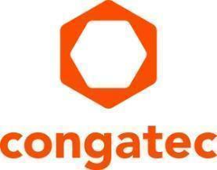
Press release

The new plug & play bundles simplify the setup of virtualized real-time IIoT platforms

congatec simplifies system consolidation by integrating the Hypervisor on its x86 Computer-on-Modules

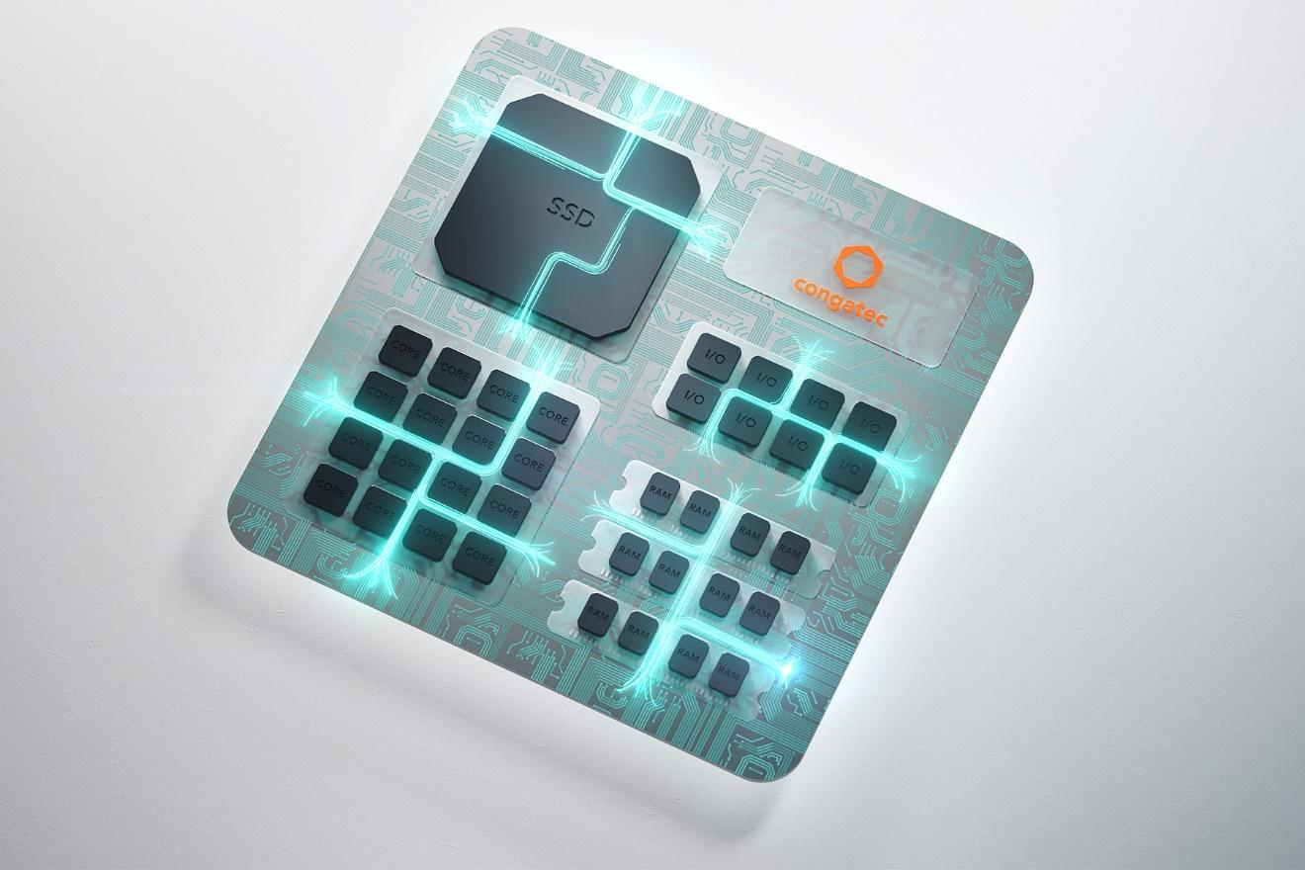

Deggendorf, Germany, January 30, 2024 * * * congatec – a leading vendor of embedded and edge computing technology – is now including the Hypervisor in all of its new x86 COMs. The Hypervisor is available as an easy addition to congatec’s x86-based Computers-on-Modules (COMs). Now the Hypervisor will be implemented in firmware and will be standard on all congatec x86 COMs, automatically lowering the barrier to start working on system consolidation. By simplifying real-time virtualization for system consolidation, congatec is making it easy to save costs; reduce system count; and reduce size, weight, and power consumption (SWaP).

“Consolidation will become significantly easier with the hypervisor directly included. The ability to simultaneously run multiple operating systems, including real-time operating systems, and have them all run at maximum efficiency, will be a major differentiator for our customers,” said Andreas Bergbauer, Manager Solution Management at congatec. “Our modules will be more application-ready than any competing solution, OEMs will be able to reduce their NRE, and they will get to market faster. It has never been easier to leverage the benefits of system consolidation as with our Hypervisor-on-Module.”

By optimizing the allocation of OSs (and applications) across multiple cores, more functionalities can be offered reducing system count to one. Moreover, the system resources of multicore designs can be fully used increasing efficiency, and reducing energy consumption. This in turn allows OEMs to build more functionality and efficiently in a single consolidated system. Costs are saved by reducing the amount of required hardware, cabling, and by minimizing system size, weight, and power consumption (SWaP). This enables OEMs to even consolidate real-time and non-real-time critical applications in parallel on a single x86 Computer-on-Module.

The Hypervisor enables developers to run multiple operating systems (OS) simultaneously on one single COM. Every OS is assigned to run on its own core or set of cores and I/Os (such as PCIe, Ethernet, USB), so that each OS can run entirely independently from each other. Booting or suspending the operation of any OS will have no effect on any other. With the Hypervisor, customers get a software and hardware package already qualified to support real-time applications, as the real-time behavior of the modules has already been verified.

As an optional add-on, the Hypervisor also supports nested virtualization with container and virtual machine (VM) support. Nested virtualization is a technique where a VM runs on top of another hypervisor, rather than on physical hardware, affording full virtualization freedom. Individual workloads can be decoupled from each other to increase reliability, for example, or containers (or other virtualization solutions) could be run within a VM.

When functions are separated among virtual machines, the collaboration between these virtual machines remains highly flexible.

Operating systems supported by Hypervisor out of the box:
- Microsoft Windows 10 and 11
- Debian
- Ubuntu
- VxWorks
- Xenomai
- TenAsys Intime distributed RTOS
- QNX Neutrino
- Real-Time Linux

Support for other operating systems can be added anytime upon request. Different operating systems may run in different execution modes at the same time and any mix of SMP and single-CPU, 32-bit and 64-bit is possible.

For more information on the Hypervisor Technology from congatec, please visit: https://www.congatec.com/en/technologies/real-time-hypervisor/

You can experience these and other innovations at embedded world from 9-11 April 2024: https://www.congatec.com/de/congatec/events/congatec-at-embedded-world-2024/
Visit congatec in Hall 3 at Stand 241.

* * *

About congatec
congatec is a rapidly growing technology company focusing on embedded and edge computing products and services. The high-performance computer modules are used in a wide range of applications and devices in industrial automation, medical technology, robotics, telecommunications and many other verticals. Backed by controlling shareholder DBAG Fund VIII, a German midmarket fund focusing on growing industrial businesses, congatec has the financing and M&A experience to take advantage of these expanding market opportunities. congatec is the global market leader in the computer-on-modules segment with an excellent customer base from start-ups to international blue chip companies. More information is available on our website at www.congatec.com or via LinkedIn, X (Twitter) and YouTube.

Intel, the Intel logo, and other Intel marks are trademarks of Intel Corporation or its subsidiaries.

Reader enquiries:
congatec
Phone: +49-991-2700-0
info@congatec.com
www.congatec.com

Press contact congatec:
congatec
Christof Wilde
Phone: +49-991-2700-2822
christof.wilde@congatec.com

Press contact agency:
Publitek GmbH
Julia Wolff
+49 (0)4181 968098-18
julia.wolff@publitek.com
Bremer Straße 6
21244 Buchholz

Please send print publications to:
Publitek GmbH
Diana Penzien
Bremer Straße 6
21244 Buchholz

