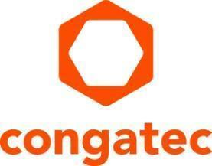
Press release

congatec adopts Bosch Rexroth’s ctrlX OS operating system

congatec enhances its Computer-on-Modules portfolio with ctrlX OS support

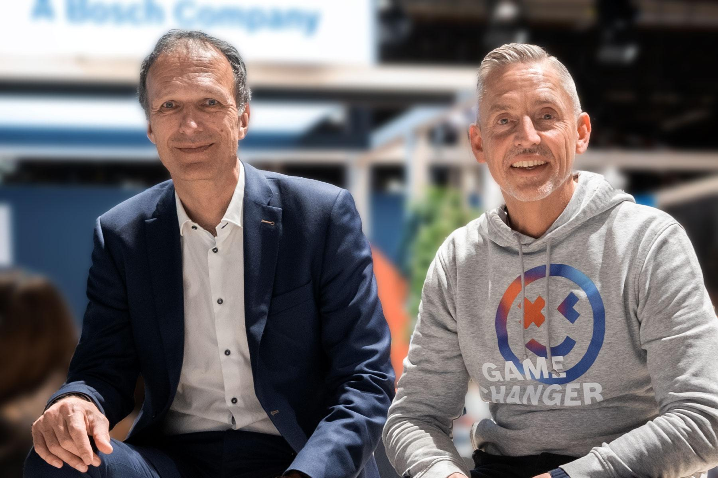
Dominik Reßing (left), CEO at congatec and Steffen Winkler (right), Sales Manager Business Unit Automation & Electrification Solutions at Bosch Rexroth

Deggendorf, Germany, February 29, 2024 * * * Bosch Rexroth has opened up the Linux-based ctrlX OS operating system for embedded computer applications from congatec. With this move, congatec’s embedded and edge computing offerings will become part of the consistently open ecosystem surrounding the ctrlX OS operating system, enabling the development of modular, scalable solutions that are highly sustainable and agile. Users benefit from integrated hardware and software solutions for their OT (Operational Technology), with use cases ranging from embedded and edge devices all the way to edge clouds (also known as fogs). The key target markets for ctrlX OS in the embedded computing segment include automation, robotics, medical technology, as well as energy/smart grids and in-vehicle applications.

congatec’s decision to adopt ctrlX OS will give the embedded computing market access to the entire solution portfolio of the ctrlX Store with its numerous apps. The apps from Bosch Rexroth and other third-party providers in the ctrlX World partner network follow an open, modular approach. This extends from the modules all the way to the end application and cloud integration. Combined building blocks at the hardware and software levels simplify the development of even complex embedded applications, including edge and cloud integration. This shortens time-to-market while providing a high level of design security.

“With this cooperation, we are taking another step towards comprehensively integrated and application-ready solutions for use cases ranging from connecting sensors and actuators in the field to the cloud. In Bosch Rexroth, we have found a strong international partner that provides very comprehensive and application-oriented software support for the modular and open design approach of our secure embedded building blocks. This makes our modular, scalable solution offering for networked and cloud-integrated applications even more attractive,” explains congatec CEO Dominik Reßing.

“Industry’s digitization and sustainability goals can best be achieved with open, modular, and demand-oriented scalable solution platforms. With congatec, we have gained another partner company that stands for and embodies these values. Based on manufacturer-independent standards, we can now support any configuration of ctrlX OS-based embedded computing platforms, making ctrlX OS universally applicable and scalable on demand,” explains Steffen Winkler, Head of Sales Business Unit Automation & Electrification Solutions at Bosch Rexroth.

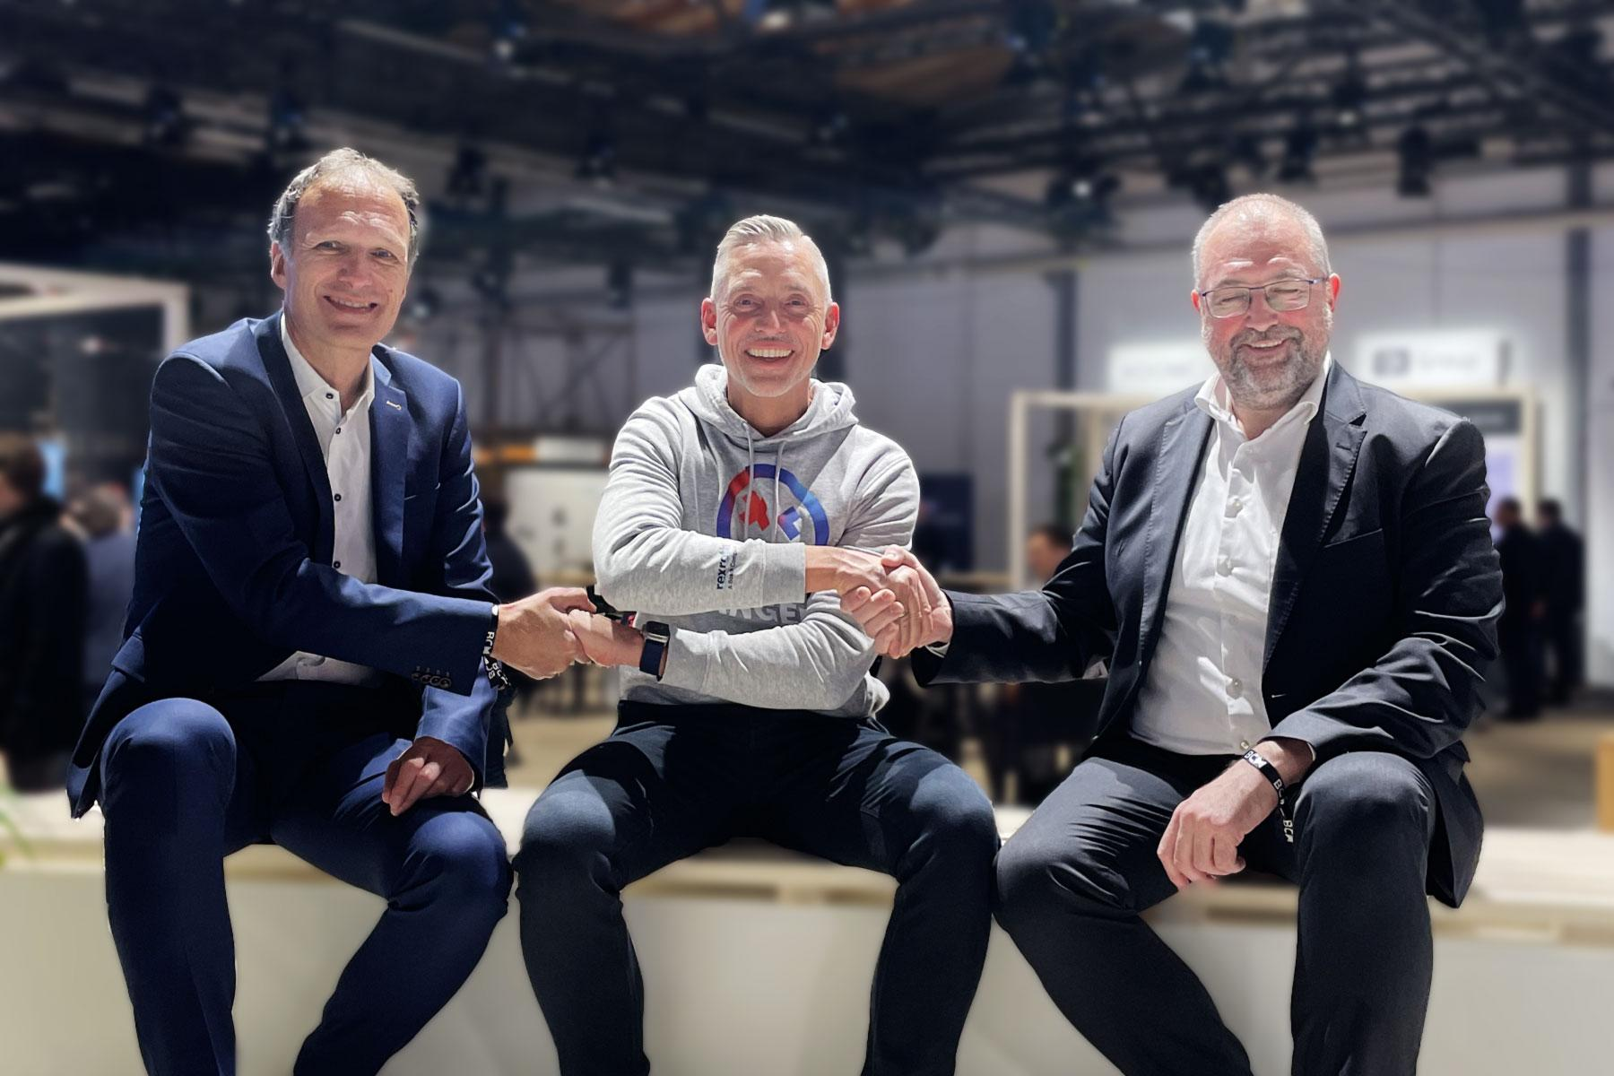
Handshake between (from left to right) Dominik Ressing (CEO at congatec), Steffen Winkler (Sales Manager Business Unit Automation & Electrification Solutions at Bosch Rexroth) and Konrad Garhammer (CTO and COO at congatec)

Application-ready COMs create added value
At congatec, developers can purchase Computer-on-Modules that come directly equipped with ctrlX OS licenses. With ctrlX OS, congatec customers gain access to the ctrlX Store with its currently around 60 apps. In addition to the Linux-based real-time operating system, ctrlX OS also offers developers superior support and root-of-trust from a German company. Furthermore, numerous apps, services and software development kits (SDKs) are just a click away. The ctrlX Store offers a wide range of solutions, for example for PLC applications, motion control and communication, as well as engineering tools. Developers also have access to a variety of IoT and cloud apps, including basic features like firewalls and VPN clients.

Interested parties can find all the apps in the ecosystem in the ctrlX Store.

About Bosch Rexroth
As one of the world’s leading suppliers of drive and control technologies, Bosch Rexroth ensures efficient, powerful and safe movement in machines and systems of any size. The company bundles global application experience in the market segments of Mobile and Industrial Applications as well as Factory Automation. With its intelligent components, customized system solutions, engineering and services, Bosch Rexroth is creating the necessary environment for fully connected applications. Bosch Rexroth offers its customers hydraulics, electric drive and control technology, gear technology and linear motion and assembly technology, including software and interfaces to the Internet of Things. With locations in over 80 countries, more than 32,000 associates generated sales revenue of around 7.0 billion euros in 2022.
To learn more, please visit www.boschrexroth.com
About congatec
congatec is a rapidly growing technology company focusing on embedded and edge computing products and services. The high-performance computer modules are used in a wide range of applications and devices in industrial automation, medical technology, robotics, telecommunications and many other verticals. Backed by controlling shareholder DBAG Fund VIII, a German midmarket fund focusing on growing industrial businesses, congatec has the financing and M&A experience to take advantage of these expanding market opportunities. congatec is the global market leader in the computer-on-modules segment with an excellent customer base from start-ups to international blue chip companies. More information is available on our website at www.congatec.com or via LinkedIn, X (Twitter) and YouTube.

Intel, the Intel logo, and other Intel marks are trademarks of Intel Corporation or its subsidiaries.

Reader enquiries:
congatec
Phone: +49-991-2700-0
info@congatec.com
www.congatec.com

Press contact congatec:
congatec
Christof Wilde
Phone: +49-991-2700-2822
christof.wilde@congatec.com

Press contact agency:
Publitek GmbH
Julia Wolff
+49 (0)4181 968098-18
julia.wolff@publitek.com
Bremer Straße 6
21244 Buchholz

Please send print publications to:
Publitek GmbH
Diana Penzien
Bremer Straße 6
21244 Buchholz

