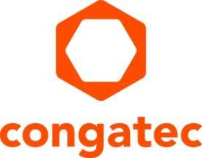
Press release

congatec COM Express modules receive IEC-60068 railway certification

Proven shock and vibration resistant for harsh environments
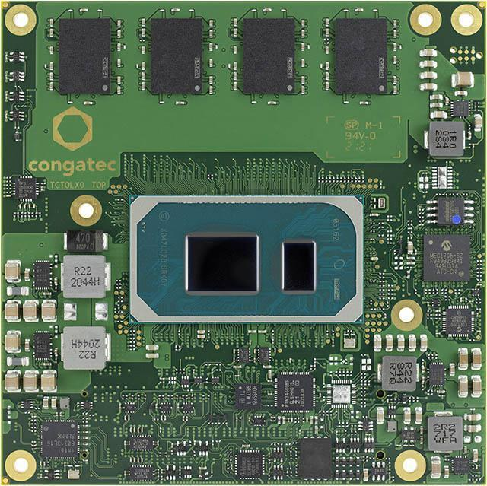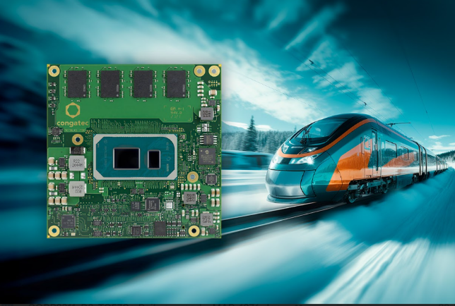

Deggendorf, Germany, 7. September 2023 * * * congatec — a leading vendor of embedded and edge computing technology, announced today that its conga-TC570r COM Express Type 6 Compact modules, based on the 11th Generation Intel® Core™ processor family (code name "Tiger Lake"), have received IEC-60068 certification. This certification qualifies these modules for operation in railway applications, confirming that they meet the requirements for extreme conditions such as extended temperatures, rapid temperature changes, shocks, and vibrations. Customers benefit from an application-ready building block with proven ruggedness for various mission critical applications.

The IEC-60068 certified conga-TC570r module suits various new railway applications, including Train Control and Management Systems (TCMS), predictive maintenance, passenger information systems, video surveillance and analytics, ticketing and fare collection, and fleet management and optimization. Additionally, they are an ideal fit for all applications beyond railway and transportation that are exposed to extreme conditions including automation, autonomous guided vehicles (AGV), autonomous mobile robots (AMR). These applications require advanced embedded computing capabilities provided by Intel's 11th Gen Core processor technology, which the module offers in an industry-compliant design certified to meet all required IEC-60068 specifications.

The certifications in detail
The conga-TC570r module has undergone rigorous testing and certification against various IEC-60068 standards. It is certified for reliable operation under extended temperatures ranging from -40 °C to +85 °C, including change of temperature (IEC-60068-2-14 Nb) and rapid change of temperature (IEC-60068-2-14 Na). It also provides shock and vibration resistance on the basis of DIN EN 61373 April 2011 category 2 (railway applications). The module is further protected against severe environmental conditions, such as high humidity, in accordance with IEC-60721-3-7 class 7K3, 7M2. Optional features include conformal coatings to enhance resistance to liquids and moisture further.

The ultra-rugged COM Express Compact Type 6 11th Gen Intel Core modules with soldered RAM and In-Band ECC (IBECC) are available in the following standard configurations, with customization options available upon request:

 | Processor |  | Cores/  Threads |  | Frequency at 28/15/12W TDP,  (Max Turbo) [GHz] |  | Cache [MB] | Graphics [Execution Units]
 | Intel® Core™ i7-1185GRE |  | 4/8 |  | 2.8/1.8/1.2 (4.4) |  | 12 | 96 EU
 | Intel® Core™ i5-1145GRE |  | 4/8 |  | 2.6/1.5/1.1 (4.1) |  | 8 | 80 EU
 | Intel® Core™ i3-1115GRE |  | 2/4 |  | 3.0/2.2/1.7 (3.9) |  | 6 | 48 EU

congatec offers also corresponding carrier boards and comprehensive cooling solutions for its IEC-60068 certified COM Express module, allowing for fast application design. The unique heat-pipe based passive cooling solutions provided by congatec ensure optimized heat dissipation and ruggedness, thanks to the fanless design, which extends the module's lifetime and reliability. Additionally, congatec's design-in and compliance measurement services for PCIe Gen4/5 and USB4 simplify and accelerate application design, improving design security and reducing time-to-market.

Further information on the new conga-TC570r COM Express Compact modules can be found here: www.congatec.com/en/products/com-express-type-6/conga-tc570r/

More information on additional 11th Generation Intel® Core™ processors solutions from congatec can be found on the main landing page: https://congatec.com/11th-gen-intel-core/
* * *
About congatec
congatec is a rapidly growing technology company focusing on embedded and edge computing products and services. The high-performance computer modules are used in a wide range of applications and devices in industrial automation, medical technology, robotics, telecommunications and many other verticals. Backed by controlling shareholder DBAG Fund VIII, a German midmarket fund focusing on growing industrial businesses, congatec has the financing and M&A experience to take advantage of these expanding market opportunities. congatec is the global market leader in the computer-on-modules segment with an excellent customer base from start-ups to international blue chip companies. More information is available on our website at www.congatec.com or via LinkedIn, Twitter and YouTube.

Reader enquiries:
congatec
Phone: +49-991-2700-0
info@congatec.com
www.congatec.com

Press contact congatec:
congatec
Christof Wilde
Phone: +49-991-2700-2822
christof.wilde@congatec.com

Press contact agency:
Publitek GmbH
Julia Wolff
+49 (0)4181 968098-18
julia.wolff@publitek.com
Bremer Straße 6
21244 Buchholz

Please send print publications to:
Publitek GmbH
Diana Penzien
Bremer Straße 6
21244 Buchholz

Intel, the Intel logo, and other Intel marks are trademarks of Intel Corporation or its subsidiaries.

