Press release

congatec introduces new Computer-on-Modules with 13th Gen Intel Core processors

Happy new year for high-end embedded computers: The world’s fastest Client Computer-on-Modules generation is here

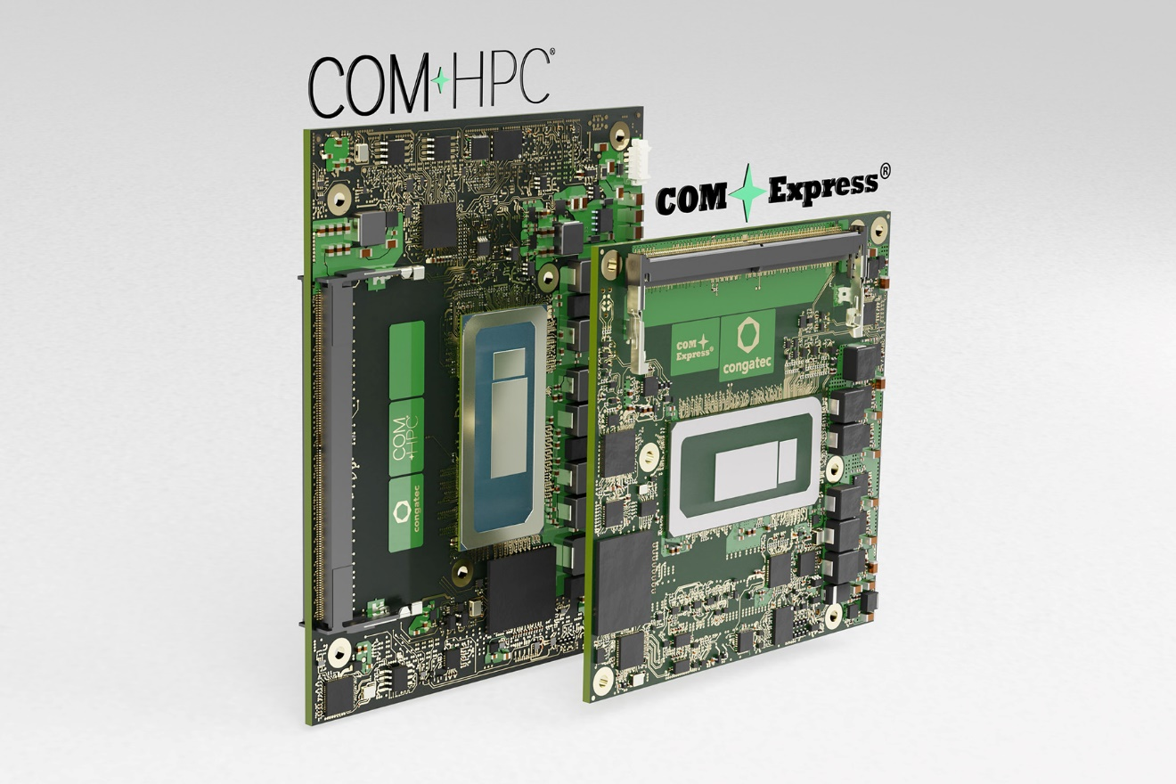

Deggendorf, Germany, 3 January 2023 * * * congatec – a leading vendor of embedded and edge computing technology – announces the availability of COM-HPC and COM Express Computer-on-Modules based on high-end 13th Gen Intel Core processors in BGA assembly. congatec expects series production of OEM designs based on these new modules to ramp up quickly and massively as the new processors with long life availability offer vast improvements in many features yet are fully hardware compatible to the predecessors, which makes implementation very fast and easy. With Thunderbolt and enhanced PCIe support up to Gen5, the modules based on the new COM-HPC standard open up new horizons for developers in terms of data throughput, I/O bandwidth and performance density. The COM Express 3.1 compliant modules primarily help to secure investments in existing OEM designs, which includes upgrade options for more data throughput thanks to PCIe Gen4 support.

The new COM-HPC and COM Express Computer-on-Modules provide up to 8% single thread and up to 5% multithread^{[1]} performance gains from the soldered 13th Gen Intel Core processors compared to 12th Gen Intel Core processors. The performance gains go hand in hand with a distinctly higher power efficiency due to an enhanced manufacturing process. Also new in this performance class (15-45 W Base Power) are DDR5 memory support and PCIe Gen5 connectivity on selected SKUs. Both contribute to even better multithread performance and data throughput. With up to 80 EU and ultra-fast encode and decode capabilities, the integrated Intel Iris Xe graphics architecture is ideally suited for enhanced graphics demands such as those found in video streaming and video data based situational awareness applications. All these features effect significant improvements in a wide range of industrial, medical, artificial intelligence (AI) and machine learning (ML) applications, as well as all types of embedded and edge computing with workload consolidation.
“The numerous improvements of the 13th Gen Intel Core processors help to make these new generations of Computer-on-Modules really outstanding. They give industry the opportunity to instantly upgrade already existing high-end embedded and edge computing solutions, which is what makes this new launch so extraordinarily significant for all our OEM customers and Value Adding Reseller partners,” explains Jürgen Jungbauer, Senior Product Line Manager at congatec.
The new conga-HPC/cRLP Computer-on-Module in COM-HPC Size A form factor and the compact conga-TC675 module based on the new COM Express 3.1 specification will become available in the below variants:
Processor |  | Cores/  (P + E) |  | Max. Turbo Freq. [GHz]  P-cores / E-cores |  | Base Freq. [GHz]  P-cores / E-cores |  | Threads |  | GPU Execution Units |  | CPU Base Power [W]
Intel Core i5-1340PE |  | 12 (4+8) |  | 4.5 /3.3 |  | 1.8 / 1.3 |  | 16 |  | 80 |  | 28
Intel Core i5-1335UE |  | 10 (2+8) |  | 4.5 / 3.3 |  | 1.3 / 1.1 |  | 12 |  | 80 |  | 15
Intel Core i3-13300HE |  | 8 (4+4) |  | 4.6 / 3.4 |  | 2.1 / 1.5 |  | 12 |  | 48 |  | 45
Intel Core i3-1320PE |  | 8 (4+4) |  | 4.5 / 3.3 |  | 1.7 / 1.2 |  | 12 |  | 48 |  | 28
Intel Core i3-1315UE |  | 6 (2+4) |  | 4.5 / 3.3 |  | 1.2 / 0.9 |  | 8 |  | 64 |  | 15
Intel Pentium U300E |  | 5 (1+4) |  | 4.3 / 3.2 |  | 1.1 / 0.9 |  | 6 |  | 48 |  | 15

Application engineers can deploy the new COM-HPC Computer-on-Modules on congatec’s Micro-ATX Application Carrier Board conga-HPC/uATX for COM-HPC Client type modules to instantly capitalize on all the benefits and improvements of these new modules in combination with ultra-fast PCIe Gen5 connectivity.
For more information on the new Computer-on-Modules in COM-HPC Size A and COM Express 3.1 form factors, their tailored cooling solutions, and congatec’s migration services, please visit congatec’s landing page for 13th Gen Intel Core processor based embedded and edge computing solutions:
https://www.congatec.com/en/technologies/13th-gen-intel-core-computer-on-modules/

The datasheet of the new conga-HPC/cRLP Computer-on-Module in COM-HPC Size A is ready for download at https://www.congatec.com/en/products/com-hpc/conga-hpccrlp/

The datasheet of the new conga-TC675 Computer-on-Module in COM Express Compact Type 6 can be found at https://www.congatec.com/en/products/com-express-type-6/conga-tc675/
* * *
About congatec
congatec is a rapidly growing technology company focusing on embedded and edge computing products and services. The high-performance computer modules are used in a wide range of applications and devices in industrial automation, medical technology, transportation, telecommunications and many other verticals. Backed by controlling shareholder DBAG Fund VIII, a German midmarket fund focusing on growing industrial businesses, congatec has the financing and M&A experience to take advantage of these expanding market opportunities. congatec is the global market leader in the computer-on-modules segment with an excellent customer base from start-ups to international blue chip companies. More information is available on our website at www.congatec.com or via LinkedIn, Twitter and YouTube.

[1] Estimated results comparing Intel Core i7-13800HE to previous-generation Intel Core i7-12800HE processor are based on SPECrate2017_int_base (1-copy and n-copy) using InteI Compiler version 2021.2. Intel Configurations:
Performance results are based on Intel estimates as of November 2022.
Processor: Intel Core i7-13800HE PL1=45W, (6C+8c) 14C20T Turbo up to5.2 GHz; Intel Iris Xe graphics architecture with up to 96 EUs, DDR5-5200 2x32GB memory; Samsung* PM9A1(CPU attached) OS: Windows* 11
Performance results are based on Intel measurements as of November 2022.
Processor: Intel Core i7-12800HE PL1=45W, (6C+8c) 14C20T Turbo up to 4.6 GHz, Intel Iris Xe graphics architecture with up to 96 EUs, DDR5-4800 32GB memory, Samsung SSD 970 EVO Plus 1TB; Platform/ motherboard: Intel Corporation AlderLake-P DDR5 RVP, Windows 10 Enterprise LTSC 21H2 Bios: ADLPFWI1.R00.2504.B00.2112100444 12/10/2021
CPUzMicrocode: 413h

Intel, the Intel logo, and other Intel marks are trademarks of Intel Corporation or its subsidiaries.

Reader enquiries:
congatec
Phone: +49-991-2700-0
info@congatec.com
www.congatec.com

Press contact congatec:
congatec
Christof Wilde
Phone: +49-991-2700-2822
christof.wilde@congatec.com

Press contact PR agency:
SAMS Network
Michael Hennen
Phone: +49-2405-4526720
congatec@sams-network.com
www.sams-network.com

Please send print publications to:
SAMS Network
Sales And Management Services
Zechenstraße 29
52146 Würselen
Germany

Links to digital publications to:
office@sams-network.com

