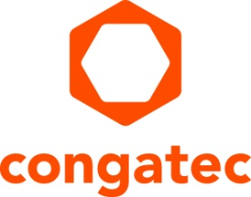

Personalia

Gerhard Edi, Managing Director and Chief Strategy Officer, will leave the Management Board of the congatec group with immediate effect

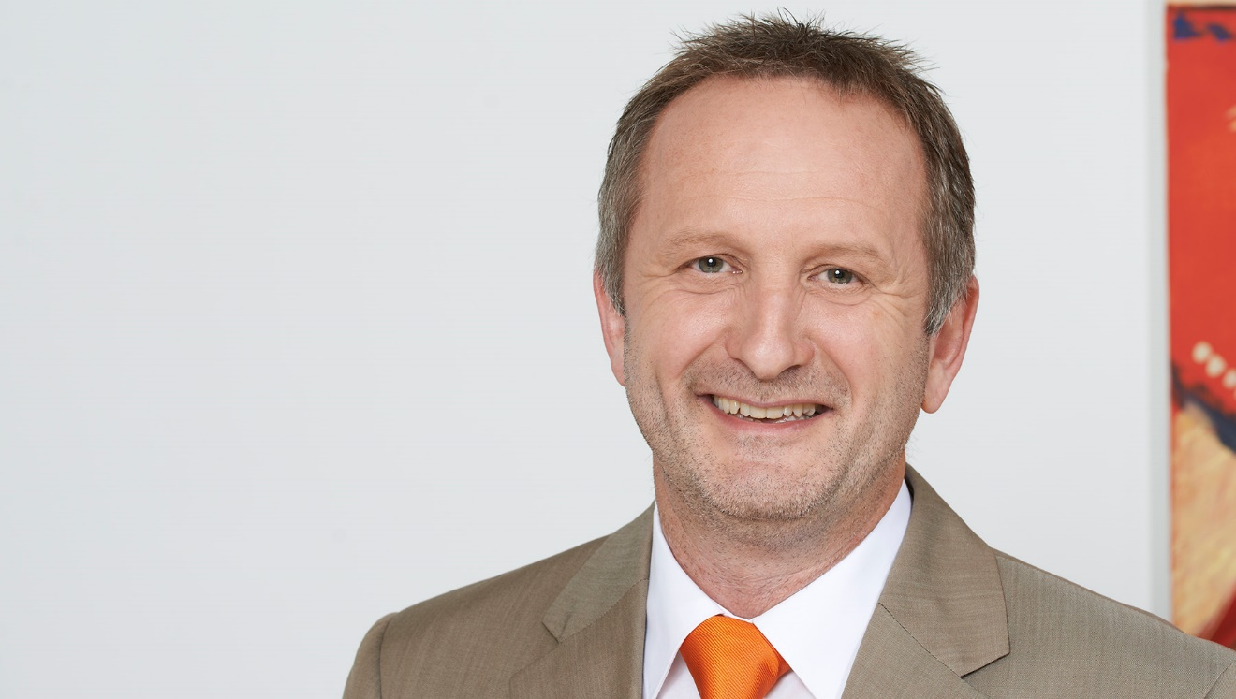
Deggendorf, Germany, 3 February, 2023 * * * We would like to inform you that Mr. Gerhard Edi, Managing Director and Chief Strategy Officer, is leaving the Management Board of the congatec group with immediate effect.

Mr. Edi is leaving the Management Board for personal reasons on the best of terms with the Shareholders, Advisory Board and Management Board. He will remain closely associated with the company, supporting the Management Board in strategic tasks and remaining as Shareholder of the congatec group.

As one of the founders of congatec, Mr. Edi has played a decisive role in shaping the company from the very beginning. His significant influence on the definition and development of the Computer-on-Module business and its standardization was a determining factor for congatec’s success and the company assuming its leading position in the global COM market.

The Shareholders, Advisory Board and Management Board deeply regret Mr. Edi’s departure from the Management Board of the congatec group and wish him all the best for the future, also on behalf of the entire congatec staff.

* * *
About congatec
congatec is a rapidly growing technology company focusing on embedded and edge computing products and services. The high-performance computer modules are used in a wide range of applications and devices in industrial automation, medical technology, transportation, telecommunications and many other verticals. Backed by controlling shareholder DBAG Fund VIII, a German midmarket fund focusing on growing industrial businesses, congatec has the financing and M&A experience to take advantage of these expanding market opportunities. congatec is the global market leader in the computer-on-modules segment with an excellent customer base from start-ups to international blue chip companies. More information is available on our website at www.congatec.com or via LinkedIn, Twitter and YouTube.

Reader enquiries:
congatec
Phone: +49-991-2700-0
info@congatec.com
www.congatec.com

Press contact congatec:
congatec
Christof Wilde
Phone: +49-991-2700-2822
christof.wilde@congatec.com

Press contact PR agency:
SAMS Network
Michael Hennen
Phone: +49-2405-4526720
congatec@sams-network.com
www.sams-network.com

Please send print publications to:
SAMS Network
Sales And Management Services
Zechenstraße 29
52146 Würselen
Germany

Links to digital publications to:
office@sams-network.com

