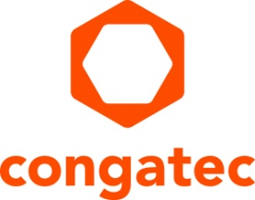
Press release

congatec showcases high-performance computing ecosystems for the edge

Digitizing the edge
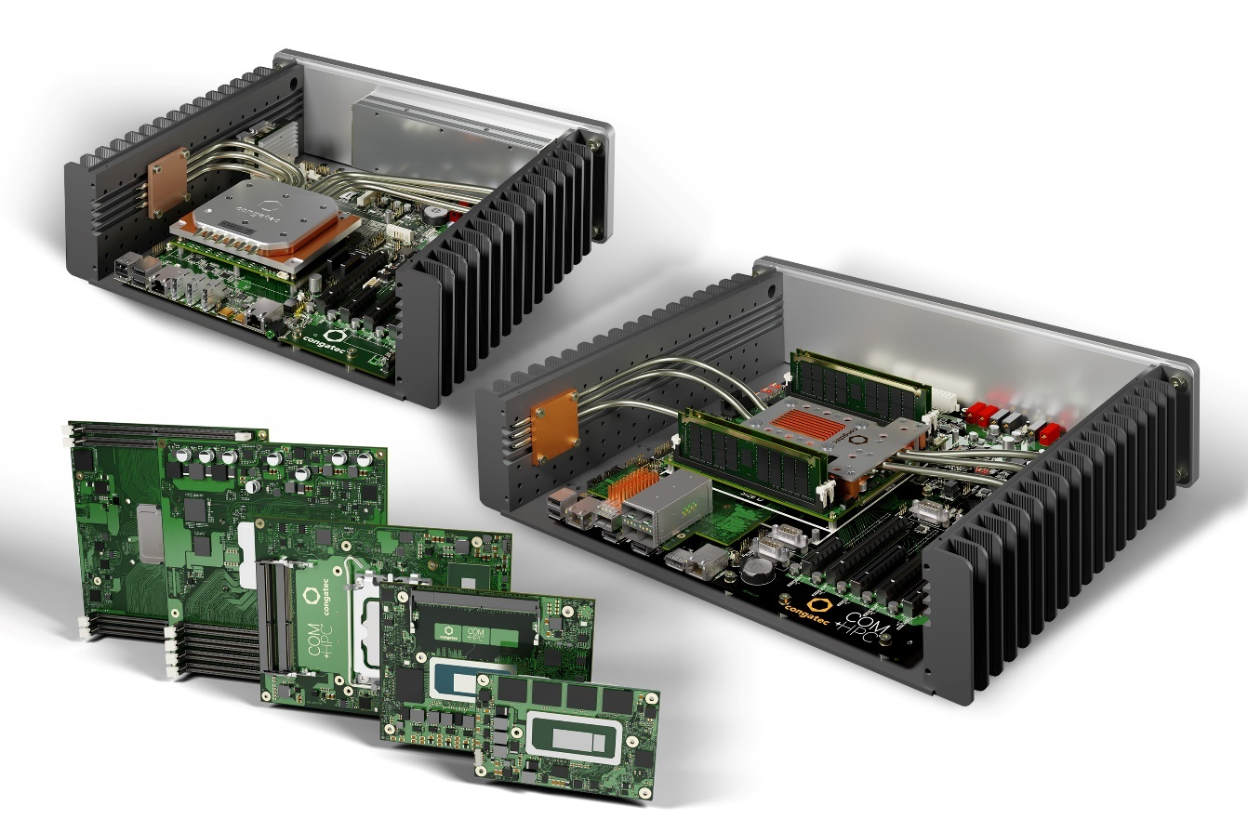

Taipei, Taiwan, 1 November 2023 * * * congatec – a leading vendor of embedded and edge computing technology – will showcase its high-performance ecosystems for digitizing the edge at EdgeTech+ 2023 (Booth No. B-L10), which takes place at Pacifico Yokohama Exhibition Hall, Japan, from 15-17 November. Presentations span from fanless rugged edge server designs to secure connectivity solutions for the digitization of brownfield equipment.

Showcase highlight: High-performance COM-HPC ecosystem
The highlight of congatec’s showcase is a complete ecosystem of COM-HPC modules to enable high-performance edge applications. With the recent ratification of the COM-HPC 1.2 specification, COM-HPC is now the most scalable and powerful standard for applications ranging from low-power to high-end servers. The new congatec COM-HPC Mini modules with 13th Gen Intel Core processors (codename Raptor Lake) represent the latest benchmark for high-end embedded and edge computing at the Client level. With this small form factor standard, even the most space-constrained solutions can now benefit from a massive performance boost and a significantly larger number of new high-speed interfaces. This will enable entire product families to migrate to the new PICMG standard.

Fanless edge server designs
Moreover, congatec is also premiering fanless edge server designs based on COM-HPC Server modules at EdgeTech+ 2023. These rugged microservers accelerate the next generation of real-time workloads in harsh environments requiring extended temperature support. Based on the latest COM-HPC Server modules, performance features include up to 20 cores, up to 1 TB RAM, PCIe Gen 4 speed, as well as up to 100 GbE connectivity and TCC/TSN support. Target applications range from industrial workload consolidation for automation, robotics and medical backend imaging, to outdoor servers for utilities and critical infrastructures like smart grids for oil, gas and electricity as well as rail and communication networks. Vision-enabled video security and surveillance are other edge applications.

congatec’s multitool for secure edge connectivity
congatec is also unveiling a new digitization solution that covers the entire journey, from the first steps to digitize production processes to the direct use and further processing of the collected data at the edge. The new solution enables secure OT/IT connection and can also consolidate OT systems across different production sections or locations.

The solution is available as a compact, application-ready system for industrial use and provides a flexible physical interface selection. The system is easy to configure, and the individual solution modules can be used directly after simple parameterization. Dedicated programming is not necessary. This makes the conga-connect ideal for machine builders looking for a flexible digitization solution, as well as for system integrators and manufacturers.

For further information about congatec’s presentations at EdgeTech+ 2023 Japan, 15-17 November 2023, booth B-L10, please visit: https://www.congatec.com/en/congatec/events/edgetech/

* * *
About congatec
congatec is a rapidly growing technology company focusing on embedded and edge computing products and services. The high-performance computer modules are used in a wide range of applications and devices in industrial automation, medical technology, transportation, telecommunications and many other verticals. Backed by controlling shareholder DBAG Fund VIII, a German midmarket fund focusing on growing industrial businesses, congatec has the financing and M&A experience to take advantage of these expanding market opportunities. congatec is the global market leader in the computer-on-modules segment with an excellent customer base from start-ups to international blue-chip companies. More information is available on our website at www.congatec.com or via LinkedIn, X and YouTube.

Intel, the Intel logo, and other Intel marks are trademarks of Intel Corporation or its subsidiaries.

Reader enquiries:
congatec
Crysta Lee
Phone: +886 2 25978577
info@congatec.com
www.congatec.com

Press contact congatec:
congatec
Christof Wilde
Phone: +49-991-2700-2822
christof.wilde@congatec.com

