Press release

congatec introduces first COM-HPC Mini modules at embedded world 2023

Small form factor to complete high-performance ecosystem
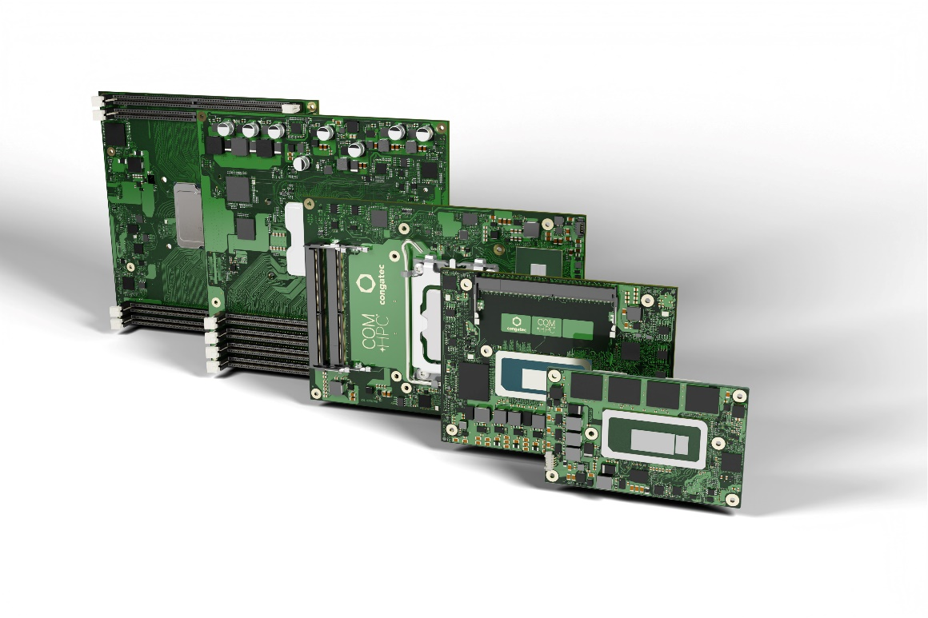

Deggendorf, Germany, 9 February 2023 * * * congatec – a leading vendor of embedded and edge computing technology – will be presenting its comprehensive COM-HPC ecosystem at embedded world 2023 (hall 3 / booth 241). The portfolio now ranges from high-performance COM-HPC Server-on-Modules to ultra-compact and brand-new COM-HPC Client-on-Modules that are hardly larger than a credit card. Together with the accompanying tailored cooling solutions, carrier boards and design-in services, congatec now provides everything designers need for their next generation of high-end embedded and edge computing platforms. And with the new COM-HPC Mini standard, even the most space-constrained solutions can now benefit from a high-performance boost and a significantly larger number of new high-speed interfaces. Thus, entire product families can now migrate to the new PICMG standard – without requiring significant modification of the internal system design and housing.

Highlight of the innovations: COM-HPC Mini
The flagship of congatec’s embedded world showcase are first samples of COM-HPC Mini designs. Launching officially after final PICMG ratification of the new specification, the first high-performance COM-HPC Mini modules will be equipped with the new 13th Gen Intel Core processors (codename Raptor Lake), which represent the latest benchmark for the high end of embedded and edge computing at client level.

Together with congatec’s recently introduced high-performance Computer-on-Modules with 13th Gen Intel Core processors on COM-HPC Client Size A and Size C, developers now have the entire bandwidth of this new processor generation at their disposal on COM-HPC. Thanks to state-of-the-art connectivity, the COM-HPC standard opens new horizons for developers of innovative designs in terms of data throughput, I/O bandwidth and performance density that cannot be achieved with COM Express. congatec’s COM Express 3.1 compliant modules with 13th Gen Intel Core processors, on the other hand, primarily help to secure investments in existing OEM designs, for instance by providing upgrade options for more data throughput thanks to PCIe Gen 4 support.

The COM-HPC Mini form factor predominantly addresses ultra-compact high-performance designs such as DIN rail PCs or rugged handhelds and tablets. However, COM-HPC Mini also solves the Gordian knot that developers of ultra-compact COM Express systems have been facing when wanting to switch to COM-HPC to be able to utilize latest interface technologies. The previously smallest COM-HPC footprint – COM-HPC Size A – did not allow this: Measuring 95x120 mm (11,400 mm²), it is almost 32% larger than the COM Express Compact form factor, which measures 95x95 mm (9,025 mm²). From a footprint standpoint, that’s 25 mm too wide to migrate existing COM Express designs to COM-HPC. Since COM Express Compact is the most widespread COM Express form factor and only the high end currently still uses the even larger COM Express Basic form factor, many developers faced considerable challenges – if only in terms of system design dimensions. But smaller is always possible. That’s why COM-HPC Mini with its 95x60 mm is a real liberator, opening up entirely new high-performance perspectives – in particular for the many ultra-compact system designs.

Further information on COM-HPC and the new COM-HPC Mini form factor can be found at: https://www.congatec.com/en/technologies/com-hpc-mini/

* * *
About congatec
congatec is a rapidly growing technology company focusing on embedded and edge computing products and services. The high-performance computer modules are used in a wide range of applications and devices in industrial automation, medical technology, transportation, telecommunications and many other verticals. Backed by controlling shareholder DBAG Fund VIII, a German midmarket fund focusing on growing industrial businesses, congatec has the financing and M&A experience to take advantage of these expanding market opportunities. congatec is the global market leader in the computer-on-modules segment with an excellent customer base from start-ups to international blue chip companies. More information is available on our website at www.congatec.com or via LinkedIn, Twitter and YouTube.

Intel, the Intel logo, and other Intel marks are trademarks of Intel Corporation or its subsidiaries.

Reader enquiries:
congatec
Phone: +49-991-2700-0
info@congatec.com
www.congatec.com

Press contact congatec:
congatec
Christof Wilde
Phone: +49-991-2700-2822
christof.wilde@congatec.com

Press contact PR agency:
SAMS Network
Michael Hennen
Phone: +49-2405-4526720
congatec@sams-network.com
www.sams-network.com

Please send print publications to:
SAMS Network
Sales And Management Services
Zechenstraße 29
52146 Würselen
Germany

Please send links to digital publications to:
office@sams-network.com

