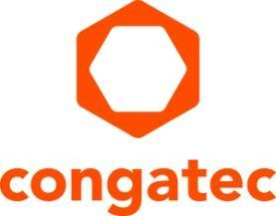
Press release

congatec takes over sales of Real-Time Systems’ products
The target: holistic consolidation and digitization offerings

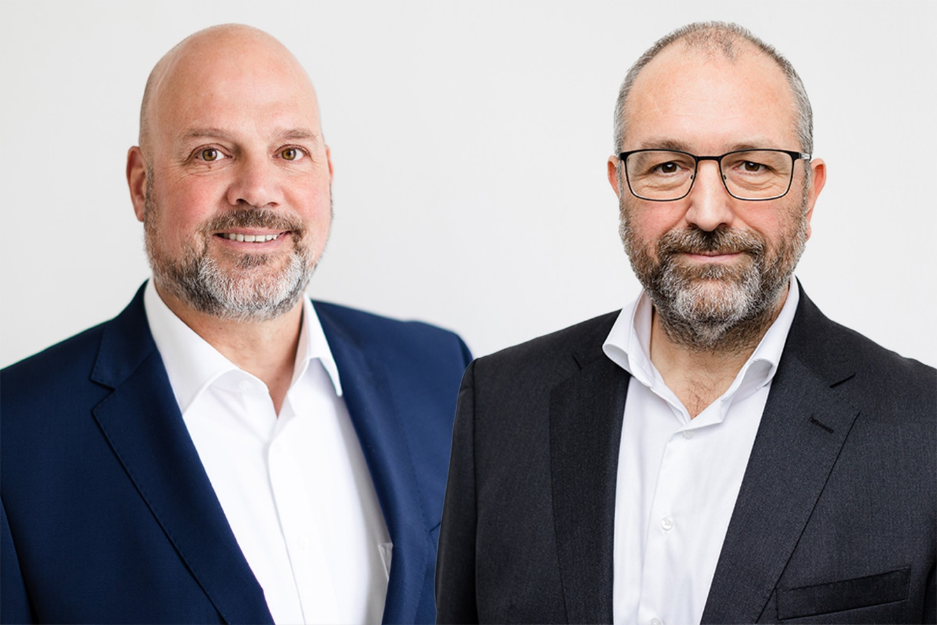
congatec Managing Directors (f.l.t.r.) Daniel Jürgens and Konrad Garhammer

Deggendorf, Germany, 24. October 2023 * * * congatec – a leading vendor of embedded and edge computing technology – will now manage the global product sales for its daughter company Real-Time Systems (RTS). Round about 80 sales representatives and field application engineers will now support the sales of RTS's real-time hypervisor and IoT platform, formerly known as Arendar. congatec expects this consolidation of sales services to significantly accelerate the deployment of Real-Time Systems' offerings. Additionally, new bundled hardware and software solutions of the congatec group will provide a holistic approach in the future, making it easier for customers to consolidate their hardware and digitize the industrial brownfield.

"By bringing together the sales of all congatec group products, we not only strengthen the position of RTS products, but also provide our customers with a more comprehensive choice from a single source," says Konrad Garhammer, Managing Director of the congatec group. "In addition, RTS will be able to integrate its innovative consolidation and digitization offerings into customer's hardware platforms more easily and cost-effectively."

"As a result of this stewardship of sales, we extend our high-performance ecosystem offerings. One contact person, shorter paths, faster and smoother development, and strengthened project management are just some of the advantages of combining sales activities," says Daniel Jürgens, Managing Director of the congatec group.

This united sales approach will not impact Real-Time Systems’ services or operational structure. It will also not affect the existing sales strategy for Real-Time Systems products. All existing customers and target groups, including other hardware vendors, will continue to be actively addressed.

For more information please visit: https://www.congatec.com/

* * *
About congatec
congatec is a rapidly growing technology company focusing on embedded and edge computing products and services. The high-performance computer modules are used in a wide range of applications and devices in industrial automation, medical technology, robotics, telecommunications and many other verticals. Backed by controlling shareholder DBAG Fund VIII, a German midmarket fund focusing on growing industrial businesses, congatec has the financing and M&A experience to take advantage of these expanding market opportunities. congatec is the global market leader in the computer-on-modules segment with an excellent customer base from start-ups to international blue chip companies. More information is available on our website at www.congatec.com or via LinkedIn, X and YouTube.

About Real-Time Systems
Real-Time Systems, is a global provider of hypervisor technology and specializes in real-time virtualization. The Intel® Co-Development Partner was founded in 2006 and is headquartered in Ravensburg, Germany. Since 2018, Real-Time Systems GmbH has been a congatec group member with partners in Europe, the USA and Asia. Today, Real-Time Systems offers a real-time hypervisor (RTS Hypervisor) on x86 hardware architecture and an IoT connectivity solution.
More information is available on the website at www.real-time-systems.com or via LinkedIn and YouTube.

Reader enquiries:
congatec
Phone: +49-991-2700-0
info@congatec.com
www.congatec.com

Press contact congatec:
congatec
Christof Wilde
Phone: +49-991-2700-2822
christof.wilde@congatec.com

Press contact agency:
Publitek GmbH
Julia Wolff
+49 (0)4181 968098-18
julia.wolff@publitek.com
Bremer Straße 6
21244 Buchholz

Please send print publications to:
Publitek GmbH
Diana Penzien
Bremer Straße 6
21244 Buchholz

