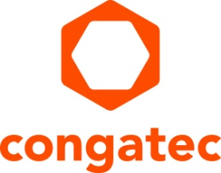
Press release

congatec and Kontron conclude joint COM-HPC evaluation carrier board standardization agreement

The goals: Reduce NRE costs, accelerate time-to-market, and improve product & supply security

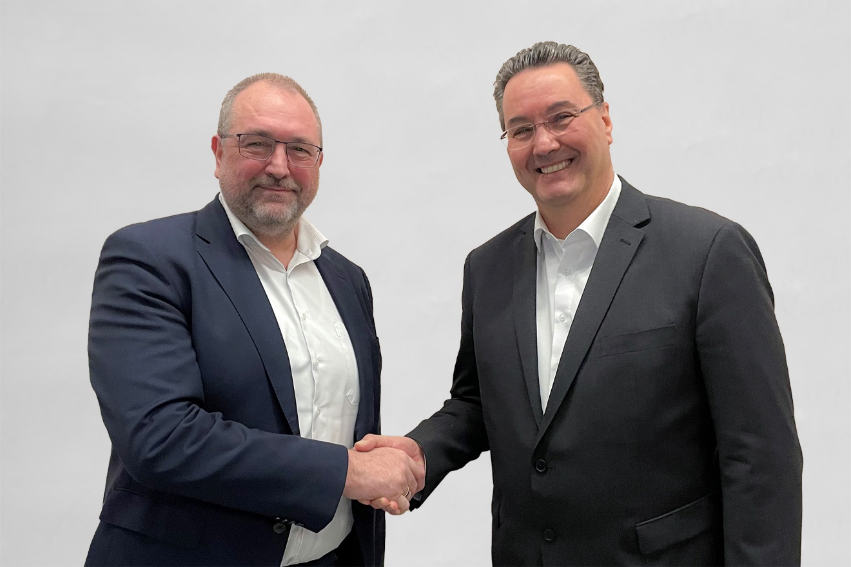
Konrad Garhammer (COO and CTO at congatec) and Michael Riegert (CEO Kontron Europe GmbH and COO IoT Europe, Executive Board Member at Kontron AG) conclude the cooperation (from left to right)

Deggendorf/Ismaning, Germany, 7 March 2023 * * * The two German embedded and edge computing heavyweights, congatec and Kontron, have concluded a cooperation agreement to standardize the design schematics of COM-HPC evaluation carrier boards from both companies, and to publish most of these schematics in public design guides. The goal is to improve design security through standardization, to reduce OEMs’ NRE costs, and to accelerate their time-to-market for new modular high-performance embedded and edge computing solutions based on the new COM-HPC® standard.

To solve the customers challenges the two German competitors cooperate not only to improve standardization but also to raise supply security through dual sourcing strategies. The global supply bottlenecks have drastically increased OEMs’ sensitivity over the last two years. The combined German design and engineering expertise addresses this need for high supply chain security by improving interoperability through joint carrier board design initiatives. congatec and Kontron will therefore put a distinct focus on plug & play capabilities so that Computer-on-Modules from either vendor can be used on any evaluation carrier board from either company to enable real multi-vendor COM and carrier strategies.

The initial focus of the cooperation between congatec and Kontron is the standardization of evaluation carrier boards for the COM-HPC® Client and Server form factors, with further module standards such as COM Express® and SMARC™ to follow. Customers will be able to use not only the design guides but also the carrier board layouts as best practice benchmarks for their own designs. As international threat scenarios have increased, the new standardized and interoperable evaluation carrier boards will follow highest cybersecurity requirements.

“This cooperation represents a new level of standardization par excellence. Even with the different module specifications and official PICMG carrier board design guides, there are still only a few efforts to ensure real interoperability on the evaluation carrier board level. And up to the application level, for that matter. It is therefore very valuable that we will now tackle these challenges together to achieve ultimate application-ready interoperability”, explains Konrad Garhammer, COO and CTO at congatec.

“Kontron and congatec are both highly focused on the benefits and good service for their customers. Therefore, I am pleased we came to this standardization agreement.
In fact, our companies are experienced in this already, having worked closely together in the PICMG and SGET standardization committees and having played a significant role in shaping all current standards. Based on this experience, we are convinced that the carrier board standardization efforts will also be executed with mutual appreciation of the respective inputs,” emphasizes Michael Riegert, CEO Kontron Europe GmbH and COO IoT Europe, Executive Board Member at Kontron AG .

Both companies emphasize that the cooperation relates exclusively to the standardization of evaluation carrier boards and that module development will remain strictly separate, as this core business is highly competitive.

* * *
About congatec
congatec is a rapidly growing technology company focusing on embedded and edge computing products and services. The high-performance computer modules are used in a wide range of applications and devices in industrial automation, medical technology, transportation, telecommunications and many other verticals. Backed by controlling shareholder DBAG Fund VIII, a German midmarket fund focusing on growing industrial businesses, congatec has the financing and M&A experience to take advantage of these expanding market opportunities. congatec is the global market leader in the computer-on-modules segment with an excellent customer base from start-ups to international blue chip companies. More information is available on our website at www.congatec.com or via LinkedIn, Twitter and YouTube.

About Kontron
Kontron is a global leader in IoT/Embedded Computing Technology (ECT) and offers individual solutions in the areas of Internet of Things (IoT) and Industry 4.0 through a combined portfolio of hardware, software and services. With its standard and customized products based on highly reliable state-of-the-art technologies, Kontron provides secure and innovative applications for a wide variety of industries. As a result, customers benefit from accelerated time-to-market, lower total cost of ownership, extended product lifecycles and the best fully integrated applications. For more information, please visit: www.kontron.com

Reader enquiries:
congatec
Phone: +49-991-2700-0
info@congatec.com
www.congatec.com

Press contact congatec:
congatec
Christof Wilde
Phone: +49-991-2700-2822
christof.wilde@congatec.com

Press contact Kontron:
Kontron Europe GmbH
Eleonore Arlart
Phone: +49-821-4086-274
eleonore.arlart@kontron.com

Press contact PR agency:
SAMS Network
Michael Hennen
Phone: +49-2405-4526720
congatec@sams-network.com
www.sams-network.com

Please send print publications to:
SAMS Network
Sales And Management Services
Zechenstraße 29
52146 Würselen
Germany

Links to digital publications to:
office@sams-network.com

