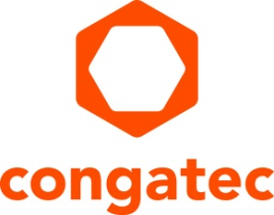
Press release

congatec adds TI processors to its strategic solutions portfolio

Building a high-performance ecosystem for Arm based SMARC modules

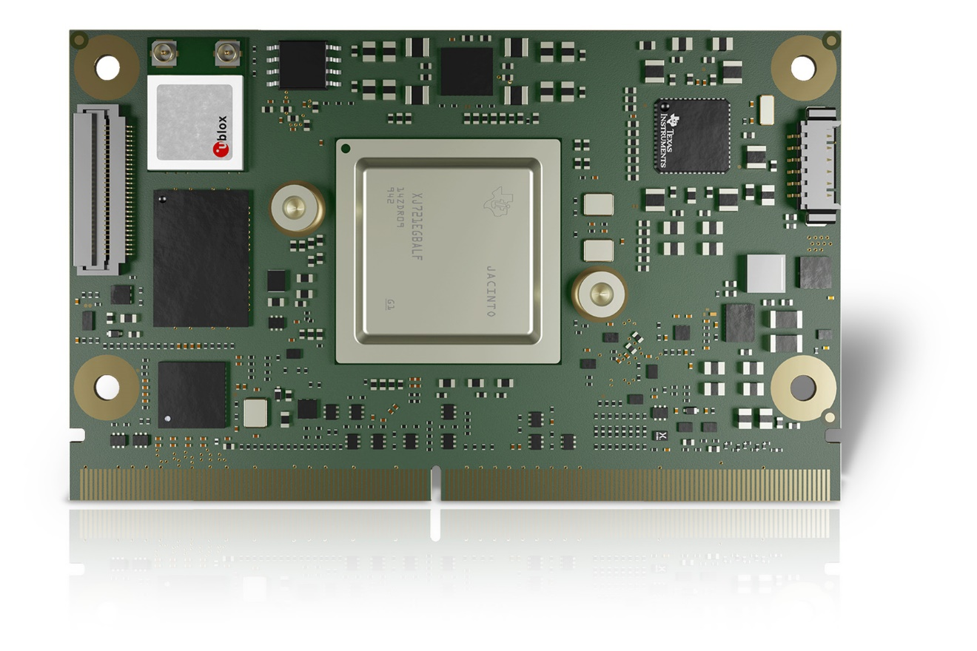
Deggendorf, Germany, 14 March 2023 * * * congatec – a leading vendor of embedded and edge computing technology – is pleased to announce that it is expanding its strategic solutions portfolio in the Arm processor sector to include Texas Instruments (TI) processors. The first solution platform is the conga-STDA4, a SMARC Computer-on-Module featuring the industrial-grade Arm® Cortex®-based TDA4VM processor. Using a system-on-chip architecture, TI incorporates accelerated vision and AI processing, real-time control, and functional safety capabilities into their TDA4VM processor. This Dual Arm Cortex-A72-based module is designed for industrial mobile machinery requiring near-field analytics, such as automated guided vehicles and autonomous mobile robots, construction and agricultural machinery. Further application areas are any vision-focused industrial or medical solution requiring powerful but energy-efficient artificial intelligence (AI) processors at the edge. Integrating the powerful TI TDA4VM processor on a standardized Computer-on-Module simplifies the design-in process of this powerful processor technology, allowing designers in various embedded industries to focus on their core competencies. This is advantageous as companies save up-front costs and shorten the time to market compared fully customized designs, especially if they are producing lower quantities of their solutions.

“Collaborating with a computer-on-module provider like congatec on their application-ready modules is a key benefit to engineers who are working with our Arm Cortex-based processors like the TDA4VM. Industrial OEMs, especially those who don’t have the resources to invest in full custom designs, can benefit from innovative SMARC COMs that help streamline design while enabling high design security and low NRE costs,” said Srik Gurrapu, Industrial Business Lead, Processors, Texas Instruments.

“We see that autonomous driving based on AI and computer vision is one of the most important markets for embedded and edge computing technologies beside the second major growth accelerator digitization. TI offers highly-integrated processors for such applications, and we are confident that our value adding Computer-on-Module approach will open new markets for such edge-server-grade, AI-driven, high-throughput technology. We will make TI processors available on our credit-card-sized SMARC Computer-on-Module ecosystem with all the added values. These include fast prototyping and application development, cost-effective carrier board designs, and ultra-reliable, responsive and performant resources from design-in to series production of OEM systems,” explains Martin Danzer, Director Product Management at congatec.

congatec will present this new strategic portfolio for the first time at embedded world 2023 (hall 3 / booth 241), highlighting the upcoming SMARC module with TI TDA4VM processor. First booting samples are expected to be available in mid-2023. Series production is scheduled for 2024. TI processors will be an integral part of congatec's Arm technology roadmap. As a result, congatec's high-performance Computer-on-Modules ecosystem will be broadly scalable and cover all major performance levels. For more information on the upcoming conga-STDA4 please visit: https://www.congatec.com/en/products/smarc/conga-STDA4/

* * *
About congatec
congatec is a rapidly growing technology company focusing on embedded and edge computing products and services. The high-performance computer modules are used in a wide range of applications and devices in industrial automation, medical technology, transportation, telecommunications and many other verticals. Backed by controlling shareholder DBAG Fund VIII, a German midmarket fund focusing on growing industrial businesses, congatec has the financing and M&A experience to take advantage of these expanding market opportunities. congatec is the global market leader in the computer-on-modules segment with an excellent customer base from start-ups to international blue chip companies. More information is available on our website at www.congatec.com or via LinkedIn, Twitter and YouTube.

All trademarks are property of their respective owners.

Reader enquiries:
congatec
Phone: +49-991-2700-0
info@congatec.com
http://www.congatec.com

Press contact congatec:
congatec
Christof Wilde
Phone: +49-991-2700-2822
christof.wilde@congatec.com

Press contact PR agency:
SAMS Network
Michael Hennen
Phone: +49-2405-4526720
congatec@sams-network.com
www.sams-network.com

Please send print publications to:
SAMS Network
Sales And Management Services
Zechenstraße 29
52146 Würselen
Germany

Please send links to digital publications to:
office@sams-network.com

