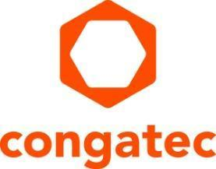
Press release

congatec welcomes ratification of COM-HPC 1.2 specification, introducing COM-HPC Mini:
Maximum performance for mini footprints

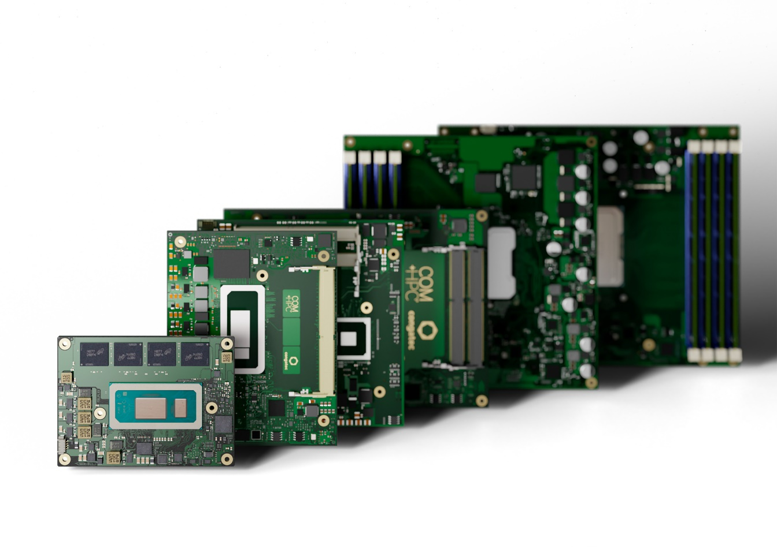
Deggendorf, Germany, 10. October 2023 * * * congatec – a leading vendor of embedded and edge computing technology – welcomes PICMG’s ratification of the COM-HPC 1.2 specification, which introduces the COM-HPC Mini form factor. This new specification provides high-performance capabilities in a small form factor, measuring only 95 mm x 70 mm. Even devices with limited space can now benefit from the superior bandwidth and interface offerings of COM-HPC, including PCIe Gen 5 and Thunderbolt.

COM-HPC establishes itself as the most scalable Computer-on-Module (CoM) standard, covering a wide range of applications from small form factor designs to edge server designs. This simplifies the design-in process and enables the creation of complete product families with reduced engineering efforts. COM-HPC modules support not only specific processors like x86 or Arm but also FPGAs, ASICS, and AI accelerators, making it a comprehensive standard for developing innovative applications based on the latest embedded and edge data processing technologies.

Christian Eder, Chairman of PICMG's COM-HPC Working Group and Director of Market Intelligence at congatec, expresses his enthusiasm for the COM-HPC standard: “COM-HPC offers the highest performance, bandwidth, interfaces, and scalability compared to other computer-on-module standards and with COM-HPC Mini, engineers can now leverage all this on a real small form factor for space constrained embedded and edge computing designs.”

congatec is committed to supporting the adoption and implementation of the COM-HPC Mini specification, enabling customers to bring their solutions to market quickly. As a leading provider of embedded computing solutions, congatec also continues to develop and deliver products that align with the latest industry standards.

For more information about congatec and its COM-HPC ecosystem, please visit: https://www.congatec.com/en/ecosystems/com-hpc-ecosystem

The specification of congatec’s fist COM-HPC Mini module can be found here: https://www.congatec.com/en/technologies/com-hpc-mini/

The official PICMG COM-HPC page can be found here:
https://www.picmg.org/openstandards/com-hpc/

* * *
About congatec
congatec is a rapidly growing technology company focusing on embedded and edge computing products and services. The high-performance computer modules are used in a wide range of applications and devices in industrial automation, medical technology, robotics, telecommunications and many other verticals. Backed by controlling shareholder DBAG Fund VIII, a German midmarket fund focusing on growing industrial businesses, congatec has the financing and M&A experience to take advantage of these expanding market opportunities. congatec is the global market leader in the computer-on-modules segment with an excellent customer base from start-ups to international blue chip companies. More information is available on our website at www.congatec.com or via LinkedIn, and YouTube.

Reader enquiries:
congatec
Phone: +49-991-2700-0
info@congatec.com
www.congatec.com

Press contact congatec:
congatec
Christof Wilde
Phone: +49-991-2700-2822
christof.wilde@congatec.com

Press contact agency:
Publitek GmbH
Julia Wolff
+49 (0)4181 968098-18
julia.wolff@publitek.com
Bremer Straße 6
21244 Buchholz

Please send print publications to:
Publitek GmbH
Diana Penzien
Bremer Straße 6
21244 Buchholz

