Press release

congatec launches new ultra-rugged 13th Gen Intel Core Computer-on-Modules with soldered RAM

Shock and vibration resistant for harsh environments

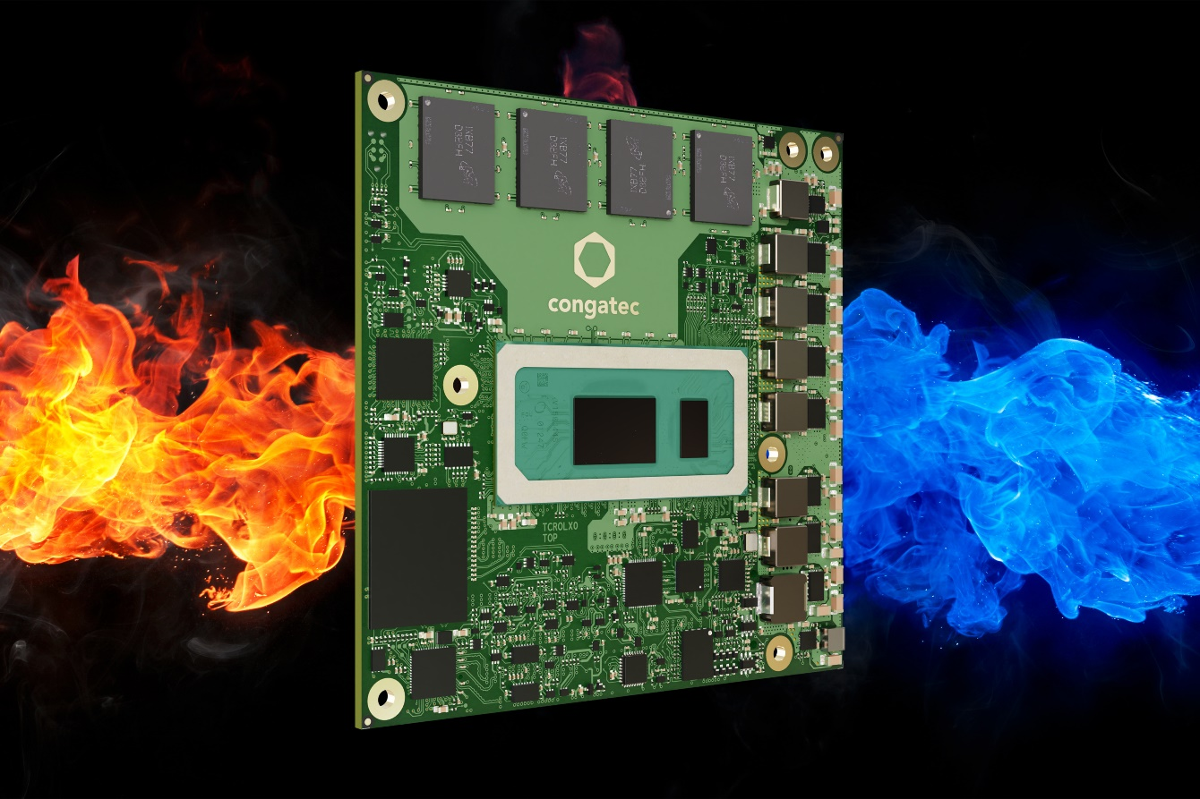

Deggendorf, Germany, 14 November, 2023 * * * congatec – a leading vendor of embedded and edge computing technology – introduces six new COM Express Compact Computer-on-Modules based on 13th Gen Intel Core processor featuring highest ruggedness. They are designed to withstand even extreme temperature ranges of -40°C to +85°C. Equipped with soldered RAM, the new COM Express Type 6 Computer-on-Modules provide full compliance for shock and vibration resistant operation in harsh environments up to highest railway standards. Target OEM applications for the new range of Computer-on-Modules based on the new Intel microarchitecture codenamed Raptor Lake are manned and unmanned rail and off-road vehicles for mining, construction, agriculture, forestry, as well as any other mobility application off paved roads. Shock and vibration resistant stationary devices and outdoor applications with high temperature fluctuations are further important application areas as digitization requires critical infrastructure protection (CIP) against earthquakes and other mission-critical events.

With up to 14 cores and 20 threads, seconded by ultra-fast LPDDR5x memory, the 13th Gen Intel Core processors deliver excellent parallel processing and multitasking options for connected outdoor, rail and off-road applications within optimized power-budgets. System designs will also become more sustainable due to improved performance per watt ratios and reduced power costs over their lifetime. These features are enabled by the Intel hybrid architecture, which is available for the first time in a highly rugged design and combines two core microarchitectures – Performance-cores (P-cores) and Efficient-cores (E-cores) – on a single processor. Moreover, the soldered LPDDR5x memory supports in-band error code correction (IBECC), so no special memory is needed for mission critical applications requiring highest data integrity, which also reduces the components to be procured. Support for Time Sensitive Networking (TSN) and Time Coordinated Computing (TCC) complete the industrial grade feature set.

The modules are supported by congatec’s high-performance ecosystem including highly efficient active and passive cooling solutions; optional conformal coating for protection against moisture, thermal shock, static, vibration, and contamination; evaluation carrier boards as well as the carrier board schematics. For virtual machine deployments and workload consolidation in edge computing scenarios customers can order the modules with pre-evaluated real-time hypervisor technology from Real-Time Systems. The hypervisor supports real-time operation and adds no additional latency. Additional service offerings including shock and vibration tests for custom system designs, temperature screening, and high-speed signal compliance testing, along with design-in services, and all required training sessions to simplify the use of congatec’s embedded computer technologies round-off the ecosystem.

The ultra-rugged COM Express Compact Type 6 modules based on the 13th Gen Intel Core (code name Raptor Lake) are available in the following standard configurations with customization options upon request:

Processor |  | Cores/  (P + E) |  | Max. Turbo Freq. [GHz]  P-cores / E-cores |  | Base Freq. [GHz]  P-cores / E-cores |  | Threads |  | GPU Execution Units [EU] |  | CPU Base Power [W]
Intel Core i7-13800HRE |  | 14  (6 + 8) |  | 5.0 /4.0 |  | 2.5 / 1.8 |  | 20 |  | 96 |  | 45
Intel Core i5-13600HRE |  | 12  (4 + 8) |  | 4.8 / 3.6 |  | 2.7 / 1.9 |  | 16 |  | 80 |  | 45
Intel Core i7-1370PRE |  | 14  (6 + 8) |  | 4.8 / 3.7 |  | 1.9 / 1.2 |  | 20 |  | 96 |  | 28
Intel Core i5-1350PRE |  | 12  (4 + 8) |  | 4.6 / 3.4 |  | 1.8 / 1.3 |  | 16 |  | 80 |  | 28
Intel Core i3-1320PRE |  | 8  (4 + 4) |  | 4.5 / 3.3 |  | 1.7 / 1.2 |  | 12 |  | 48 |  | 28
Intel Core i7-1365URE |  | 10  (2 + 8) |  | 4.9 / 3.7 |  | 1.7 / 1.2 |  | 12 |  | 96 |  | 15

Further information on the new conga-TC675r COM Express Compact modules can be found here: www.congatec.com/en/products/com-express-type-6/conga-tc675r/

* * *

About congatec
congatec is a rapidly growing technology company focusing on embedded and edge computing products and services. The high-performance computer modules are used in a wide range of applications and devices in industrial automation, medical technology, robotics, telecommunications and many other verticals. Backed by controlling shareholder DBAG Fund VIII, a German midmarket fund focusing on growing industrial businesses, congatec has the financing and M&A experience to take advantage of these expanding market opportunities. congatec is the global market leader in the computer-on-modules segment with an excellent customer base from start-ups to international blue chip companies. More information is available on our website at www.congatec.com or via LinkedIn, X (Twitter) and YouTube.

Reader enquiries:
congatec
Phone: +49-991-2700-0
info@congatec.com
www.congatec.com

Press contact congatec:
congatec
Christof Wilde
Phone: +49-991-2700-2822
christof.wilde@congatec.com

Press contact PR agency:
SAMS Network – a Publitek brand
Michael Hennen
Phone: +49-2405-4526720
congatec@sams-network.com
www.sams-network.com

Please send print publications to:
SAMS Network – a Publitek brand
Sales And Management Services
Zechenstraße 29
52146 Würselen
Germany

Links to digital publications to:
office@sams-network.com

Intel, the Intel logo, and other Intel marks are trademarks of Intel Corporation or its subsidiaries.

