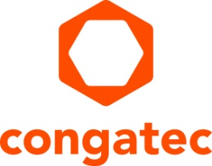
Press release

congatec presents industry’s most comprehensive COM-HPC ecosystem to Chinese market

Small form factor to complete high-performance ecosystem
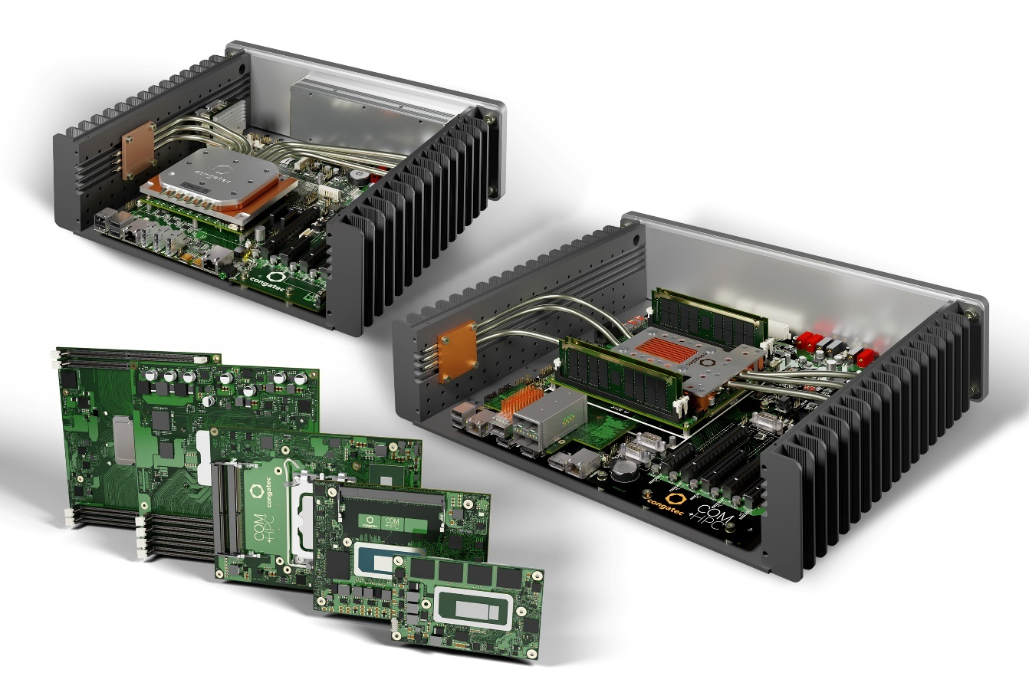

Taipei, Taiwan, 23 May 2023 * * * congatec – a leading vendor of embedded and edge computing technology – will be presenting the industry’s most comprehensive COM-HPC ecosystem for the first time to its Chinese audience at Security China (booth 1C63) and embedded world China (booth A172). The portfolio ranges from high-performance COM-HPC Server-on-Modules to ultra-compact and brand-new COM-HPC Mini modules. Together with the accompanying tailored cooling solutions, carrier boards and design-in services, congatec now provides everything designers need for their next generation of high-end embedded and edge computing platforms.

Highlight of the innovations: COM-HPC Mini
The flagship of congatec’s embedded world China showcase are first samples of COM-HPC Mini designs. Launching officially after final PICMG ratification of the new specification, the first high-performance COM-HPC Mini modules will be equipped with the new 13th Gen Intel Core processors (codename Raptor Lake), which represent the latest benchmark for the high end of embedded and edge computing at client level. With this new standard, even the most space-constrained solutions can now benefit from a high-performance boost and a significantly larger number of new high-speed interfaces. Thus, entire product families can now migrate to the new PICMG standard.

Fanless edge server designs
Moreover, congatec will premiere brand-new fanless edge server designs. These rugged edge servers will accelerate the next generation of real-time microserver workloads in harsh environments and extended temperature ranges. A real-world example is an edge server platform for 5G infrastructure deployments such as radio access networks (RAN). Based on latest COM-HPC Server modules, performance features include up to 20 cores, up to 1 TB RAM, PCIe Gen 4 speed, as well as up to 100 GbE connectivity and TCC/TSN support. In addition, two rugged edge designs demonstrate the extended possibilities congatec’s modules and sophisticated cooling solutions hold for edge computing. Target applications range from industrial workload consolidation servers for automation, robotics and medical backend imaging to outdoor servers for utilities and critical infrastructures – such as smart grids for oil, gas and electricity as well as rail and communication networks – and also include vision enabled applications such video infrastructures for safety and security.

Edge computer for mobile intralogistics
Another highlight will be the development platform for autonomous guided vehicles (AGVs) to digitalize smart mobility and robotic applications in harsh environments such as industrial machinery and agriculture. The rugged platform provides a precise positioning solution by integrating an RTK-enabled GNSS unit with accelerometer, gyroscope and magnetometer in one rugged industrial device that is powered by a congatec Computer-on-Module. Designed for harshest environments and automotive voltage ranges up to 36V, the Intel Atom processor based platform comes with a wide operating temperature range of -40 to 85°C and IP65/67 protection. For connectivity towards the vehicle communication networks, it offers extension options for real-time Ethernet (TSN), RS232, RS485 and CAN. Further edge connectivity options include Wi-Fi and Bluetooth as well as LTE/5G. Ambient pressure, humidity and temperature sensors round off the feature set.

For further information on congatec’s presentations at Security China, 7-10 June 2023, booth 1C63, please visit: https://www.congatec.com/en/congatec/events/bejing-security/

For further information on congatec’s presentations at embedded world China, 14-16 June 2023, booth A172, please visit: https://www.congatec.com/en/congatec/events/embedded-world-china/

* * *
About congatec
congatec is a rapidly growing technology company focusing on embedded and edge computing products and services. The high-performance computer modules are used in a wide range of applications and devices in industrial automation, medical technology, transportation, telecommunications and many other verticals. Backed by controlling shareholder DBAG Fund VIII, a German midmarket fund focusing on growing industrial businesses, congatec has the financing and M&A experience to take advantage of these expanding market opportunities. congatec is the global market leader in the computer-on-modules segment with an excellent customer base from start-ups to international blue chip companies. More information is available on our website at www.congatec.com or via LinkedIn, Twitter and YouTube.

Intel, the Intel logo, and other Intel marks are trademarks of Intel Corporation or its subsidiaries.

Reader enquiries:
congatec
Crysta Lee
Phone: +886 2 25978577
info@congatec.com
www.congatec.com

Press contact congatec:
congatec
Christof Wilde
Phone: +49-991-2700-2822
christof.wilde@congatec.com

Please send links to digital publications to:
office@sams-network.com

