Press release

PICMG COM-HPC committee approves COM-HPC Mini pinout
Mini form factor for maximum performance

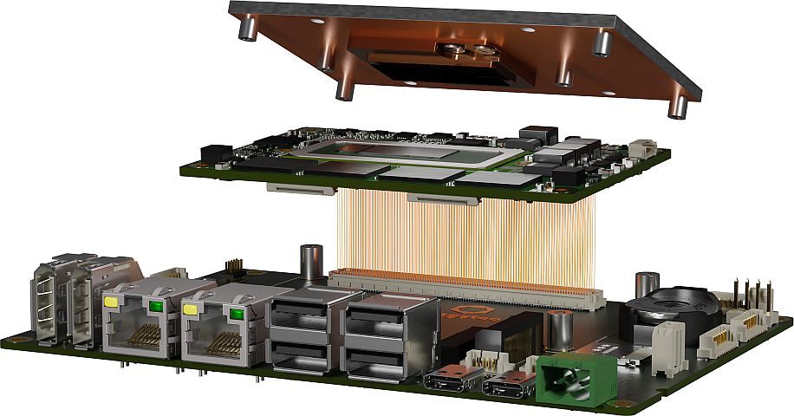

Deggendorf, Germany, 13. December 2022 * * * congatec is pleased to announce that the PICMG COM-HPC technical subcommittee has approved the pinout and footprint of the new credit-card-sized (95x60mm) high-performance Computer-on-Module specification COM-HPC Mini. The new COM-HPC Mini standard is now entering the home stretch towards final ratification, which is scheduled for the first half of 2023. Designed for small yet extremely performance-hungry applications the new COM-HPC Mini specification will open up the prospect of developing ultra-powerful microcomputers the size of a 4- or 8-port Ethernet switch, for example. Such small system sizes are needed in many segments of embedded and edge computing. Target markets include box PCs and control cabinet / DIN-rail PCs, adaptive IoT gateways for the brownfield, cyber-secure edge computers for critical IT/OT infrastructures, rugged tablets, and even ultra-rugged robots and in-vehicle computers wanting to take advantage of the soldered RAM which is a standard feature of these modules. Processors predestined for this new form factor are the 12th Gen Intel Core processor series – for which congatec already offers a ready-to-deploy design study for initial lab tests and customer feedback loops – and its future successors.

“The pinout approval is an essential milestone as carrier board designers and Computer-on-Module manufacturers such as congatec who are active in the COM-HPC working group can now embark on first compliant small form factor sized embedded and edge computer solutions based on this pre-approved data. The goal is to bring modules to market at the same time as Intel and other application processor vendors launch their new high-end processor generations, which is expected to happen next year,” explains Christian Eder, director product marketing congatec, and chairman of the COM-HPC working group.

Providing 400 pins, as compared to COM Express Mini’s 220 pins, the new COM-HPC Mini standard is designed to satisfy the rising interface needs of heterogeneous and multi-functional edge computers. Extensions include up to 4x USB 4.0 with full functionality including Thunderbolt and DisplayPort alternate mode, PCIe Gen 4/5 with up to 16 lanes, 2x 10 Gbit/s Ethernet port and much more. Add to that the fact that the COM-HPC Mini connector is qualified for bandwidths of more than 32 Gbit/s – enough to support PCIe Gen 5 or even Gen 6 – it is clear that its capabilities go well beyond those of all other credit-card-sized module standards.

For more information on the new COM-HPC Mini Computer-on-Module standard and the congatec COM-HPC Mini design study based on the 12th Gen Intel® Core™ processor series that is pin-compatible to upcoming successors, please visit https://www.congatec.com/en/technologies/com-hpc-mini/.

* * *
About congatec
congatec is a rapidly growing technology company focusing on embedded and edge computing products and services. The high-performance computer modules are used in a wide range of applications and devices in industrial automation, medical technology, transportation, telecommunications and many other verticals. Backed by controlling shareholder DBAG Fund VIII, a German midmarket fund focusing on growing industrial businesses, congatec has the financing and M&A experience to take advantage of these expanding market opportunities. congatec is the global market leader in the computer-on-modules segment with an excellent customer base from start-ups to international blue chip companies. More information is available on our website at www.congatec.com or via LinkedIn, Twitter and YouTube.

Intel, the Intel logo, and other Intel marks are trademarks of Intel Corporation or its subsidiaries.

Reader enquiries:
congatec
Phone: +49-991-2700-0
info@congatec.com
www.congatec.com

Press contact congatec:
congatec
Christof Wilde
Phone: +49-991-2700-2822
christof.wilde@congatec.com

Press contact PR agency:
SAMS Network
Michael Hennen
Phone: +49-2405-4526720
congatec@sams-network.com
www.sams-network.com

Please send print publications to:
SAMS Network
Sales And Management Services
Zechenstraße 29
52146 Würselen
Germany

Links to digital publications to:
office@sams-network.com

