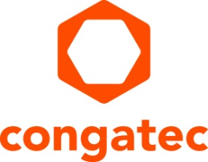
Press release

congatec welcomes COM Express 3.1 specification with compliant Computer-on-Modules
Performance boost now standard-compliant
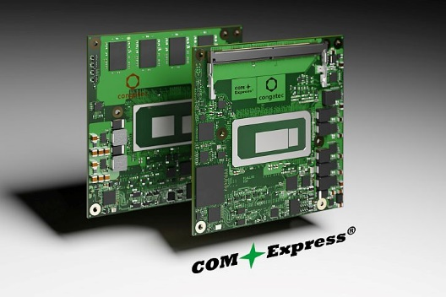
Deggendorf, Germany, 29 November 2022 * * * congatec – a leading vendor of embedded and edge computing technology – welcomes the ratification of the COM Express 3.1 standard with the launch of 10 compliant Computer-on-Modules based on 12th Gen Intel Core processors (formerly codenamed Alder Lake). The modules will be equipped with the new updated 16 Gbps COM Express connector and support high-speed interfaces such as PCIe 4.0 and USB 3.2. As upgrades of the already existing family of COM Express Type 6 modules, the new 3.1 compliant modules offer up to 14 cores/20 threads. With these new modules, customers can now give their designs a performance boost that is compliant to this officially ratified specification. This delivers maximum design security and safeguards reliable high-performance roadmaps for existing COM Express designs long into the future.

“The launch of the COM Express 3.1 specification is a huge step in future-proofing this established standard that has been on the market for nearly 18-years. All existing high-performance embedded designs based on COM Express Computer-on-Modules can now receive further performance upgrades in compliance with the standard. Accomplishing this has been one of the most important recent tasks of the PICMG organization, as customers need to sustainably secure their existing investments in COM Express compliant carrier board designs in these challenging times,” explains Christian Eder, Director Product Marketing at congatec.

Besides the support of PCIe 4.0 the new 3.1 COM Express specification allows further advanced features that were not previously supported, such as USB 4, MIPI-CSI connectors, signal integrity and loss budget information for SATA Gen 3 and SoundWire support. Despite all these improvements COM Express 3.1 Type 6 modules are fully backward compatible with 3.0 modules and carrier boards, ensuring that even older designs can get equipped with latest processor technologies.

For more information on the new COM Express 3.1 compliant conga-TC670 Computer-on-Modules, please visit https://www.congatec.com/en/products/com-express-type-6/conga-tc670/

The COM Express 3.1 specification can be purchased at https://www.picmg.org/product/com-express-module-base-specification-rev-3-1/
* * *

About congatec
congatec is a rapidly growing technology company focusing on embedded and edge computing products and services. The high-performance computer modules are used in a wide range of applications and devices in industrial automation, medical technology, transportation, telecommunications and many other verticals. Backed by controlling shareholder DBAG Fund VIII, a German midmarket fund focusing on growing industrial businesses, congatec has the financing and M&A experience to take advantage of these expanding market opportunities. congatec is the global market leader in the computer-on-modules segment with an excellent customer base from start-ups to international blue chip companies. More information is available on our website at www.congatec.com or via LinkedIn, Twitter and YouTube.

Intel, the Intel logo, and other Intel marks are trademarks of Intel Corporation or its subsidiaries.

Reader enquiries:
congatec
Phone: +49-991-2700-0
info@congatec.com
www.congatec.com

Press contact congatec:
congatec
Christof Wilde
Phone: +49-991-2700-2822
christof.wilde@congatec.com

Press contact PR agency:
SAMS Network
Michael Hennen
Phone: +49-2405-4526720
congatec@sams-network.com
www.sams-network.com

Please send print publications to:
SAMS Network
Sales And Management Services
Zechenstraße 29
52146 Würselen
Germany

Links to digital publications to:
office@sams-network.com

