Press release

congatec introduces its ecosystem for TSN networked real-time factories and critical infrastructures

Accelerating the real-time digitization

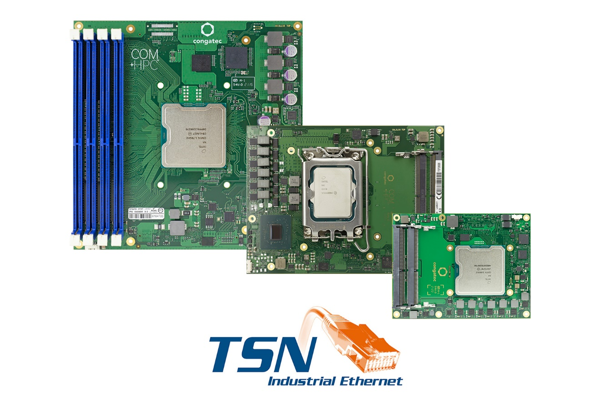

Deggendorf, Germany, November 15, 2022 * * * congatec – a leading vendor of embedded and edge computing technology – introduces its new ecosystem for TSN aimed at networked factories and critical infrastructures. The goal of the comprehensive edge computing platform portfolio for TSN is to make it as easy for real-time solution providers to build time sensitive networks for smart factory and critical infrastructure operators as deploying standard Ethernet infrastructures. Such entirely connected solutions need secure real-time gateway technologies to connect the brownfield and real-time clouds – both synchronized via Time Sensitive Networking (TSN) for various real-time services. The congatec solution platforms are prepared for reliable low-latency communication at the edge and include real-time hypervisor support for deterministic and secure data processing and data exchange between the devices and real-time clouds in harsh industrial environments. Target applications of the new TSN enabled ecosystem include industrial manufacturing, healthcare, energy and utilities, transportation and logistics, aerospace, government, and public safety.

“All the various real-time connected industries must support high-bandwidth and low-latency communication from the devices to the real-time clouds and back again. Providers of such end-to-end solutions need highly homogeneous solution platforms along these data supply chains, from the edge servers of the network infrastructure to the distributed and mobile devices, to make implementation as easy as possible. congatec provides everything needed for such all-encompassing solution platforms – including all interface options to connect the distributed equipment and its peripherals and I/Os via 100Base-T1,” explains Christian Eder, Director Product Management at congatec.

congatec’s new TSN enabled edge computing ecosystem spans the entire range of latest Computer-on-Modules supporting even real-time enabled 5G cellular connectivity for real-time 5G clients and gateways, as well as server-grade real-time cloud and base station Server-on-Modules. All those modules are TSN enabled, support Real-Time Hypervisor technology and are prepared to host any third-party real-time enabled cellular 5G connectivity. OEMs can utilize these platforms to deploy their real-time applications in pre-configured real-time virtual machines, focusing all their attention on the development of the application instead of having to concern themselves with the specific settings required to enable the hardware to communicate via TSN. For local wired infrastructures between servers and clients, TSN enabled smart switching platforms are available as well. Personal integration support and training programs on how to implement IEEE 802.1 Qbv compliant TSN clock synchronization and time-triggered communication round off congatec’s TSN ecosystem offering.

More information on congatec’s entire edge computing ecosystem for TSN enabled real-time factories and critical infrastructures can be found at: https://www.congatec.com/en/technologies/tsn-ecosystem/
* * *

About congatec
congatec is a rapidly growing technology company focusing on embedded and edge computing products and services. The high-performance computer modules are used in a wide range of applications and devices in industrial automation, medical technology, transportation, telecommunications and many other verticals. Backed by controlling shareholder DBAG Fund VIII, a German midmarket fund focusing on growing industrial businesses, congatec has the financing and M&A experience to take advantage of these expanding market opportunities. congatec is the global market leader in the computer-on-modules segment with an excellent customer base from start-ups to international blue chip companies. More information is available on our website at www.congatec.com or via LinkedIn, Twitter and YouTube.

Reader enquiries:
congatec
Telefon: +49-991-2700-0
info@congatec.com
www.congatec.com

Press contact congatec:
congatec
Christof Wilde
Telefon: +49-991-2700-2822
christof.wilde@congatec.com

Press contact agency:
SAMS Network
Michael Hennen
Telefon: +49-2405-4526720
congatec@sams-network.com
www.sams-network.com

Please send print publications to:
SAMS Network
Sales And Management Services
Michael Hennen
Zechenstraße 29
52146 Würselen
Germany

Links to digital publications to:
office@sams-network.com

