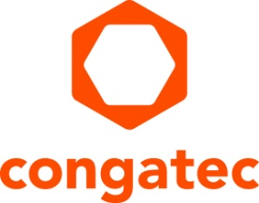
Press release

congatec, S.I.E and secunet present edge gateway at MEDICA 2022
Healthcare and the cloud: secunet medical connect securely links medical devices and networks
Data processing will shape day-to-day healthcare in the future. Providing a secure gateway for hardware, operating system and interface, secunet medical connect helps companies to implement digitalization for individual needs. With the "one box solution" developed by congatec, S.I.E and secunet, decentralized medical structures can be integrated quickly, agilely and securely.
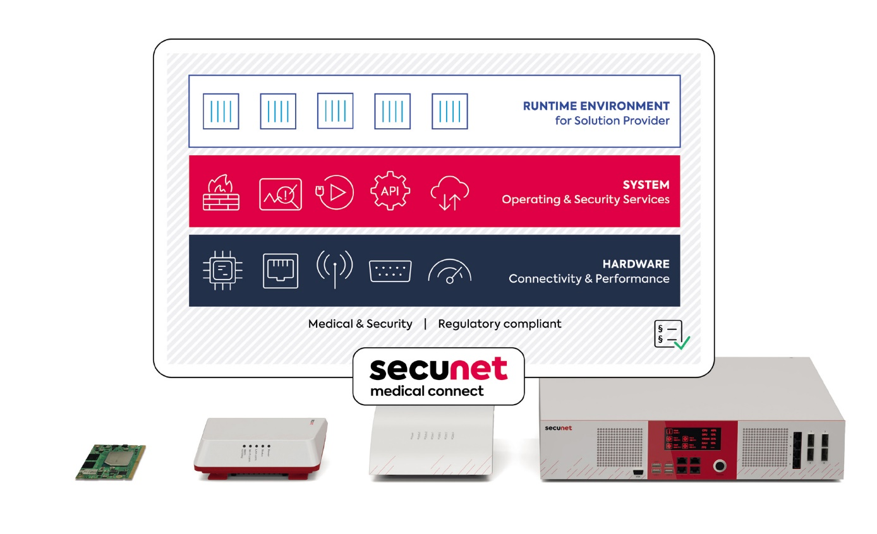
Düsseldorf, Germany, 14 November 2022 * * * Value-added alliance partners congatec, S.I.E and secunet will be at MEDICA (Hall 3, Stand B50) to present their joint solution portfolio for securely connecting medical devices and networks with modern data-driven IT services and healthcare platforms. The edge gateway family secunet medical connect enables the use of secure and GDPR-compliant cloud applications.

Data room edge gateway
Hosting secure off-premise data rooms requires the integration of gateway platforms such as secunet medical connect into existing clinical networks. Solution providers can then implement their data-driven services on these platforms. This starts with secure and legally compliant collection, processing and pseudonymization of machine and patient data that is then in a next step transferred to the cloud. Throughout this process, the medical networks must be protected at all times, and patient data must be processed securely and in accordance with all medical regulations, standards and norms. And not only within the applications, but also across the system and interfaces themselves. secunet medical connect offers comprehensive security, from the hardware to the secure execution environment.

A gateway platform for numerous digitization tasks
Providers of digitization solutions for the healthcare sector such as Honic (Health Data Technologies GmbH) rely on secunet medical connect. The company offers a GDPR-compliant medical health data platform that enables data-based research and development. Applications from Honic are used on the edge gateway.

Complete development package for solution providers
The value creation alliance gives companies in regulated industries such as healthcare the opportunity to react quickly and agilely to new requirements in product development and shortens development cycles from concept to initial minimum viable products (MVPs). These can be tested with end users in real-life Proof of Concepts (PoCs) to realize rapid market maturity of user-centric solutions. Numerous industry-specific regulations and certifications are supported, including MDR-certified medical computers and cybersecurity standards.

Further information on the trade fair showcase of the value-added alliance partners congatec, S.I.E and secunet can be found at: https://www.congatec.com/en/congatec/events/medica/

* * *
About secunet
secunet is Germany’s leading cybersecurity company. In an increasingly connected world, the company’s combination of products and consulting assures resilient digital infrastructures and the utmost protection for data, applications and digital identities. secunet specializes in areas with unique security requirements – such as cloud, IIoT, eGovernment and eHealth. With security solutions from secunet, companies can maintain the highest security standards in digitization projects and advance their digital transformation. Over 1,000 experts strengthen the digital sovereignty of governments, businesses and society. secunet’s customers include federal ministries, more than 20 DAX-listed corporations as well as other national and international organizations. The company was established in 1997, is listed in the SDAX and generated revenues of around 337 million euros in 2021. secunet is an IT security partner to the Federal Republic of Germany and a partner of the German Alliance for Cyber Security. More information at www.secunet.com.

About S.I.E
S.I.E (System Industrie Electronic GmbH) is one of the market-leading engineering and manufacturing specialists for embedded systems and cyber-physical systems in challenging regulatory environments (medicine, industry, cyber security). As a full-service provider, the company supports its customers throughout the entire product lifecycle, starting with creative ideation and consulting processes, through development and production, to quality and lifecycle services. Despite all digital DNA, the focus and common ambition is to generate sustainable added value for people. Visit www.sie.at for more information.

About congatec
congatec is a rapidly growing technology company focusing on embedded and edge computing products and services. The high-performance computer modules are used in a wide range of applications and devices in industrial automation, medical technology, transportation, telecommunications and many other verticals. Backed by controlling shareholder DBAG Fund VIII, a German midmarket fund focusing on growing industrial businesses, congatec has the financing and M&A experience to take advantage of these expanding market opportunities. congatec is the global market leader in the computer-on-modules segment with an excellent customer base from start-ups to international blue chip companies. More information is available on our website at www.congatec.com or via LinkedIn, Twitter and YouTube.

Reader enquiries:
congatec
Phone: +49-991-2700-0
info@congatec.com
www.congatec.com

Press contact congatec:
congatec
Christof Wilde
Telefon: +49-991-2700-2822
christof.wilde@congatec.com

Press contact PR agency:
SAMS Network
Michael Hennen
Phone: +49-2405-4526720
congatec@sams-network.com
www.sams-network.com

Press contact secunet:
Patrick Franitza
Press Officer
Phone: +49-201-5454-1234
presse@secunet.com
www.secunet.com

Press contact S.I.E:
Sami Badawi
Head of Marketing & Corporate Communication
Phone: +49-871-9657807-14
Sami.Badawi@sie.at
www.sie.at

Please send print publications to:
SAMS Network
Sales And Management Services
Michael Hennen
Zechenstraße 29
52146 Würselen
Germany

Links to digital publications to:
office@sams-network.com

