Press release

congatec launches five new COM-HPC Server Size D modules with Intel Xeon D-2700 processors following the “less is more” approach

An advance into the world of mixed-critical real-time servers

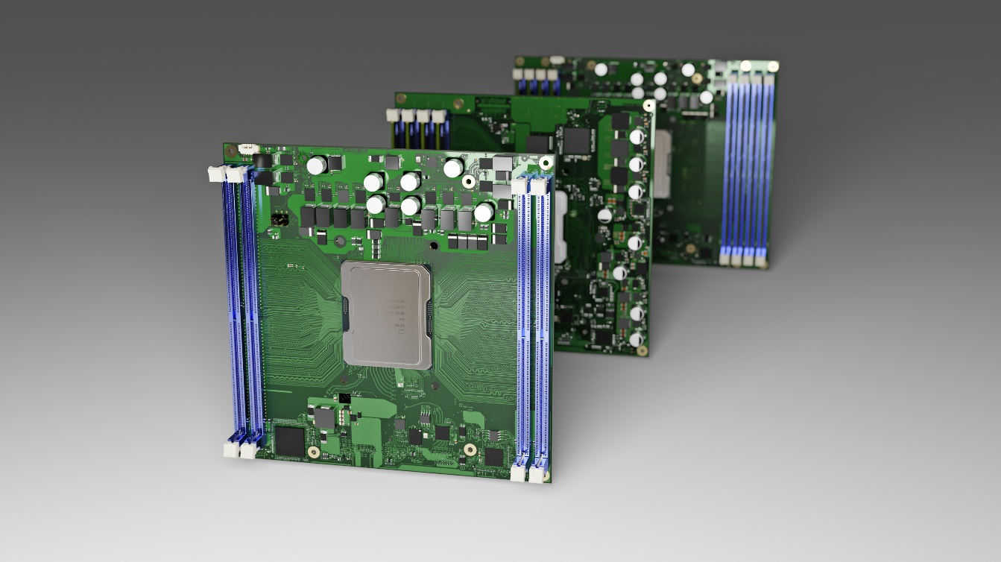
congatec’s Intel Xeon D-2700 processor based Server-on-Modules in the compact COM-HPC Server Size D form factor

Deggendorf/Nuremberg, Germany, 21 June, 2022 * * * congatec – a leading vendor of embedded and edge computing technology – extends its Intel Xeon D-2700 processor based Server-on-Module portfolio by launching five new modules in the compact (160x160mm) COM-HPC Server Size D performance class. The launch underlines the massive industry demand for edge server performance in a small form factor that is rugged and outdoor capable. It also takes the Intel Xeon D-2700 processors, with up to 20 cores even deeper into the realm of real-time demanding mixed-critical applications. Compared to the already available larger (200x160mm) COM-HPC Server Size E modules, the number of supported DRAM modules is halved from 8 to 4 bars. Nevertheless, impressive 512 GB of DDR4 RAM at 2,933 MT/s are provided. The benefit of limiting the RAM is that the modules take up less space, which reduces the required footprint by 20% compared to Size E. Target applications of the new Intel Xeon D-2700 processor based COM-HPC modules are deeply embedded, space-constrained edge server deployments with high data throughput but less memory-intensive workloads. They are typically found in IIoT-networked real-time environments of smart factories and critical infrastructures.

"Our current launch is best described as ‘less is more’: Mixed-critical edge server applications don’t have to handle RAM-intensive server workloads. Rather, they need to host multiple real-time applications side-by-side and therefore require as many cores as possible. They also must meet the demands of industrial communications with many small message packets that need to be processed in real time. Again, memory is not as critical compared to database-driven web servers that are used by thousands of people in parallel. It is true that customers can operate COM-HPC Server Size E modules with only 4 RAM bars. However, saving space is also very important for them. That's why we now also offer the Intel Xeon processor in COM-HPC Server Size D," explains Martin Danzer, Head of Product Management at congatec.

Independent of the various Server-on-Module specifications, all congatec COM-HPC Server modules with Intel Xeon processors (formerly Ice Lake D) in Size E and Size D as well as the COM Express Type 7 form factor accelerate the next generation of real-time microserver workloads in rugged environments and extended temperature ranges. Improvements include up to 20 cores, up to 1 TB RAM, double throughput per PCIe lane to Gen 4 speeds, as well as up to 100 GbE connectivity and TCC/TSN support. Target applications range from industrial workload consolidation servers for automation, robotics and medical backend imaging to outdoor servers for utilities and critical infrastructures – such as smart grids for oil, gas and electricity as well as rail and communication networks – and also include vision enabled applications such as autonomous vehicles and video infrastructures for safety and security.

Besides the huge bandwidth and performance improvements, congatec’s Server-on-Module families significantly extend the lifecycle of next-gen rugged edge server designs compared to common servers as long-term availability of up to ten years is part of the roadmap. The module families further convince with a comprehensive server-grade feature set: For mission critical designs, they offer powerful hardware security features including Intel Boot Guard, Intel Total Memory Encryption – Multi-Tenant (Intel TME-MT) and Intel Software Guard Extensions (Intel SGX). AI applications benefit from built-in hardware acceleration including AVX-512 and VNNI. For best RAS capabilities, the processor modules integrate the Intel Resource Director Technology (Intel RDT) and support remote hardware management features.

The feature set in detail
The five new conga-HPC/sILH Server-on-Modules with Intel Xeon D-2700 series processors extend congatec’s existing COM-HPC Server Size D product family with Intel Xeon D-1700 processors. Both processor series are based on the generation formerly codenamed Ice Lake. The present launch doubles the available number of cores of this compact, 160x160mm high-performance Server-on-Module from up to 10 to up to 20. Memory support is extended from up to three to up to four DDR4 RAM channels with up to 512 GB at 2,933 MT/s. For the connection of a broad range of dedicated controllers, computing accelerator cards and NVMe storage media in rugged edge server installations, they feature 32x PCIe Gen 4 lanes besides 16x PCIe Gen 3 lanes. For real-time networking there is 1x 2.5 GbE with TSN and TCC support on top of an extended Ethernet bandwidth of 100Gb in various configurations including 1x 100 GbE, 2x 50 GbE, 4x 25 GbE as well as several other configurations via KR or SFI interfaces. Further interfaces include 4x USB 3.1, and 4x USB 2.0. For non-volatile storage, the modules optionally support an integrated eMMC 5.1 with up to 128 GB capacity as well as 2x SATA III interfaces.

The new application-ready COM-HPC Server-on-Modules come with comprehensive board support packages for Windows, Linux and VxWorks. For workload consolidation, real-time virtual machine support is available thanks to congatec’s comprehensive support of RTS Hypervisor implementations from Real-Time Systems. congatec also offers perfectly matched cooling solutions, ranging from powerful active cooling with heat pipe adapter to fully passive cooling solutions for best mechanical resilience against vibration and shocks.

The new Intel Xeon D-2700 processor based conga-HPC/sILH COM-HPC Server Size D modules (160x160mm) will be available in the following variants:

Processor |  | Cores / Threads |  | Freq. [GHz] |  | LLC Cache [MB] |  | CPU Base Power [W] |  | Temperature  range
Intel Xeon D-2796TE |  | 20 / 40 |  | 2.0 |  | 30 |  | 118 |  | Extended
Intel Xeon D-2775TE |  | 16 / 32 |  | 2.0 |  | 25 |  | 100 |  | Extended
Intel Xeon D-2752TER |  | 12 / 24 |  | 1.8 |  | 20 |  | 77 |  | Extended
Intel Xeon D-2733NT |  | 8 / 16 |  | 2.1 |  | 15 |  | 80 |  | Commercial
Intel Xeon D-2712T |  | 4 / 8 |  | 1.9 |  | 15 |  | 65 |  | Commercial

For more information on the conga-HPC/sILH COM-HPC Server Size D Server-on-Module, please visit https://www.congatec.com/en/products/com-hpc/conga-hpcsilh/

Further information about the new Intel Xeon D-2700 processors can be found on the main landing page: https://www.congatec.com/en/technologies/intel-xeon-d-modules/

* * *
About congatec
congatec is a rapidly growing technology company focusing on embedded and edge computing products and services. The high-performance computer modules are used in a wide range of applications and devices in industrial automation, medical technology, transportation, telecommunications and many other verticals. Backed by controlling shareholder DBAG Fund VIII, a German midmarket fund focusing on growing industrial businesses, congatec has the financing and M&A experience to take advantage of these expanding market opportunities. congatec is the global market leader in the computer-on-modules segment with an excellent customer base from start-ups to international blue chip companies. Founded in 2004 and headquartered in Deggendorf, Germany, the company reached sales of 127.5 million US dollars in 2020. More information is available on our website at www.congatec.com or via LinkedIn, Twitter and YouTube.

Reader enquiries:  congatec GmbH  Christian Eder  Phone: +49-991-2700-0  info@congatec.com  www.congatec.com | Press contact:  SAMS Network  Michael Hennen  Phone: +49-2405-4526720  info@sams-network.com  www.sams-network.com

Text and photograph available at: https://www.congatec.com/en/congatec/press-releases.html

Intel, the Intel logo, and other Intel marks are trademarks of Intel Corporation or its subsidiaries.

