Press release

congatec and S.I.E launch co-creation services for the digitization of healthcare

Value partnership for creating medical edge computing systems that meet patient, data, and cybersecurity requirements

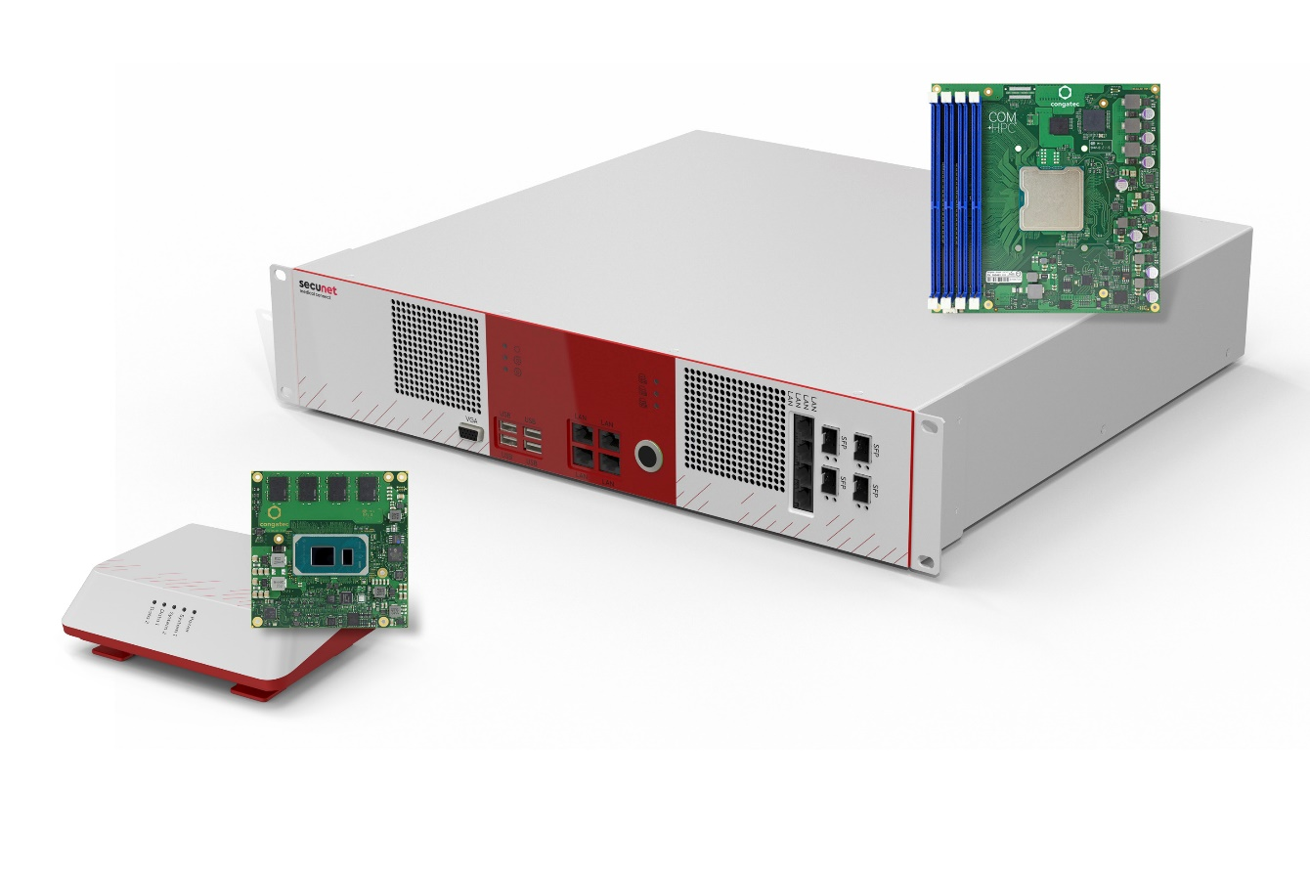Proofs of concept for the co-creation offering: secunet’s medical edge systems Carna (left) and Athene (right)

Deggendorf/Nuremberg, Germany, 21 June, 2022 * * * At embedded world 2022 (hall 5, booth 135), congatec – a leading vendor of embedded and edge computing technology – and System Industrie Electronic (S.I.E) – an ISO 13485 certified expert in system design and integration, mass production and assembly of medical OEM platforms – have officially launched their new co-creation services for the design of IT/ OT systems dedicated for the medical and healthcare sector. The system engineering value of the collaboration between the two companies and its customers extends across the entire supply chain, from Computer-on-Modules to series production of certified system platforms. The joint offering targets medical device manufacturers and infrastructure solution providers requiring patient, data, and cybersecurity to digitize medical care. The first proofs of concept of congatec's and S.I.E's co-creation services will be celebrating their world premiere at the congatec booth even before the official market launch: two new medical edge computing systems, called secunet medical connect Carna and Athene, which are developed and manufactured in collaboration with OEM customer secunet.

The two secunet systems are perfect examples for the most demanding system design challenges medical device OEMs are facing today: Edge computing platforms for the digitization of the healthcare sector must be 100% compliant with the data and cybersecurity specifications of ITSEC or Common Criteria and/or ready for B3S KRITIS and ISO/IEC 80001 certification. For point-of-care (POC) operation, their medical computing platforms must also be EN 60601-1/EN 60601-2 compliant and MDR/FDA certifiable. All this requires 100% reliable and traceable components, comprehensive documentation, and trusted sources across the entire supply chain and for the entire lifecycle of the medical devices. As application-ready platforms that meet these state-of-the-art patient, data, and cybersecurity requirements, secunet medical connect Carna and Athene address virtually all needs for the digitization of POC medical devices and secure patient data processing in hospital networks – such as backend systems for medical image processing in CT, MRT, x-ray and ultrasound appliances.

The secunet Carna platform, for instance, can be connected to any medical device and is therefore ideally suited for the digitization of existing platforms, either driven by OEMs or hospitals themselves. OEMs looking for a dedicated solution to digitize their medical systems can use these platforms as proof-of-concept and are invited to ask for customization of the existing platforms or even evaluate entirely new platform co-creations with congatec, S.I.E and, of course, secunet.

Beside these digitization-focused edge computing platforms, the co-creation team also targets any other medical panel or box PC needs OEMs may have – including functional safety on x86, enabled by Intel’s initiatives on the basis of Intel Atom x6000E processors for functional safety and the expected future support of further cores. Engineers of mixed-critical implementations can also take advantage of the new safety hypervisor technology support by congatec’s subsidiary Real-Time Systems, also announced today, and congatec’s value offering for application-ready safety Computer-on-Modules. Within the co-creation offering from congatec and S.I.E, OEMs receive an unparalleled value proposition with full system responsibility – from the computing core to certification, mass production and lifecycle management. This is especially valuable if customers in regulated markets want to concentrate on their core competences and are looking for a reliable source with central European roots.

In addition to critical healthcare infrastructures and medical OEM equipment, the two companies also aim to enter further embedded and edge computing markets for critical infrastructures, such as the financial and insurance sector, water and energy utilities, information technology and telecommunications, and even transportation and traffic, all of which rely on cyber-secure systems for their IT infrastructures.

More information about the co-creation offerings from congatec and S.I.E and all the benefits of this value partnership for OEMs can be found at https://www.congatec.com/en/congatec/partner/value-partner/

* * *
About S.I.E
S.I.E is one of the market-leading engineering and manufacturing specialists for embedded systems and cyber-physical systems in challenging regulatory environments (medicine, industry, cyber security). As a full-service provider, the company supports its customers throughout the entire product lifecycle, starting with creative ideation and consulting processes, through development and production, to quality and lifecycle services. Despite all digital DNA, the focus and common ambition is to generate sustainable added value for people.

About congatec
congatec is a rapidly growing technology company focusing on embedded and edge computing products and services. The high-performance computer modules are used in a wide range of applications and devices in industrial automation, medical technology, transportation, telecommunications and many other verticals. Backed by controlling shareholder DBAG Fund VIII, a German midmarket fund focusing on growing industrial businesses, congatec has the financing and M&A experience to take advantage of these expanding market opportunities. congatec is the global market leader in the computer-on-modules segment with an excellent customer base from start-ups to international blue chip companies. More information is available on our website at www.congatec.com or via LinkedIn, Twitter and YouTube.

Reader enquiries:  congatec GmbH  Christian Eder  Phone: +49-991-2700-0  info@congatec.com  www.congatec.com | Press contact:  SAMS Network  Michael Hennen  Phone: +49-2405-4526720  congatec@sams-network.com  www.sams-network.com

Text and photograph available at: https://www.congatec.com/en/congatec/press-releases.html

Intel, the Intel logo, and other Intel marks are trademarks of Intel Corporation or its subsidiaries

