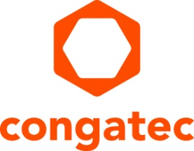
Press release

COM-HPC Carrier Design Guide compliant ecosystem

congatec simplifies COM-HPC designs

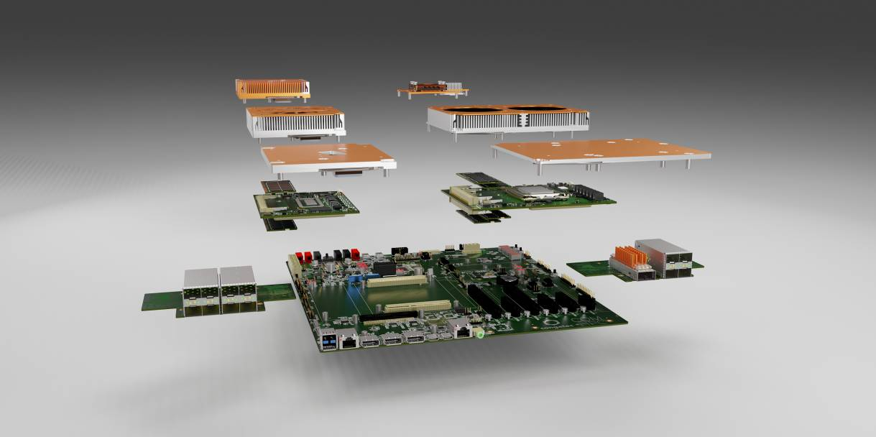

Deggendorf, Germany, 10 February, 2022 * * * congatec – a leading vendor of embedded and edge computing technology – welcomes the publication of the COM-HPC Carrier Board Design Guide by the PCI Industrial Computer Manufacturers Group (PICMG) with the launch of a fully specification compliant ecosystem for engineers of COM-HPC Client and Server module based designs. From now on, engineers can dive right in and start to develop fully compliant designs by picking their appropriate Computer-on-Module, add a COM-HPC Server or COM-HPC Client evaluation carrier and appropriate cooling solution, install their application and run programming, debugging and test routines on this new high-performance embedded computing standard.

The congatec COM-HPC ecosystem is fully compliant to the entire range of new PICMG COM-HPC specifications, namely the COM-HPC Module Base Specification, the brand new Carrier Board Design Guide, the Embedded EEPROM specification and the Platform Management Interface specification. Supported by all leading embedded computing vendors, including congatec, this set of PICMG standards offers engineers the benefits of best in class design security.

“The launch of the COM-HPC Carrier Design Guide was the last building block of the COM-HPC specifications that has been eagerly awaited by engineers. It is essential to build interoperable and scalable customized embedded computing platforms on the basis of this powerful Computer-on-Module standard, which is optimized for edge servers and high-performance embedded clients. So here we go! The design race for best-in-class high-end embedded and edge computing solutions can now begin,” says Christian Eder, Director Marketing at congatec, delighted that the COM-HPC committee has reached the final milestone of PICMG’s fundamental standardization process under his chairmanship.

The congatec ecosystem for COM-HPC Server and Client designs will be complemented by personal integration support as well as design verification and test services to tackle all challenges, from initial carrier board design verification to mass production testing. Carrier board and system design services will also be offered by congatec in collaboration with cooperation partners. To round off the ecosystem, a carrier board design training program is available where OEMs, VARs and system integrators can get a quick, easy and efficient deep dive into the design rules. The training program will guide engineers through all the mandatory and recommended design essentials and best practice schematics of COM-HPC carrier boards and accessories, such as fanless high-end cooling solutions for server designs up to and even beyond 100 Watt. The reference platform will be COM-HPC Client carrier boards equipped with COM-HPC Client modules based on 12th Gen Intel Core processors (codenamed Alder Lake). COM-HPC Server training courses will start with the availability of corresponding Intel Xeon modules and evaluation carriers, which are expected to be launched later this year.

The COM-HPC Carrier Design Guide, which serves as the main foundation for congatec’s fully compliant ecosystem, is ready for free download at the PICMG website (https://www.picmg.org/wp-content/uploads/PICMG_COMHPC_CDG_R2_0.pdf) or at the congatec website (https://www.congatec.com/com-hpc/). As the core landing page for all COM-HPC related issues, the latter also allows developers to explore the entire congatec COM-HPC ecosystem.

* * *

About congatec
congatec is a rapidly growing technology company focusing on embedded and edge computing products and services. The high-performance computer modules are used in a wide range of applications and devices in industrial automation, medical technology, transportation, telecommunications and many other verticals. Backed by controlling shareholder DBAG Fund VIII, a German midmarket fund focusing on growing industrial businesses, congatec has the financing and M&A experience to take advantage of these expanding market opportunities. congatec is the global market leader in the computer-on-modules segment with an excellent customer base from start-ups to international blue chip companies. Founded in 2004 and headquartered in Deggendorf, Germany, the company reached sales of 127.5 million US dollars in 2020. More information is available on our website at www.congatec.com or via LinkedIn, Twitter and YouTube.

Reader enquiries:  congatec GmbH  Christian Eder  Phone: +49-991-2700-0  info@congatec.com  www.congatec.com | Press contact:  SAMS Network  Michael Hennen  Phone: +49-2405-4526720  info@sams-network.com  www.sams-network.com

Text and photograph available at: https://www.congatec.com/en/congatec/press-releases.html

Intel, the Intel logo, and other Intel marks are trademarks of Intel Corporation or its subsidiaries.

