Press release

congatec introduces three new Server-on-Module families with Intel Xeon D processors

World premiere for x86 based COM-HPC Server

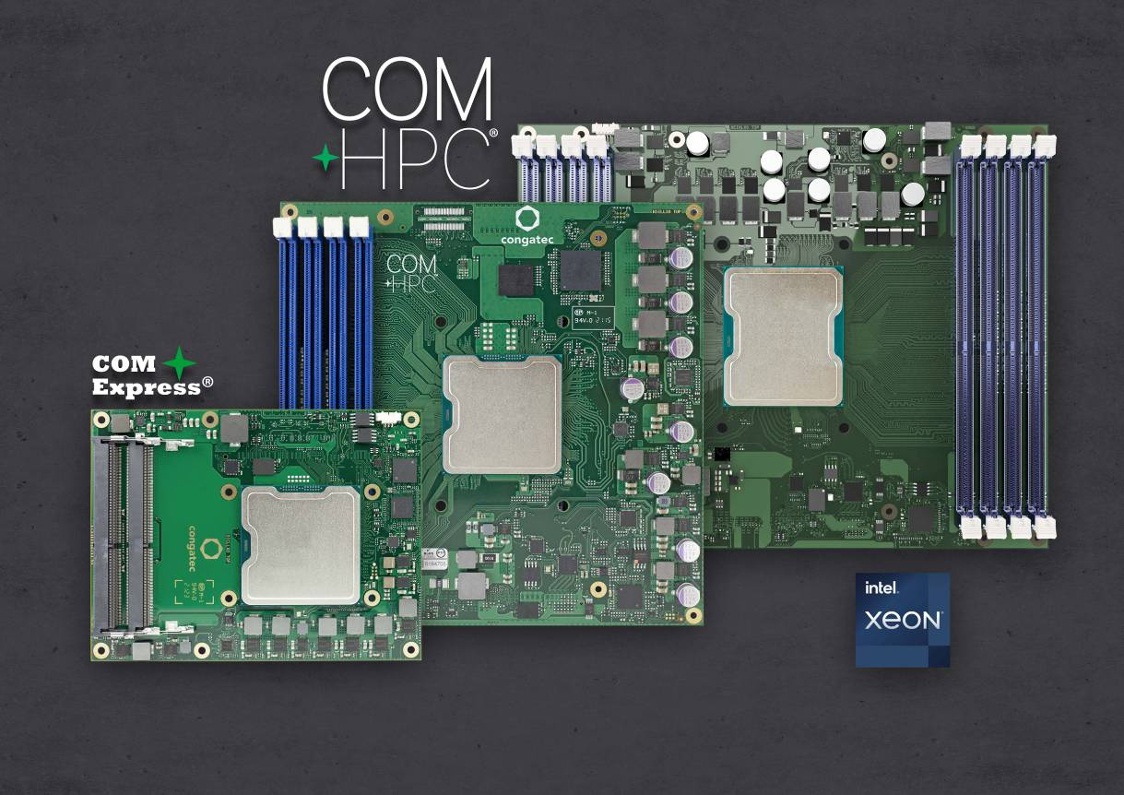
congatec’s Intel Xeon D-1700 and D-2700 processor based Server-on-Modules in COM-HPC Server Size E, Size D and COM Express Type 7 form factor (from right to left)

Deggendorf, Germany, February 24, 2022 * * * congatec – a leading vendor of embedded and edge computing technology – celebrates the world premiere for x86 based COM-HPC Server modules by announcing the availability of three new Server-on-Module families parallel to the launch of the brand-new Intel Xeon D processor family, formerly codenamed Ice Lake D. The new COM-HPC Server modules in Size E and Size D as well as the COM Express Type 7 modules will accelerate the next generation of real-time microserver workloads in rugged environments and extended temperature ranges. Improvements include up to 20 cores, RAM to up to 1 TB, double throughput per PCIe lanes to Gen 4 speed, as well as up to 100 GbE connectivity and TCC/TSN support. Target applications range from industrial workload consolidation servers for automation, robotics and medical backend imaging to outdoor servers for utilities and critical infrastructures – such as smart grids for oil, gas and electricity as well as rail and communication networks – and also includes vision enabled applications such as autonomous vehicles and video infrastructures for safety and security.

“The launch of our massive workload accelerating Intel Xeon D processor based COM-HPC Server-on-Modules is a milestone for the various edge server industries in three respects,” explains Martin Danzer, Director of Product Management at congatec. “First, Intel Xeon D processor based Server-on-Modules now target not only standard industrial environments but also outdoor and in-vehicle applications due to the extended temperature range support. Second, the worldwide first x86 COM-HPC Server-on-Modules extend the available number of cores for the first time to 20 and with up to 8 RAM sockets enable massively more memory bandwidth, which is essential for server workloads. Third, these server modules have real-time capabilities both with respect to the processor cores and TCC/TSN enabled real-time Ethernet. This is a combination that many OEMs have been eagerly waiting for.”

Besides the huge bandwidth and performance improvements, congatec’s three new Server-on-Module families will significantly extend the lifecycle of next-gen rugged edge server designs compared to common servers as long-term availability of up to ten years is planned. The module families further convince with a comprehensive server-grade feature set: For mission critical designs, they offer powerful hardware security features including Intel Boot Guard, Intel Total Memory Encryption – Multi-Tenant (Intel TME-MT) and Intel Software Guard Extensions (Intel SGX). AI applications benefit from built-in hardware acceleration including AVX-512 and VNNI. For best RAS capabilities, the processor modules integrate the Intel Resource Director Technology (Intel RDT) and support remote hardware management features such as IPMI and redfish.

The new modules will become available in a High Core Count (HCC) and a Low Core Count (LCC) variant featuring different flavors of the Intel Xeon D processor series:
- The conga-HPC/sILH COM-HPC Server Size E modules will be equipped with 5 different Intel Xeon D-2700 processors with a choice of 4 to 20 cores, 8 DIMM sockets for up to 1 TByte of 2933 MT/s fast DDR4 memory with ECC, 32x PCIe Gen 4 and 16x PCIe Gen 3 as well as 100 GbE throughput plus real-time capable 2.5 Gbit/s Ethernet with TSN and TCC support at a processor base power of 65 to 118 Watt.
- The COM-HPC Server Size D and COM Express Type 7 modules will come with 5 different Intel Xeon D-1700 processors with a choice of 4 to 10 cores. While the conga-B7Xl COM Express Server-on-Module supports up to 128 GB DDR4 2666 MT/s RAM via up to 3 SODIMM sockets, the conga-HPC/sILL COM-HPC Server Size D module offers 4 DIMM sockets for up to 256 GB of 2933 MT/s fast DDR4 RAM. Both module families offer 16x PCIe Gen 4 and 16x PCIe Gen 3 lanes. For fast networking, they provide up to 100 GbE throughput and TSN TCC support via 2.5 Gbit/s Ethernet at a processor base power of 40 to 67 Watt.

The Intel Xeon D-2700 processor based conga-HPC/sILH COM-HPC Server Size E modules (200 mm x 160 mm) will be available in the following variants:
Processor |  | Cores / Threads |  | Freq. [GHz] |  | LLC Cache [MB] |  | CPU Base Power [W] |  | Temperature  range
Intel Xeon D-2796TE |  | 20 / 40 |  | 2.0 |  | 30 |  | 118 |  | Extended Temp
Intel Xeon D-2775TE |  | 16 / 32 |  | 2.0 |  | 25 |  | 100 |  | Extended Temp
Intel Xeon D-2752TER |  | 12 / 24 |  | 1.8 |  | 20 |  | 77 |  | Extended Temp
Intel Xeon D-2733NT |  | 8 / 16 |  | 2.1 |  | 15 |  | 80 |  | Commercial Temp
Intel Xeon D-2712T |  | 4 / 8 |  | 1.9 |  | 15 |  | 65 |  | Commercial Temp

The Intel Xeon D-1700 processor based conga-HPC/sILL COM-HPC Server Size D modules (160mm x 160mm) and conga-B7Xl COM Express Type 7 modules (95 mm x 120 mm) will be available in the following configurations:
Processor |  | Cores / Threads |  | Freq. [GHz] |  | LLC Cache [MB] |  | CPU Base Power [W] |  | Temperature  range
Intel Xeon D-1746TER |  | 10 / 20 |  | 2.0 |  | 15 |  | 67 |  | Extended Temp
Intel Xeon D-1732TE |  | 8 / 16 |  | 1.9 |  | 15 |  | 52 |  | Extended Temp
Intel Xeon D-1735TR |  | 8 / 16 |  | 2.2 |  | 15 |  | 59 |  | Commercial Temp
Intel Xeon D-1715TER |  | 4 / 8 |  | 2.4 |  | 10 |  | 50 |  | Extended Temp
Intel Xeon D-1712TR |  | 4 / 8 |  | 2.0 |  | 10 |  | 40 |  | Commercial Temp

The new COM-HPC and COM Express Server-on-Modules are application ready and available with appropriate rugged cooling solutions, ranging from powerful active cooling with heat pipe adapter to fully passive cooling solutions for best mechanical resilience against vibration and shocks. On the software side, the new modules come with comprehensive board support packages for Windows, Linux and VxWorks. For workload consolidation, real-time virtual machine support is available thanks to congatec’s comprehensive support of RTS Hypervisor implementations from Real-Time Systems.

For more information on the conga-HPC/sILH COM-HPC Server Size E Server-on-Module, please visit https://www.congatec.com/en/products/com-hpc/conga-hpcsilh/

For more information on the conga-HPC/sILL COM-HPC Server Size D Server-on-Module, please visit https://www.congatec.com/en/products/com-hpc/conga-hpcsill/

For more information on the conga-B7Xl COM Express Type 7 Server-on-Module, please visit https://www.congatec.com/en/products/com-express-type7/conga-b7xi/

Further information about the new Intel Xeon D1700 and D2700 processors (formerly Ice Lake) can be found on the main landing page: https://www.congatec.com/en/technologies/intel-xeon-d-modules/

* * *
About congatec
congatec is a rapidly growing technology company focusing on embedded and edge computing products and services. The high-performance computer modules are used in a wide range of applications and devices in industrial automation, medical technology, transportation, telecommunications and many other verticals. Backed by controlling shareholder DBAG Fund VIII, a German midmarket fund focusing on growing industrial businesses, congatec has the financing and M&A experience to take advantage of these expanding market opportunities. congatec is the global market leader in the computer-on-modules segment with an excellent customer base from start-ups to international blue chip companies. Founded in 2004 and headquartered in Deggendorf, Germany, the company reached sales of 127.5 million US dollars in 2020. More information is available on our website at www.congatec.comor via LinkedIn, Twitter and YouTube.

Reader enquiries:  congatec GmbH  Christian Eder  Phone: +49-991-2700-0  info@congatec.com  www.congatec.com | Press contact:  SAMS Network  Michael Hennen  Phone: +49-2405-4526720  info@sams-network.com  www.sams-network.com

Text and photograph available at: https://www.congatec.com/en/congatec/press-releases.html

Intel, the Intel logo, and other Intel marks are trademarks of Intel Corporation or its subsidiaries.

