Press release

congatec launches 10 new COM-HPC and COM Express Computer-on-Modules with 12th Gen Intel Core processors

A quantum leap in core count

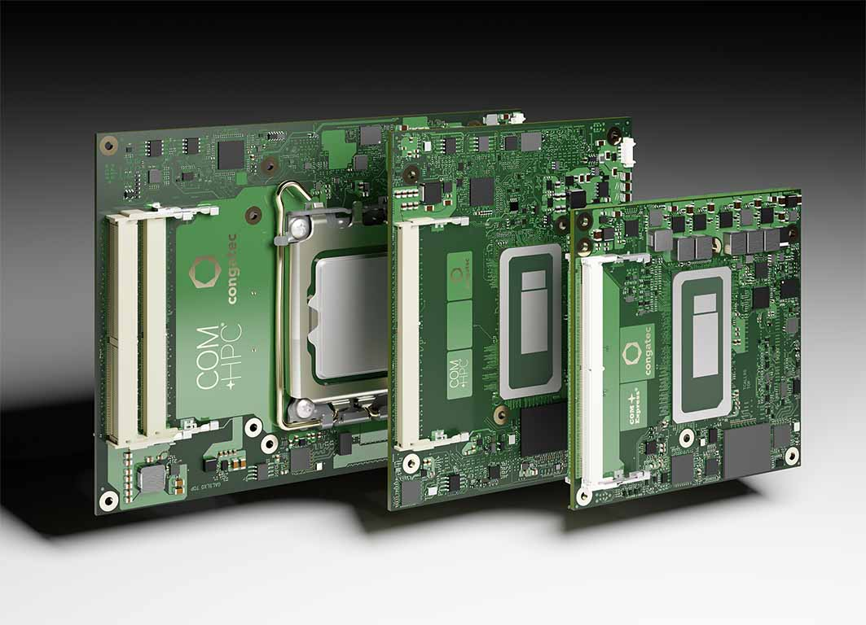

Deggendorf/Germany, Las Vegas/USA, 4 January 2022 * * * congatec – a leading vendor of embedded and edge computing technology – introduces the 12th Generation Intel Core mobile and desktop processors (formerly code named Alder Lake) on 10 new COM-HPC and COM Express Computer-on-Modules. Featuring the latest high performance cores from Intel, the new modules in COM-HPC Size A and C as well as COM Express Type 6 form factors offer major performance gains and improvements for the world of embedded and edge computing systems. Most impressive is the fact that engineers can now leverage Intel’s innovative performance hybrid architecture. Offering of up to 14 cores/20 threads on BGA and 16 cores/24 threads on desktop variants (LGA mounted), 12th Gen Intel Core processors provide a quantum leap [1] in multitasking and scalability levels. Next-gen IoT and edge applications benefit from up to 6 or 8 (BGA/LGA) optimized Performance-cores (P-cores) plus up to 8 low power Efficient-cores (E-cores) and DDR5 memory support to accelerate multithreaded applications and execute background tasks more efficiently.

In addition, the mobile BGA processors with, up to 96 Execution Units of the integrated Intel Iris Xe GPU have been estimated to deliver extraordinary improvements of up to 129% [2] in graphics performance for immersive user experience and can also process parallelized workloads faster, such as artificial intelligence (AI) algorithms, as compared to the 11th Gen Intel Core processors.

Optimized for highest embedded client performance, the graphics of the LGA processor based modules delivers now up to 94 % faster performance and its image classification inference performance has nearly tripled with up to 181% higher throughput [3]. In addition the modules offer massive bandwidth to connect discrete GPUs for maximum graphics and GPGPU based AI performance. Compared to the BGA versions, these and all other peripherals benefit from doubled lane speed as they come with ultra-fast PCIe 5.0 interface technology in addition to PCIe 4.0 off the processor. Furthermore, the desktop chipsets provide up to 8x PCIe 3.0 lanes for additional connectivity and the mobile BGA variants also offer up to 16x PCIe 4.0 lanes off the CPU and up to 8 PCIe 3.0 lanes off the chipset.

Target industrial markets for both BGA and LGA variants can be found wherever high end embedded and edge computer technology is deployed. This includes, for example, edge computers and IoT gateways incorporating multiple virtual machines for smart factories and process automation, AI based quality inspection and industrial vision, real-time collaborative robotics, and autonomous logistics vehicles for warehouses and shipping. Typical outdoor applications include autonomous vehicles and mobile machines, video security and gateway applications in transportation and smart cities, as well as 5G cloudlets and edge devices requiring AI supported packet inspection.

“Leveraging Intel’s innovative performance hybrid architecture with impressive P - core performance in combination with power efficient E - cores Intel Thread Director assigns each workload to the proper cores for optimum performance. Selected processors are also suitable for hard real-time applications with Intel TCC and TSN. In combination with full support for Real-Time Systems’ hypervisor technology, they are the ideal platform to consolidate a multitude of different workloads on one single edge platform. As this applies to low-power and high-performance scenarios alike, it enables highly sustainable designs with a small ecological footprint,” explains Christian Eder, Director Marketing at congatec.

Besides highest bandwidth and performance, the new flagship COM-HPC Client and COM Express Type 6 modules impress with dedicated AI engines supporting Windows ML, Intel Distribution of OpenVINO toolkit and Chrome Cross ML. The different AI workloads can seamlessly be delegated to the P-cores, E-cores, as well as the GPU execution units to process even the most intensive edge AI workloads. The built-in Intel Deep Learning boost technology leverages different cores via Vector Neural Network Instructions (VNNI), and the integrated graphics supports AI accelerated DP4a GPU instructions that can even be scaled to dedicated GPUs. Furthermore, Intel’s lowest power built-in AI accelerator, the Intel Gaussian & Neural Accelerator 3.0 (Intel GNA 3.0), enables dynamic noise suppression and speech recognition and can even run while the processor is in low power states for wake-up voice commands.

Combining these features with support for Real-Time Systems’ hypervisor technology as well as OS support for Real-Time Linux and Wind River VxWorks, makes these modules a truly rounded ecosystem package to facilitate and accelerate the development of edge computing applications.

The 12th Gen Intel Core mobile processor based conga-TC670 COM Express Type 6 Compact modules (95 mm x 95 mm) and the conga-HPC/cALP COM-HPC Client Size A modules (120 mm x 95 mm) will be available in the following configurations:

Processor |  | Cores/  (P + E) |  | P-cores  Freq. [GHz] |  | E-cores  Freq. [GHz] |  | Threads |  | GPU Compute Units |  | CPU Base Power [W]
Intel Core i7 12800HE |  | 14 (6+8) |  | 2.4 / 4.6 |  | 1.8 / 3.5 |  | 20 |  | 96 |  | 45
Intel Core i5 12600HE |  | 12 (4+8) |  | 2.5 / 4.5 |  | 1.8 / 3.3 |  | 16 |  | 80 |  | 45
Intel Core i3 12300HE |  | 8 (4+4) |  | 1.9 / 4.3 |  | 1.5 / 3.3 |  | 12 |  | 48 |  | 45

12th Gen Intel Core desktop processor based conga-HPC/cALS COM-HPC Client Size C modules (120 mm x 160 mm) will be available in the following variants:

Processor |  | Cores/  (P + E) |  | P-cores  Freq. [GHz] |  | E-cores  Freq. [GHz] |  | Threads |  | GPU Compute Units |  | CPU Base Power [W]
Intel Core i9 12900E |  | 16 (8+8) |  | 2.3 / 5.0 |  | 1.7 / 3.8 |  | 24 |  | 32 |  | 65
Intel Core i7 12700E |  | 12 (8+4) |  | 2.1 / 4.8 |  | 1.6 / 3.6 |  | 20 |  | 32 |  | 65
Intel Core i5 12500E |  | 6 (6+0) |  | 2.9 / 4.5 |  | - / - |  | 12 |  | 32 |  | 65
Intel Core i3 12100E |  | 4 (4+0) |  | 3.2 / 4.2 |  | - / - |  | 8 |  | 24 |  | 60

All these modules come with comprehensive board support packages for all these leading RTOSes, including hypervisor support from Real-Time Systems as well as Linux, Windows and Android.

For more information on the conga-HPC/cALS COM-HPC Client Size C modules, please visit https://www.congatec.com/en/products/com-hpc/conga-hpccals/

Further information on the new conga-HPC/cALP COM-HPC Client Size A modules can be found at: https://www.congatec.com/en/products/com-hpc/conga-hpccalp/

To find out more about the conga-TC670 COM Express Type 6 Compact modules, please visit https://www.congatec.com/en/products/com-express-type-6/conga-tc670/

* * *

About congatec
congatec is a rapidly growing technology company focusing on embedded and edge computing products and services. The high-performance computer modules are used in a wide range of applications and devices in industrial automation, medical technology, transportation, telecommunications and many other verticals. Backed by controlling shareholder DBAG Fund VIII, a German midmarket fund focusing on growing industrial businesses, congatec has the financing and M&A experience to take advantage of these expanding market opportunities. congatec is the global market leader in the Computer-on-Modules segment with an excellent customer base from start-ups to international blue chip companies. Founded in 2004 and headquartered in Deggendorf, Germany, the company reached sales of 127.5 million US dollars in 2020. More information is available on our website at www.congatec.com or via LinkedIn, Twitter and YouTube.

Reader enquiries:  congatec GmbH  Christian Eder  Phone: +49-991-2700-0  info@congatec.com  www.congatec.com | Press contact:  SAMS Network  Michael Hennen  Phone: +49-2405-4526720  info@sams-network.com  www.sams-network.com

Text and image available at: https://www.congatec.com/en/congatec/press-releases.html

Intel, the Intel logo, and other Intel marks are trademarks of Intel Corporation or its subsidiaries.

[1] Previous congatec COM Express Type 6 and COM-HPC Client size A modules with 11th Gen Intel Core and Xeon processors featured up to 8 cores.

[2] Source: Measurements by Intel as of November 2021. Single-threaded performance measured with SPECrate2017_int_base (1-copy)IC19_0u4. Multithreaded performance measured with SPECrate2017_int_base (n-copy)IC19_0u4. Graphics performance measured with 3DMark Ver. 2.11.6846, Fire Strike graphics score. GPU image classification inference performance measured with MLPerf TM v1.1 OpenVINO v2021.4.1,
resnet50: Offline, int8, GPU. MLPerf™ Inference Edge v1.1 Inference ResNet-v1.5; Result not verified by the MLCommons™ Association. The MLPerf name and logo are trademarks of MLCommons Association in the United States and other countries. All rights reserved. Unauthorized use strictly prohibited. See www.mlcommons.org for more information.10th Gen Intel® Core™ processors are the previous generation in this series for IoT. Configuration 1: Processor: Intel® Core™ i9-12900E PL1=65W TDP, 16(8+8)C, 24T, Turbo up to 5.0GHz. Graphics: Intel® UHD Graphics 770 driven by X e Architecture. Memory: 32GB DDR5-4800.
Storage: Intel® SSDPEKNW010T8 (1024 GB, PCI-E 3.0 x4). OS: Windows 10 Enterprise LTSC 21H2.Bios: ADLSFWI1.R00.2355.B00.2108270706 (08/27/2021). CPUz Microcode: 0xD. Configuration 2: Processor:
Intel® Core™ i9-10900E PL1=65W TDP, 10C, 20T, Turbo up to 5.2GHz. Graphics: Intel® UHD Graphics 630. Memory: 32GB DDR4-2933. Storage: Samsung SSD 970 EVO Plus 1TB. OS: Windows 10 Enterprise LTSC
21H2. Bios: AMI UEFI (03/23/2021) CPUz Microcode: 0xCA.

[3] Source: Intel Core i7-12800HE scores are estimated by Intel as of November 2021. Pre-silicon estimates are subject to +/- 7 percent error. Intel® Core™ i7-11850HE scores are measured by Intel. Single-threaded performance measured with SPECrate2017_int_base (1-copy)IC19_0u4 (est). Multithreaded performance measured with SPECrate2017_int_base (n-copy)IC19_0u4 (est). Graphics performance measured with 3DMark Fire Strike graphics score. Configuration 1: Processor: Intel® Core™ i7-12800HE, PL1=45W, (6C+8c) 14C, 20T, Turbo up to 4.6GHz. Graphics: Intel® Iris® Xe Graphics Architecture with up to 96 EUs. Memory: DDR5-4800 2x32GB. Storage: Samsung 970 Evo Plus (CPU attached). OS: Windows* 10 20H2, Windows Defender OFF, Virtual Based Security OFF. Configuration 2: Processor: Intel® Core™ i7-11850HE (TGL-H), PL1=45W TDP, 8C16T, Turbo up to 4.7GHz. Graphics: Intel® Xe Graphics Architecture with up to 32 EUs. Memory: DDR4-3200 2x32GB. Storage: Intel® SSDSC2KW512GB (512 GB, SATA-III). Platform/ motherboard: Intel internal reference platform. OS: Windows 10 Pro 21H1, Windows Defender OFF, Virtual Based Security OFF. Bios: TGLSFWI1.R00.4151.A01.2104060640 (Release date: 04/06/2021).CPUz Microcode: 28h

