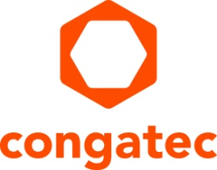
Press release

Arm Project Cassini completed: congatec modules with NXP i.MX 8M Plus processor now Arm SystemReady IR certified

congatec simplifies Arm deployments with i.MX 8M Plus

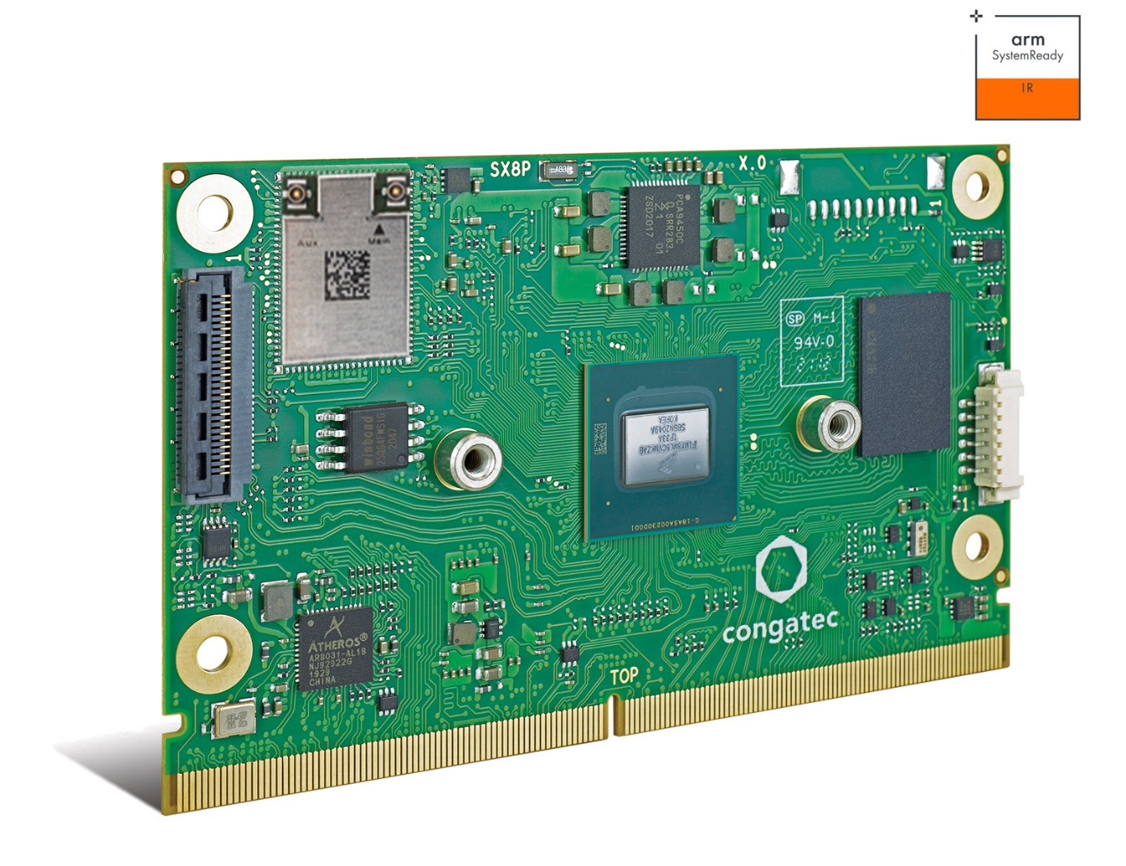

Deggendorf, Germany, 17 May, 2022 * * * congatec – a leading vendor of embedded and edge computing technology – announces that its SMARC Computer-on-Modules based on NXP i.MX8 M Plus processor technology have achieved SystemReady IR certification within the Arm driven Cassini project. The project aims to overcome the barriers of Arm deployments by providing a comprehensive and secure ecosystem of standards while delivering a cloud-native software experience similar to an app store with easy download, install and run routines with only a few clicks. By leveraging software that allows hardware diversity and provides powerful security APIs and certification, OEMs benefit from reduced development effort and time to market as they can now port and deploy their applications to the entire Cassini certified Arm ecosystem. Hardware with Cassini SystemReady IR certified bootloader is validated to run unmodified ISO images of Ubuntu, Fedora, openSUSE and Debian operating systems, making native software installation an easily executable task. Combined with congatec’s OS build services and build environment expertise on the basis of the Yocto project, OEMs not only gain instant entry but also efficient customization services for applications based on congatec’s SMARC module conga-SMX8-Plus with NXP i.MX8 processor.

By building Arm systems on the basis of Computer-on-Module standards and standardized ISO images, application designs become highly efficient, reducing NRE costs and accelerating OEMs’ time to market. As a long term strategy, Cassini Project also has the potential to become the standard for how Arm based IoT and edge devices will be updated, managed and secured.

“We love the idea of Project Cassini as it builds a comprehensive ecosystem to improve the design-in efficiency of Arm applications,” explains Martin Danzer, Director Product Management at congatec. “Testing applications on standard platforms with standard ISO images is the right step to fast and easy evaluation, for example - securely managed virtualized gateways hosting cloud-native stacks that can be orchestrated remotely. But please don’t forget that a secure boot implementation is mandatory for such applications.”

The congatec Cassini enabled platform in detail
The first congatec starter set suitable to implement the Cassini SystemReady IR certified bootloader available at congatec’s GIT server targets AI accelerated vision applications and contains the entire ecosystem developers need to instantly start designing applications on the basis of the next-generation NXP i.MX 8M plus platform, which offers highly efficient vision and AI integration. At the heart of the starter set is the new SMARC 2.1 Computer-on-Module conga-SMX8-Plus. It features 4 powerful Arm Cortex®-A53 cores, 1x Arm Cortex®-M7 controller and the NXP Neural Processing Unit (NPU) to accelerate deep learning algorithms and comes with passive cooling. Within the scope of customer-specific projects, the 3.5 inch carrier board conga-SMC1/SMARC-ARM can be directly connected to the 13 MP Basler dart daA4200-30mci BCON for MIPI camera via MIPI CSI-2.0 without any additional converter modules. Next to MIPI, CSI-2.0 also USB and GigE vision cameras can be also supported. On the software side, congatec provides a bootable SD card with preconfigured boot loader,Yocto build OS image, and matching BSPs. Also the processor-optimized Basler embedded vision software enabling immediate AI inference training on the basis of captured images and video sequences can be made available as plug & play ready for qualified customer projects.

Further information on congatec’s ecosystem for i.MX 8 based designs can be found at: https://www.congatec.com/imx8
* * *

About congatec
congatec is a rapidly growing technology company focusing on embedded and edge computing products and services. The high-performance computer modules are used in a wide range of applications and devices in industrial automation, medical technology, transportation, telecommunications and many other verticals. Backed by controlling shareholder DBAG Fund VIII, a German midmarket fund focusing on growing industrial businesses, congatec has the financing and M&A experience to take advantage of these expanding market opportunities. congatec is the global market leader in the computer-on-modules segment with an excellent customer base from start-ups to international blue chip companies. More information is available on our website at www.congatec.comor via LinkedIn, Twitter and YouTube.

Reader enquiries:  congatec GmbH  Christian Eder  Phone: +49-991-2700-0  info@congatec.com  www.congatec.com | Press contact:  SAMS Network  Michael Hennen  Phone: +49-2405-4526720  info@sams-network.com  www.sams-network.com

Text and photograph available at: https://www.congatec.com/en/congatec/press-releases.html

