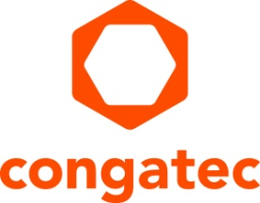
Press release

congatec announces changes in top management to further accelerate company growth

Dr. Dirk Haft is new CEO, Daniel Jürgens new CFO

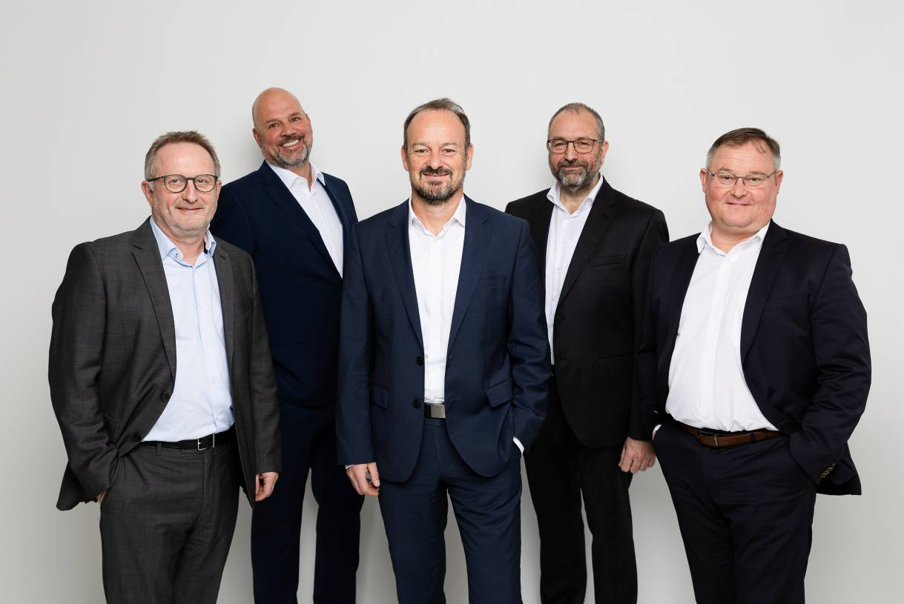
From left: Gerhard Edi CSO, Daniel Jürgens CFO, Dr. Dirk Haft CEO, Konrad Garhammer CTO, Thomas Schultze COO

Deggendorf, Germany, December 21, 2021 * * * congatec – a leading vendor of embedded and edge computing technology – is pleased to announce its new leadership team, with Dr. Dirk Haft taking over as the new CEO and Daniel Jürgens as the new CFO. Gerhard Edi, previously CTO, will assume the newly created position of CSO (Chief Strategy Officer). Konrad Garhammer, previously Worldwide Director of Engineering, will move to the position of CTO. The aim of the new top management team is to accelerate internationalization, make the supply chain even more reliable and efficient, and generate further growth in new markets such as functional safety and critical infrastructures, which require congatec to build up new competencies in both software and manufacturing.

Dr. Haft brings a wealth of leadership experience to take congatec to a new level of growth in the embedded and edge computing markets. Jürgens adds international M&A and private equity experience to the updated congatec management team. Gerhard Edi, a congatec co-founder and a veteran of the embedded computing industry, will be responsible for the future technology and product strategy as CSO and also drive expansion of strategic partnerships with technology suppliers, partners and customers.

The congatec advisory board warmly welcomes Dr. Dirk Haft, Daniel Jürgens and Konrad Garhammer to the management team and looks forward to working with them for the next stage of congatec’s growth trajectory, which aims to further strengthen the company’s position as a global market leader in embedded and edge computing. The accelerated growth strategy will make congatec an even stronger partner for customers, helping them even more effectively to solve their constantly changing technology and business challenges.

Bringing more than 20 years of experience in leading technology companies, Dr. Haft is looking forward to his new position: “It is an honor to become the CEO of such an innovative high-tech company. congatec has a clear focus, direction and mission in a dynamic and growing market. My task now is to identify and coordinate internal and external growth opportunities, with the goal to continue elevating congatec’s status as a global player in embedded computer technologies. With Gerhard Edi as CSO, Konrad Garhammer as CTO, Daniel Jürgens as CFO and Thomas Schultze as COO, I am very fortunate to have such strong and experienced partners in the executive board who complement my skills and will support me in driving our growth strategies.” Dr. Haft comes to congatec from his roles as board member of Wittenstein SE and as CEO of attocube systems AG. He holds a PhD in Physics from LMU Munich (Ludwig-Maximilians-Universität München).

Daniel Jürgens joins congatec from his previous position as CFO at VIA optronics AG, a fast-growing high-tech company listed at the New York stock exchange (NYSE:VIAO). On the basis of this experience, Jürgens also sees strong growth potential for congatec. “congatec is an iconic company in the embedded computing segment and already well positioned for growth,” states Jürgens, adding: “I’ll be bringing my M&A and private equity experience plus my own motivation to the table to accelerate the growth and success of congatec.”

The new CTO Konrad Garhammer joined congatec in 2016 from what is now Saab Sensor Systems Germany (formerly Saab Medav Technologies). Under the leadership of Gerhard Edi, he expanded the global development team to over 100 employees in his role as Worldwide Director of Engineering, drove technological development, introduced agile workflows and led the team as Edi’s right hand. “I am very pleased to have been entrusted to take on full responsibility for this team and look forward to expanding our performance further,” explains Garhammer.

Daniel Jürgens started in September 2021, Dr. Dirk Haft took up his new role on November 1. Gerhard Edi and Konrad Garhammer assumed their new positions on December 15. The outgoing CEO Jason Carlson and CFO Josef Wenzl will support the new management team as Senior Advisors to facilitate a smooth transition. The congatec advisory board wants to take the opportunity to thank Carlson and Wenzl for their efforts and leadership in helping to institutionalize congatec’s organization and processes, and in securing its global leadership position in embedded computing.

* * *

About congatec
congatec is a rapidly growing technology company focusing on embedded and edge computing products and services. The high-performance computer modules are used in a wide range of applications and devices in industrial automation, medical technology, transportation, telecommunications and many other verticals. Backed by controlling shareholder DBAG Fund VIII, a German midmarket fund focusing on growing industrial businesses, congatec has the financing and M&A experience to take advantage of these expanding market opportunities. congatec is the global market leader in the computer-on-modules segment with an excellent customer base from start-ups to international blue chip companies. Founded in 2004 and headquartered in Deggendorf, Germany, the company reached sales of 127.5 million US dollars in 2020. More information is available on our website at www.congatec.com or via LinkedIn, Twitter and YouTube.

Reader enquiries:  congatec GmbH  Christian Eder  Phone: +49-991-2700-0  info@congatec.com  www.congatec.com | Press contact:  SAMS Network  Michael Hennen  Phone: +49-2405-4526720  info@sams-network.com  www.sams-network.com

Text and photograph available at: www.congatec.com/en/congatec/press-releases.html

